Laporan Jarak Antar Fasa 20kV APEL & ANGGUR SPAN 1-156

Tegangan : 20kV
Nama RoW : APEL & ANGGUR SPAN 1-156
Unit Pelaksana : PT PLN ELECTRICITY SERVICES
Unit Pelaporan : OASIS

2026/09/21

Laporan Jarak Antar Fasa 20kV APEL & ANGGUR SPAN 1-156

1.Daftar Jarak Antar Fasa
No. | Span | ID dan Lokasi Fasa | Nilai (m) (m) | Jarak Ke Menara Kecil (m)
1 | 1-2(1_2) | S1(LeftUpFasaPowerLineAndLeftDownFasaPowerLine) | 1.115 | 25.620
2 | 1-2(1_2) | S2(RightUpFasaPowerLineAndRightDownFasaPowerLine) | 0.693 | 24.815
3 | 1-2(1_2) | S3(LeftUpFasaPowerLineAndRightUpFasaPowerLine) | 1.195 | 42.204
4 | 1-2(1_2) | S4(RightUpFasaPowerLineAndLeftDownFasaPowerLine) | 1.759 | 39.103
5 | 1-2(1_2) | S5(Fasa Kiri Atas ke Fasa Kiri Tengah) | 0.946 | 32.807
6 | 1-2(1_2) | S6(Fasa Kiri Tengah ke Fasa Kiri Bawah) | 0.703 | 39.009
7 | 1-2(1_2) | S7(LeftMiddleFasaPowerLineAndRightMiddleFasaPowerLine) | 0.783 | 17.900
8 | 1-2(1_2) | S8(Fasa Kanan Atas ke Fasa Kanan Tengah) | 0.549 | 34.904
9 | 1-2(1_2) | S9(LeftDownFasaPowerLineAndRightMiddleFasaPowerLine) | 1.479 | 34.803
10 | 2-3(2_3) | S1(LeftUpFasaPowerLineAndLeftDownFasaPowerLine) | 1.183 | 21.118
11 | 2-3(2_3) | S2(RightUpFasaPowerLineAndRightDownFasaPowerLine) | 1.006 | 23.711
12 | 3-4(3_4) | S1(Fasa Kiri Atas ke Fasa Kiri Tengah) | 1.234 | 5.122
13 | 3-4(3_4) | S2(RightUpFasaPowerLineAndRightDownFasaPowerLine) | 1.010 | 23.211
14 | 4-5(4_5) | S1(Fasa Kiri Atas ke Fasa Kiri Tengah) | 1.112 | 26.311
15 | 4-5(4_5) | S2(Fasa Kanan Atas ke Fasa Kanan Tengah) | 1.034 | 23.215
16 | 5-6(5_6) | S1(Fasa Kiri Atas ke Fasa Kiri Tengah) | 1.057 | 22.612
17 | 5-6(5_6) | S2(RightUpFasaPowerLineAndRightDownFasaPowerLine) | 1.158 | 19.017
18 | 6-7(6_7) | S1(Fasa Kiri Atas ke Fasa Kiri Tengah) | 1.159 | 8.883
19 | 6-7(6_7) | S2(RightUpFasaPowerLineAndRightDownFasaPowerLine) | 1.110 | 37.959
20 | 7-8(7_8) | S1(Fasa Kiri Atas ke Fasa Kiri Tengah) | 1.226 | 27.114
21 | 7-8(7_8) | S2(RightUpFasaPowerLineAndRightDownFasaPowerLine) | 1.120 | 21.012
22 | 8-9(8_9) | S1(LeftUpFasaPowerLineAndLeftDownFasaPowerLine) | 1.212 | 23.413
23 | 8-9(8_9) | S2(RightUpFasaPowerLineAndRightDownFasaPowerLine) | 1.213 | 5.114
24 | 9-10(9_10) | S1(LeftUpFasaPowerLineAndLeftDownFasaPowerLine) | 1.218 | 5.215
25 | 9-10(9_10) | S2(RightUpFasaPowerLineAndRightDownFasaPowerLine) | 1.224 | 12.873
26 | 10-11(10_11) | S1(Fasa Kiri Atas ke Fasa Kiri Tengah) | 1.215 | 6.011
27 | 10-11(10_11) | S2(Fasa Kanan Atas ke Fasa Kanan Tengah) | 1.184 | 38.357
28 | 11-12(11_12) | S1(LeftUpFasaPowerLineAndLeftDownFasaPowerLine) | 1.265 | 40.659
29 | 11-12(11_12) | S2(Fasa Kanan Atas ke Fasa Kanan Tengah) | 1.192 | 40.657
30 | 13-14(13_14) | S1(Fasa Kiri Atas ke Fasa Kiri Tengah) | 0.939 | 6.897
31 | 13-14(13_14) | S2(RightUpFasaPowerLineAndRightDownFasaPowerLine) | 0.972 | 12.321
32 | 15-16(15_16) | S1(Fasa Kiri Atas ke Fasa Kiri Tengah) | 0.780 | 5.232
33 | 15-16(15_16) | S2(RightUpFasaPowerLineAndLeftMiddleFasaPowerLine) | 1.105 | 5.108
34 | 15-16(15_16) | S3(Fasa Kiri Tengah ke Fasa Kiri Bawah) | 0.547 | 5.860
35 | 15-16(15_16) | S4(LeftMiddleFasaPowerLineAndRightMiddleFasaPowerLine) | 1.287 | 5.130
36 | 15-16(15_16) | S5(LeftMiddleFasaPowerLineAndRightDownFasaPowerLine) | 0.976 | 5.752
37 | 15-16(15_16) | S6(LeftUpFasaPowerLineAndLeftDownFasaPowerLine) | 1.011 | 13.788
38 | 15-16(15_16) | S7(LeftDownFasaPowerLineAndRightDownFasaPowerLine) | 1.251 | 5.877
39 | 15-16(15_16) | S8(Fasa Kanan Atas ke Fasa Kanan Tengah) | 1.152 | 33.550
40 | 15-16(15_16) | S9(Fasa Kanan Tengah ke Fasa Kanan Bawah) | 0.492 | 8.201
41 | 16-17(16_17) | S1(LeftUpFasaPowerLineAndLeftDownFasaPowerLine) | 1.206 | 23.113
42 | 16-17(16_17) | S2(RightUpFasaPowerLineAndRightDownFasaPowerLine) | 1.054 | 20.315
43 | 17-18(17_18) | S1(LeftUpFasaPowerLineAndLeftDownFasaPowerLine) | 1.072 | 22.616
44 | 17-18(17_18) | S2(RightUpFasaPowerLineAndRightDownFasaPowerLine) | 1.163 | 5.205
45 | 18-19(18_19) | S1(RightUpFasaPowerLineAndLeftDownFasaPowerLine) | 1.819 | 14.380
46 | 18-19(18_19) | S2(RightUpFasaPowerLineAndRightDownFasaPowerLine) | 1.033 | 23.223
47 | 18-19(18_19) | S3(RightUpFasaPowerLineAndLeftMiddleFasaPowerLine) | 1.164 | 14.382
48 | 18-19(18_19) | S4(RightUpFasaPowerLineAndLeftUpFasaPowerLine) | 1.269 | 16.100
49 | 18-19(18_19) | S5(LeftUpFasaPowerLineAndLeftDownFasaPowerLine) | 0.565 | 14.504
50 | 18-19(18_19) | S6(RightDownFasaPowerLineAndLeftDownFasaPowerLine) | 2.179 | 16.037
51 | 19-20(19_20) | S1(LeftUpFasaPowerLineAndLeftDownFasaPowerLine) | 1.014 | 21.014
52 | 19-20(19_20) | S2(RightUpFasaPowerLineAndRightDownFasaPowerLine) | 1.222 | 38.758
53 | 20-21(20_21) | S1(LeftUpFasaPowerLineAndLeftDownFasaPowerLine) | 1.060 | 26.865
54 | 20-21(20_21) | S2(RightUpFasaPowerLineAndRightDownFasaPowerLine) | 1.049 | 17.614
55 | 21-22(21_22) | S1(LeftUpFasaPowerLineAndLeftDownFasaPowerLine) | 0.980 | 22.313
56 | 21-22(21_22) | S2(RightUpFasaPowerLineAndRightDownFasaPowerLine) | 1.142 | 24.214
57 | 22-23(22_23) | S1(LeftUpFasaPowerLineAndLeftDownFasaPowerLine) | 1.072 | 17.818
58 | 22-23(22_23) | S2(RightUpFasaPowerLineAndRightDownFasaPowerLine) | 1.101 | 25.311
59 | 23-24(23_24) | S1(LeftUpFasaPowerLineAndLeftDownFasaPowerLine) | 1.105 | 24.713
60 | 23-24(23_24) | S2(RightUpFasaPowerLineAndRightDownFasaPowerLine) | 1.081 | 22.814
61 | 24-25(24_25) | S1(LeftUpFasaPowerLineAndLeftDownFasaPowerLine) | 1.089 | 19.813
62 | 24-25(24_25) | S2(RightUpFasaPowerLineAndRightDownFasaPowerLine) | 1.180 | 22.717
63 | 25-26(25_26) | S1(LeftUpFasaPowerLineAndLeftDownFasaPowerLine) | 1.173 | 20.413
64 | 25-26(25_26) | S2(RightUpFasaPowerLineAndRightDownFasaPowerLine) | 1.247 | 37.860
65 | 26-27(26_27) | S1(Fasa Kiri Atas ke Fasa Kiri Tengah) | 1.184 | 5.115
66 | 26-27(26_27) | S2(RightUpFasaPowerLineAndRightDownFasaPowerLine) | 1.337 | 5.207
67 | 27-28(27_28) | S1(Fasa Kiri Atas ke Fasa Kiri Tengah) | 1.171 | 37.557
68 | 27-28(27_28) | S2(RightUpFasaPowerLineAndRightDownFasaPowerLine) | 1.333 | 5.122
69 | 28-29(28_29) | S1(LeftUpFasaPowerLineAndLeftDownFasaPowerLine) | 1.243 | 5.215
70 | 28-29(28_29) | S2(RightUpFasaPowerLineAndRightDownFasaPowerLine) | 1.461 | 41.607
71 | 28-29(28_29) | S3(Fasa Kanan Atas ke Fasa Kanan Tengah) | 1.295 | 7.960
72 | 28-29(28_29) | S4(Fasa Kiri Atas ke Fasa Kiri Tengah) | 1.099 | 7.964
73 | 28-29(28_29) | S5(RightUpFasaPowerLineAndLeftMiddleFasaPowerLine) | 1.379 | 7.950
74 | 28-29(28_29) | S6(LeftDownFasaPowerLineAndRightDownFasaPowerLine) | 2.192 | 7.900
75 | 28-29(28_29) | S7(Fasa Kanan Tengah ke Fasa Kanan Bawah) | 0.716 | 7.930
76 | 29-30(29_30) | S1(Fasa Kiri Atas ke Fasa Kiri Tengah) | 1.299 | 5.111
77 | 29-30(29_30) | S2(RightUpFasaPowerLineAndRightDownFasaPowerLine) | 1.338 | 5.112
78 | 30-31(30_31) | S1(Fasa Kiri Atas ke Fasa Kiri Tengah) | 1.139 | 17.306
79 | 30-31(30_31) | S2(RightUpFasaPowerLineAndRightDownFasaPowerLine) | 1.335 | 31.059
80 | 30-31(30_31) | S3(LeftUpFasaPowerLineAndLeftDownFasaPowerLine) | 1.211 | 26.353
81 | 31-32(31_32) | S1(Fasa Kiri Atas ke Fasa Kiri Tengah) | 1.203 | 5.169
82 | 31-32(31_32) | S2(RightUpFasaPowerLineAndRightDownFasaPowerLine) | 1.257 | 26.564
83 | 32-33(32_33) | S1(LeftUpFasaPowerLineAndLeftDownFasaPowerLine) | 1.233 | 5.208
84 | 32-33(32_33) | S2(RightUpFasaPowerLineAndRightDownFasaPowerLine) | 1.296 | 5.111
85 | 33-34(33_34) | S1(LeftUpFasaPowerLineAndLeftDownFasaPowerLine) | 1.215 | 5.226
86 | 33-34(33_34) | S2(RightUpFasaPowerLineAndRightDownFasaPowerLine) | 1.316 | 37.056
87 | 34-35(34_35) | S1(Fasa Kiri Atas ke Fasa Kiri Tengah) | 1.322 | 41.610
88 | 34-35(34_35) | S2(Fasa Kanan Atas ke Fasa Kanan Tengah) | 1.224 | 41.606
89 | 34-35(34_35) | S3(LeftUpFasaPowerLineAndRightDownFasaPowerLine) | 1.538 | 35.050
90 | 34-35(34_35) | S4(RightUpFasaPowerLineAndRightDownFasaPowerLine) | 1.271 | 35.051
91 | 34-35(34_35) | S5(Fasa Kiri Tengah ke Fasa Kiri Bawah) | 0.748 | 35.111
92 | 34-35(34_35) | S6(RightMiddleFasaPowerLineAndLeftDownFasaPowerLine) | 1.509 | 35.101
93 | 35-36(35_36) | S1(Fasa Kiri Atas ke Fasa Kiri Tengah) | 0.738 | 32.458
94 | 35-36(35_36) | S2(Fasa Kanan Atas ke Fasa Kanan Tengah) | 0.656 | 16.119
95 | 35-36(35_36) | S3(Fasa Kiri Tengah ke Fasa Kiri Bawah) | 0.687 | 13.718
96 | 35-36(35_36) | S4(LeftMiddleFasaPowerLineAndRightDownFasaPowerLine) | 1.504 | 13.703
97 | 35-36(35_36) | S5(RightUpFasaPowerLineAndRightDownFasaPowerLine) | 0.763 | 16.107
98 | 35-36(35_36) | S6(Fasa Kanan Tengah ke Fasa Kanan Bawah) | 0.766 | 16.216
99 | 37-38(37_38) | S1(Fasa Kiri Atas ke Fasa Kiri Tengah) | 0.800 | 24.657
100 | 37-38(37_38) | S2(Fasa Kanan Atas ke Fasa Kanan Tengah) | 0.874 | 23.897
101 | 38-39(38_39) | S1(Fasa Kiri Atas ke Fasa Kiri Tengah) | 1.053 | 22.711
102 | 38-39(38_39) | S2(RightUpFasaPowerLineAndRightDownFasaPowerLine) | 1.002 | 23.418
103 | 39-40(39_40) | S1(Fasa Kiri Atas ke Fasa Kiri Tengah) | 1.046 | 23.506
104 | 39-40(39_40) | S2(Fasa Kanan Atas ke Fasa Kanan Tengah) | 0.934 | 20.520
105 | 40-41(40_41) | S1(Fasa Kiri Atas ke Fasa Kiri Tengah) | 1.083 | 16.018
106 | 40-41(40_41) | S2(RightUpFasaPowerLineAndRightDownFasaPowerLine) | 1.043 | 25.416
107 | 41-42(41_42) | S1(Fasa Kiri Atas ke Fasa Kiri Tengah) | 1.066 | 25.313
108 | 41-42(41_42) | S2(RightUpFasaPowerLineAndRightDownFasaPowerLine) | 0.974 | 22.213
109 | 42-43(42_43) | S1(Fasa Kiri Atas ke Fasa Kiri Tengah) | 1.098 | 18.614
110 | 42-43(42_43) | S2(RightUpFasaPowerLineAndRightDownFasaPowerLine) | 1.130 | 19.120
111 | 43-44(43_44) | S1(LeftUpFasaPowerLineAndLeftDownFasaPowerLine) | 1.081 | 21.766
112 | 43-44(43_44) | S2(RightUpFasaPowerLineAndRightDownFasaPowerLine) | 1.019 | 26.311
113 | 44-45(44_45) | S1(Fasa Kiri Atas ke Fasa Kiri Tengah) | 1.283 | 31.910
114 | 44-45(44_45) | S2(Fasa Kanan Atas ke Fasa Kanan Tengah) | 1.167 | 27.208
115 | 45-46(45_46) | S1(LeftUpFasaPowerLineAndLeftDownFasaPowerLine) | 1.199 | 36.158
116 | 45-46(45_46) | S2(Fasa Kanan Atas ke Fasa Kanan Tengah) | 1.268 | 34.859
117 | 47-48(47_48) | S1(Fasa Kiri Atas ke Fasa Kiri Tengah) | 0.888 | 24.244
118 | 47-48(47_48) | S2(Fasa Kanan Atas ke Fasa Kanan Tengah) | 1.200 | 29.640
119 | 47-48(47_48) | S3(RightUpFasaPowerLineAndRightDownFasaPowerLine) | 0.962 | 26.216
120 | 47-48(47_48) | S4(LeftUpFasaPowerLineAndLeftDownFasaPowerLine) | 1.015 | 28.456
121 | 47-48(47_48) | S5(RightUpFasaPowerLineAndLeftDownFasaPowerLine) | 1.192 | 22.375
122 | 47-48(47_48) | S6(LeftMiddleFasaPowerLineAndRightMiddleFasaPowerLine) | 2.201 | 29.455
123 | 47-48(47_48) | S7(RightDownFasaPowerLineAndRightMiddleFasaPowerLine) | 0.699 | 14.383
124 | 47-48(47_48) | S8(LeftMiddleFasaPowerLineAndRightDownFasaPowerLine) | 1.513 | 26.040
125 | 47-48(47_48) | S9(LeftDownFasaPowerLineAndRightMiddleFasaPowerLine) | 1.482 | 26.079
126 | 48-49(48_49) | S1(Fasa Kiri Atas ke Fasa Kiri Tengah) | 1.031 | 15.721
127 | 48-49(48_49) | S2(Fasa Kanan Atas ke Fasa Kanan Tengah) | 1.044 | 20.015
128 | 49-50(49_50) | S1(RightMiddleFasaPowerLineAndLeftUpFasaPowerLine) | 1.747 | 29.802
129 | 49-50(49_50) | S2(Fasa Kanan Tengah ke Fasa Kanan Bawah) | 1.219 | 25.512
130 | 50-51(50_51) | S1(LeftUpFasaPowerLineAndLeftDownFasaPowerLine) | 0.951 | 20.663
131 | 50-51(50_51) | S2(RightUpFasaPowerLineAndRightDownFasaPowerLine) | 1.078 | 26.312
132 | 51-52(51_52) | S1(Fasa Kiri Atas ke Fasa Kiri Tengah) | 0.969 | 25.379
133 | 51-52(51_52) | S2(Fasa Kanan Atas ke Fasa Kanan Tengah) | 0.960 | 27.612
134 | 52-53(52_53) | S1(LeftUpFasaPowerLineAndLeftDownFasaPowerLine) | 1.073 | 33.709
135 | 52-53(52_53) | S2(Fasa Kanan Atas ke Fasa Kanan Tengah) | 1.081 | 27.411
136 | 53-54(53_54) | S1(LeftUpFasaPowerLineAndLeftDownFasaPowerLine) | 1.012 | 19.866
137 | 53-54(53_54) | S2(RightUpFasaPowerLineAndRightDownFasaPowerLine) | 1.048 | 26.213
138 | 54-55(54_55) | S1(LeftUpFasaPowerLineAndLeftDownFasaPowerLine) | 1.064 | 24.012
139 | 54-55(54_55) | S2(RightUpFasaPowerLineAndRightDownFasaPowerLine) | 1.058 | 17.070
140 | 55-56(55_56) | S1(LeftUpFasaPowerLineAndLeftDownFasaPowerLine) | 1.120 | 18.711
141 | 55-56(55_56) | S2(RightUpFasaPowerLineAndRightDownFasaPowerLine) | 1.108 | 24.518
142 | 56-57(56_57) | S1(LeftUpFasaPowerLineAndLeftDownFasaPowerLine) | 1.062 | 20.114
143 | 56-57(56_57) | S2(Fasa Kanan Atas ke Fasa Kanan Tengah) | 0.967 | 20.716
144 | 57-58(57_58) | S1(Fasa Kiri Atas ke Fasa Kiri Tengah) | 0.920 | 21.711
145 | 57-58(57_58) | S2(Fasa Kanan Atas ke Fasa Kanan Tengah) | 1.170 | 20.222
146 | 58-59(58_59) | S1(Fasa Kiri Atas ke Fasa Kiri Tengah) | 0.883 | 22.511
147 | 58-59(58_59) | S2(Fasa Kanan Atas ke Fasa Kanan Tengah) | 1.109 | 22.914
148 | 59-60(59_60) | S1(Fasa Kiri Atas ke Fasa Kiri Tengah) | 0.884 | 22.513
149 | 59-60(59_60) | S2(RightUpFasaPowerLineAndRightDownFasaPowerLine) | 1.168 | 25.112
150 | 60-61(60_61) | S1(Fasa Kiri Atas ke Fasa Kiri Tengah) | 0.973 | 23.511
151 | 60-61(60_61) | S2(Fasa Kanan Atas ke Fasa Kanan Tengah) | 1.111 | 25.014
152 | 61-62(61_62) | S1(Fasa Kiri Atas ke Fasa Kiri Tengah) | 0.906 | 23.214
153 | 61-62(61_62) | S2(RightUpFasaPowerLineAndRightDownFasaPowerLine) | 1.240 | 5.212
154 | 62-63(62_63) | S1(Fasa Kiri Atas ke Fasa Kiri Tengah) | 0.846 | 21.312
155 | 62-63(62_63) | S2(RightUpFasaPowerLineAndRightDownFasaPowerLine) | 1.222 | 33.062
156 | 63-64(63_64) | S1(Fasa Kiri Atas ke Fasa Kiri Tengah) | 0.963 | 18.017
157 | 63-64(63_64) | S2(RightUpFasaPowerLineAndRightDownFasaPowerLine) | 1.279 | 5.216
158 | 64-65(64_65) | S1(Fasa Kiri Atas ke Fasa Kiri Tengah) | 0.940 | 22.910
159 | 64-65(64_65) | S2(RightUpFasaPowerLineAndRightDownFasaPowerLine) | 1.216 | 42.160
160 | 65-66(65_66) | S1(LeftUpFasaPowerLineAndLeftDownFasaPowerLine) | 0.905 | 28.309
161 | 65-66(65_66) | S2(Fasa Kanan Atas ke Fasa Kanan Tengah) | 0.887 | 41.707
162 | 65-66(65_66) | S3(Fasa Kiri Tengah ke Fasa Kiri Bawah) | 0.687 | 28.410
163 | 65-66(65_66) | S4(LeftMiddleFasaPowerLineAndRightDownFasaPowerLine) | 0.850 | 62.400
164 | 65-66(65_66) | S5(RightUpFasaPowerLineAndRightDownFasaPowerLine) | 0.631 | 31.853
165 | 65-66(65_66) | S6(LeftDownFasaPowerLineAndRightDownFasaPowerLine) | 1.496 | 58.801
166 | 65-66(65_66) | S7(RightUpFasaPowerLineAndLeftDownFasaPowerLine) | 1.574 | 62.601
167 | 65-66(65_66) | S8(RightUpFasaPowerLineAndLeftUpFasaPowerLine) | 0.776 | 62.600
168 | 66-67(66_67) | S1(LeftUpFasaPowerLineAndLeftDownFasaPowerLine) | 1.442 | 14.619
169 | 66-67(66_67) | S2(RightUpFasaPowerLineAndRightDownFasaPowerLine) | 1.490 | 37.607
170 | 67-68(67_68) | S1(LeftUpFasaPowerLineAndLeftDownFasaPowerLine) | 1.239 | 41.506
171 | 67-68(67_68) | S2(RightUpFasaPowerLineAndRightDownFasaPowerLine) | 1.337 | 41.509
172 | 68-69(68_69) | S1(Fasa Kiri Atas ke Fasa Kiri Tengah) | 1.066 | 17.105
173 | 68-69(68_69) | S2(RightUpFasaPowerLineAndRightDownFasaPowerLine) | 1.233 | 37.953
174 | 69-70(69_70) | S1(Fasa Kiri Atas ke Fasa Kiri Tengah) | 0.814 | 27.012
175 | 69-70(69_70) | S2(RightUpFasaPowerLineAndRightDownFasaPowerLine) | 0.899 | 27.009
176 | 69-70(69_70) | S3(RightMiddleFasaPowerLineAndLeftUpFasaPowerLine) | 0.497 | 23.902
177 | 69-70(69_70) | S4(Fasa Kanan Atas ke Fasa Kanan Tengah) | 0.757 | 23.801
178 | 69-70(69_70) | S5(Fasa Kiri Tengah ke Fasa Kiri Bawah) | 0.915 | 9.230
179 | 69-70(69_70) | S6(RightDownFasaPowerLineAndLeftDownFasaPowerLine) | 1.320 | 35.155
180 | 69-70(69_70) | S7(RightMiddleFasaPowerLineAndLeftMiddleFasaPowerLine) | 1.336 | 35.157
181 | 69-70(69_70) | S8(RightUpFasaPowerLineAndLeftUpFasaPowerLine) | 1.084 | 13.999
182 | 69-70(69_70) | S9(RightDownFasaPowerLineAndLeftUpFasaPowerLine) | 1.799 | 27.197
183 | 70-71(70_71) | S1(LeftUpFasaPowerLineAndLeftDownFasaPowerLine) | 1.377 | 50.856
184 | 70-71(70_71) | S2(Fasa Kanan Tengah ke Fasa Kanan Bawah) | 1.327 | 5.231
185 | 70-71(70_71) | S3(Fasa Kiri Atas ke Fasa Kiri Tengah) | 1.135 | 50.851
186 | 70-71(70_71) | S4(RightMiddleFasaPowerLineAndLeftMiddleFasaPowerLine) | 2.005 | 50.853
187 | 71-72(71_72) | S1(Fasa Kiri Atas ke Fasa Kiri Tengah) | 1.375 | 5.224
188 | 71-72(71_72) | S2(RightUpFasaPowerLineAndRightDownFasaPowerLine) | 1.317 | 36.661
189 | 71-72(71_72) | S3(LeftUpFasaPowerLineAndLeftDownFasaPowerLine) | 1.099 | 36.653
190 | 71-72(71_72) | S4(RightUpFasaPowerLineAndLeftDownFasaPowerLine) | 1.857 | 36.654
191 | 72-73(72_73) | S1(Fasa Kiri Atas ke Fasa Kiri Tengah) | 1.490 | 5.128
192 | 72-73(72_73) | S2(Fasa Kanan Tengah ke Fasa Kanan Bawah) | 1.178 | 5.106
193 | 72-73(72_73) | S3(LeftUpFasaPowerLineAndLeftDownFasaPowerLine) | 1.145 | 29.153
194 | 72-73(72_73) | S4(RightMiddleFasaPowerLineAndLeftDownFasaPowerLine) | 1.798 | 5.108
195 | 73-74(73_74) | S1(LeftUpFasaPowerLineAndLeftDownFasaPowerLine) | 1.589 | 42.910
196 | 73-74(73_74) | S2(Fasa Kanan Tengah ke Fasa Kanan Bawah) | 1.288 | 5.116
197 | 73-74(73_74) | S3(Fasa Kiri Atas ke Fasa Kiri Tengah) | 1.172 | 5.069
198 | 73-74(73_74) | S4(RightMiddleFasaPowerLineAndLeftMiddleFasaPowerLine) | 1.924 | 5.065
199 | 74-75(74_75) | S1(LeftUpFasaPowerLineAndLeftDownFasaPowerLine) | 1.438 | 38.161
200 | 74-75(74_75) | S2(Fasa Kanan Tengah ke Fasa Kanan Bawah) | 1.253 | 5.223
201 | 74-75(74_75) | S3(Fasa Kiri Atas ke Fasa Kiri Tengah) | 1.098 | 38.153
202 | 74-75(74_75) | S4(RightMiddleFasaPowerLineAndLeftMiddleFasaPowerLine) | 1.944 | 17.805
203 | 75-76(75_76) | S1(LeftUpFasaPowerLineAndLeftDownFasaPowerLine) | 1.470 | 5.225
204 | 75-76(75_76) | S2(Fasa Kanan Tengah ke Fasa Kanan Bawah) | 1.295 | 20.120
205 | 75-76(75_76) | S3(Fasa Kiri Atas ke Fasa Kiri Tengah) | 1.107 | 34.153
206 | 75-76(75_76) | S4(RightMiddleFasaPowerLineAndLeftMiddleFasaPowerLine) | 1.940 | 19.505
207 | 76-77(76_77) | S1(LeftUpFasaPowerLineAndLeftDownFasaPowerLine) | 1.494 | 39.461
208 | 76-77(76_77) | S2(Fasa Kanan Tengah ke Fasa Kanan Bawah) | 1.193 | 19.919
209 | 76-77(76_77) | S3(Fasa Kiri Atas ke Fasa Kiri Tengah) | 1.079 | 39.453
210 | 76-77(76_77) | S4(RightMiddleFasaPowerLineAndLeftMiddleFasaPowerLine) | 1.866 | 21.805
211 | 77-78(77_78) | S1(LeftUpFasaPowerLineAndLeftDownFasaPowerLine) | 1.344 | 36.864
212 | 77-78(77_78) | S2(Fasa Kanan Tengah ke Fasa Kanan Bawah) | 1.076 | 36.860
213 | 77-78(77_78) | S3(Fasa Kiri Atas ke Fasa Kiri Tengah) | 1.114 | 5.077
214 | 77-78(77_78) | S4(RightMiddleFasaPowerLineAndLeftMiddleFasaPowerLine) | 1.670 | 36.855
215 | 78-79(78_79) | S1(LeftUpFasaPowerLineAndLeftDownFasaPowerLine) | 1.360 | 5.155
216 | 78-79(78_79) | S2(Fasa Kanan Tengah ke Fasa Kanan Bawah) | 1.090 | 5.201
217 | 78-79(78_79) | S3(Fasa Kiri Atas ke Fasa Kiri Tengah) | 1.032 | 41.855
218 | 78-79(78_79) | S4(RightMiddleFasaPowerLineAndLeftMiddleFasaPowerLine) | 1.674 | 5.056
219 | 79-80(79_80) | S1(LeftUpFasaPowerLineAndLeftDownFasaPowerLine) | 1.352 | 5.223
220 | 79-80(79_80) | S2(RightUpFasaPowerLineAndRightDownFasaPowerLine) | 1.211 | 5.134
221 | 79-80(79_80) | S3(Fasa Kiri Atas ke Fasa Kiri Tengah) | 0.944 | 12.907
222 | 79-80(79_80) | S4(RightUpFasaPowerLineAndLeftMiddleFasaPowerLine) | 1.933 | 15.007
223 | 80-81(80_81) | S1(LeftUpFasaPowerLineAndLeftDownFasaPowerLine) | 1.313 | 37.812
224 | 80-81(80_81) | S2(Fasa Kanan Tengah ke Fasa Kanan Bawah) | 0.985 | 11.408
225 | 80-81(80_81) | S3(Fasa Kiri Atas ke Fasa Kiri Tengah) | 0.997 | 25.155
226 | 80-81(80_81) | S4(RightMiddleFasaPowerLineAndLeftMiddleFasaPowerLine) | 1.174 | 23.251
227 | 81-82(81_82) | S1(LeftUpFasaPowerLineAndLeftDownFasaPowerLine) | 1.328 | 37.560
228 | 81-82(81_82) | S2(Fasa Kanan Tengah ke Fasa Kanan Bawah) | 1.297 | 5.227
229 | 81-82(81_82) | S3(Fasa Kiri Atas ke Fasa Kiri Tengah) | 1.014 | 24.904
230 | 81-82(81_82) | S4(RightMiddleFasaPowerLineAndLeftMiddleFasaPowerLine) | 1.887 | 21.305
231 | 82-83(82_83) | S1(LeftUpFasaPowerLineAndLeftDownFasaPowerLine) | 1.153 | 22.568
232 | 82-83(82_83) | S2(LeftUpFasaPowerLineAndRightDownFasaPowerLine) | 1.288 | 22.850
233 | 82-83(82_83) | S3(Fasa Kiri Atas ke Fasa Kiri Tengah) | 0.662 | 23.054
234 | 83-84(83_84) | S1(LeftUpFasaPowerLineAndLeftDownFasaPowerLine) | 1.010 | 32.864
235 | 83-84(83_84) | S2(Fasa Kanan Tengah ke Fasa Kanan Bawah) | 1.005 | 30.466
236 | 83-84(83_84) | S3(Fasa Kiri Atas ke Fasa Kiri Tengah) | 0.908 | 14.106
237 | 83-84(83_84) | S4(RightMiddleFasaPowerLineAndLeftMiddleFasaPowerLine) | 1.379 | 37.609
238 | 85-86(85_86) | S1(LeftUpFasaPowerLineAndLeftDownFasaPowerLine) | 1.054 | 5.278
239 | 85-86(85_86) | S2(Fasa Kanan Tengah ke Fasa Kanan Bawah) | 0.879 | 42.357
240 | 85-86(85_86) | S3(Fasa Kiri Atas ke Fasa Kiri Tengah) | 0.994 | 35.455
241 | 85-86(85_86) | S4(RightMiddleFasaPowerLineAndLeftMiddleFasaPowerLine) | 1.294 | 13.052
242 | 85-86(85_86) | S5(LeftDownFasaPowerLineAndRightDownFasaPowerLine) | 1.793 | 15.699
243 | 85-86(85_86) | S6(LeftMiddleFasaPowerLineAndRightDownFasaPowerLine) | 0.988 | 15.604
244 | 85-86(85_86) | S7(LeftUpFasaPowerLineAndRightMiddleFasaPowerLine) | 1.498 | 42.452
245 | 85-86(85_86) | S8(Fasa Kanan Atas ke Fasa Kanan Tengah) | 0.736 | 42.402
246 | 85-86(85_86) | S9(RightMiddleFasaPowerLineAndLeftDownFasaPowerLine) | 2.341 | 40.643
247 | 86-87(86_87) | S1(LeftUpFasaPowerLineAndLeftDownFasaPowerLine) | 1.268 | 32.761
248 | 86-87(86_87) | S2(Fasa Kanan Tengah ke Fasa Kanan Bawah) | 1.058 | 5.102
249 | 86-87(86_87) | S3(Fasa Kiri Atas ke Fasa Kiri Tengah) | 0.954 | 32.752
250 | 86-87(86_87) | S4(RightMiddleFasaPowerLineAndLeftMiddleFasaPowerLine) | 1.704 | 5.056
251 | 87-88(87_88) | S1(LeftUpFasaPowerLineAndLeftDownFasaPowerLine) | 1.065 | 28.866
252 | 87-88(87_88) | S2(Fasa Kanan Tengah ke Fasa Kanan Bawah) | 0.916 | 28.966
253 | 87-88(87_88) | S3(Fasa Kiri Atas ke Fasa Kiri Tengah) | 0.883 | 21.904
254 | 87-88(87_88) | S4(RightMiddleFasaPowerLineAndLeftMiddleFasaPowerLine) | 1.850 | 20.805
255 | 88-89(88_89) | S1(LeftUpFasaPowerLineAndLeftDownFasaPowerLine) | 1.752 | 5.218
256 | 88-89(88_89) | S2(Fasa Kanan Tengah ke Fasa Kanan Bawah) | 0.870 | 5.159
257 | 88-89(88_89) | S3(Fasa Kiri Atas ke Fasa Kiri Tengah) | 1.069 | 35.202
258 | 88-89(88_89) | S4(RightMiddleFasaPowerLineAndLeftMiddleFasaPowerLine) | 1.750 | 32.401
259 | 89-90(89_90) | S1(LeftUpFasaPowerLineAndLeftDownFasaPowerLine) | 0.948 | 36.066
260 | 89-90(89_90) | S2(RightUpFasaPowerLineAndRightDownFasaPowerLine) | 0.876 | 40.908
261 | 89-90(89_90) | S3(Fasa Kiri Atas ke Fasa Kiri Tengah) | 0.906 | 24.107
262 | 89-90(89_90) | S4(RightUpFasaPowerLineAndLeftMiddleFasaPowerLine) | 1.516 | 40.953
263 | 90-91(90_91) | S1(LeftUpFasaPowerLineAndLeftDownFasaPowerLine) | 0.937 | 17.367
264 | 90-91(90_91) | S2(Fasa Kanan Tengah ke Fasa Kanan Bawah) | 0.868 | 5.222
265 | 90-91(90_91) | S3(Fasa Kiri Atas ke Fasa Kiri Tengah) | 0.929 | 28.625
266 | 90-91(90_91) | S4(RightMiddleFasaPowerLineAndLeftMiddleFasaPowerLine) | 1.519 | 5.137
267 | 91-92(91_92) | S1(LeftUpFasaPowerLineAndLeftDownFasaPowerLine) | 0.887 | 19.520
268 | 91-92(91_92) | S2(RightUpFasaPowerLineAndRightDownFasaPowerLine) | 1.064 | 5.234
269 | 91-92(91_92) | S3(Fasa Kiri Atas ke Fasa Kiri Tengah) | 0.842 | 17.689
270 | 91-92(91_92) | S4(RightUpFasaPowerLineAndLeftMiddleFasaPowerLine) | 1.914 | 42.630
271 | 92-93(92_93) | S1(LeftUpFasaPowerLineAndLeftDownFasaPowerLine) | 0.887 | 17.944
272 | 92-93(92_93) | S2(Fasa Kanan Tengah ke Fasa Kanan Bawah) | 1.222 | 5.149
273 | 92-93(92_93) | S3(Fasa Kiri Atas ke Fasa Kiri Tengah) | 1.074 | 17.931
274 | 92-93(92_93) | S4(RightMiddleFasaPowerLineAndLeftMiddleFasaPowerLine) | 1.887 | 5.094
275 | 92-93(92_93) | S5(RightUpFasaPowerLineAndLeftUpFasaPowerLine) | 0.808 | 17.903
276 | 92-93(92_93) | S6(RightMiddleFasaPowerLineAndLeftUpFasaPowerLine) | 1.773 | 6.902
277 | 92-93(92_93) | S7(LeftUpFasaPowerLineAndRightDownFasaPowerLine) | 1.853 | 17.848
278 | 101-102(101_102) | S1(LeftDownFasaPowerLineAndLeftMiddleFasaPowerLine) | 0.390 | 9.966
279 | 103-104(103_104) | S1(Fasa Kiri Tengah ke Fasa Kiri Bawah) | 0.495 | 5.037
280 | 104-105(104_105) | S1(LeftUpFasaPowerLineAndLeftDownFasaPowerLine) | 1.377 | 5.342
281 | 104-105(104_105) | S2(Fasa Kanan Tengah ke Fasa Kanan Bawah) | 0.853 | 15.467
282 | 104-105(104_105) | S3(Fasa Kiri Atas ke Fasa Kiri Tengah) | 1.431 | 37.005
283 | 104-105(104_105) | S4(RightMiddleFasaPowerLineAndLeftMiddleFasaPowerLine) | 1.588 | 5.254
284 | 104-105(104_105) | S5(Fasa Kiri Tengah ke Fasa Kiri Bawah) | 0.897 | 12.813
285 | 104-105(104_105) | S6(RightDownFasaPowerLineAndLeftDownFasaPowerLine) | 1.846 | 12.850
286 | 104-105(104_105) | S7(LeftUpFasaPowerLineAndRightDownFasaPowerLine) | 1.661 | 20.156
287 | 104-105(104_105) | S8(RightDownFasaPowerLineAndLeftMiddleFasaPowerLine) | 0.995 | 13.552
288 | 105-106(105_106) | S1(Fasa Kiri Atas ke Fasa Kiri Tengah) | 1.315 | 35.866
289 | 105-106(105_106) | S2(Fasa Kanan Tengah ke Fasa Kanan Bawah) | 0.674 | 25.514
290 | 105-106(105_106) | S3(LeftUpFasaPowerLineAndLeftDownFasaPowerLine) | 1.180 | 5.127
291 | 105-106(105_106) | S4(RightMiddleFasaPowerLineAndLeftDownFasaPowerLine) | 1.547 | 35.807
292 | 105-106(105_106) | S5(LeftUpFasaPowerLineAndRightMiddleFasaPowerLine) | 1.793 | 13.453
293 | 105-106(105_106) | S6(Fasa Kanan Atas ke Fasa Kanan Tengah) | 0.885 | 13.422
294 | 105-106(105_106) | S7(RightMiddleFasaPowerLineAndLeftMiddleFasaPowerLine) | 2.278 | 33.360
295 | 106-107(106_107) | S1(LeftUpFasaPowerLineAndLeftDownFasaPowerLine) | 1.230 | 5.360
296 | 106-107(106_107) | S2(Fasa Kanan Tengah ke Fasa Kanan Bawah) | 1.172 | 5.291
297 | 106-107(106_107) | S3(Fasa Kiri Atas ke Fasa Kiri Tengah) | 1.259 | 51.353
298 | 106-107(106_107) | S4(RightMiddleFasaPowerLineAndLeftMiddleFasaPowerLine) | 1.612 | 5.251
299 | 107-108(107_108) | S1(LeftUpFasaPowerLineAndLeftDownFasaPowerLine) | 1.273 | 5.174
300 | 107-108(107_108) | S2(RightUpFasaPowerLineAndRightDownFasaPowerLine) | 1.222 | 5.198
301 | 107-108(107_108) | S3(Fasa Kiri Atas ke Fasa Kiri Tengah) | 1.308 | 5.090
302 | 107-108(107_108) | S4(RightUpFasaPowerLineAndLeftMiddleFasaPowerLine) | 1.599 | 43.903
303 | 108-109(108_109) | S1(LeftUpFasaPowerLineAndLeftDownFasaPowerLine) | 1.711 | 5.105
304 | 108-109(108_109) | S2(Fasa Kanan Tengah ke Fasa Kanan Bawah) | 0.955 | 45.508
305 | 108-109(108_109) | S3(Fasa Kiri Atas ke Fasa Kiri Tengah) | 1.104 | 29.847
306 | 108-109(108_109) | S4(RightMiddleFasaPowerLineAndLeftMiddleFasaPowerLine) | 1.515 | 36.650
307 | 108-109(108_109) | S5(Fasa Kiri Tengah ke Fasa Kiri Bawah) | 0.950 | 36.449
308 | 108-109(108_109) | S6(RightDownFasaPowerLineAndLeftDownFasaPowerLine) | 1.729 | 36.448
309 | 109-110(109_110) | S1(LeftUpFasaPowerLineAndLeftDownFasaPowerLine) | 1.450 | 5.220
310 | 109-110(109_110) | S2(Fasa Kanan Tengah ke Fasa Kanan Bawah) | 1.155 | 5.111
311 | 109-110(109_110) | S3(Fasa Kiri Atas ke Fasa Kiri Tengah) | 1.115 | 5.168
312 | 109-110(109_110) | S4(RightMiddleFasaPowerLineAndLeftMiddleFasaPowerLine) | 1.838 | 5.160
313 | 110-111(110_111) | S1(LeftUpFasaPowerLineAndLeftDownFasaPowerLine) | 1.041 | 34.563
314 | 110-111(110_111) | S2(Fasa Kanan Tengah ke Fasa Kanan Bawah) | 1.046 | 34.564
315 | 110-111(110_111) | S3(Fasa Kiri Atas ke Fasa Kiri Tengah) | 1.167 | 5.066
316 | 110-111(110_111) | S4(RightMiddleFasaPowerLineAndLeftMiddleFasaPowerLine) | 1.427 | 34.560
317 | 111-112(111_112) | S1(LeftUpFasaPowerLineAndLeftDownFasaPowerLine) | 0.944 | 41.057
318 | 111-112(111_112) | S2(Fasa Kanan Atas ke Fasa Kanan Tengah) | 1.067 | 20.122
319 | 111-112(111_112) | S3(LeftUpFasaPowerLineAndRightDownFasaPowerLine) | 1.149 | 41.052
320 | 111-112(111_112) | S4(RightUpFasaPowerLineAndRightDownFasaPowerLine) | 1.335 | 5.073
321 | 112-113(112_113) | S1(Fasa Kiri Tengah ke Fasa Kiri Bawah) | 1.192 | 5.183
322 | 112-113(112_113) | S2(Fasa Kanan Atas ke Fasa Kanan Tengah) | 1.088 | 5.271
323 | 112-113(112_113) | S3(LeftMiddleFasaPowerLineAndRightDownFasaPowerLine) | 1.175 | 5.146
324 | 112-113(112_113) | S4(RightUpFasaPowerLineAndRightDownFasaPowerLine) | 1.526 | 38.304
325 | 113-114(113_114) | S1(Fasa Kiri Tengah ke Fasa Kiri Bawah) | 1.106 | 57.852
326 | 113-114(113_114) | S2(Fasa Kanan Atas ke Fasa Kanan Tengah) | 1.060 | 57.908
327 | 113-114(113_114) | S3(LeftMiddleFasaPowerLineAndRightDownFasaPowerLine) | 1.079 | 57.900
328 | 113-114(113_114) | S4(RightUpFasaPowerLineAndRightDownFasaPowerLine) | 1.526 | 5.086
329 | 114-115(114_115) | S1(LeftUpFasaPowerLineAndLeftDownFasaPowerLine) | 1.133 | 60.910
330 | 114-115(114_115) | S2(RightUpFasaPowerLineAndRightDownFasaPowerLine) | 1.025 | 60.904
331 | 114-115(114_115) | S3(Fasa Kiri Atas ke Fasa Kiri Tengah) | 1.053 | 10.287
332 | 114-115(114_115) | S4(RightUpFasaPowerLineAndLeftMiddleFasaPowerLine) | 1.256 | 57.352
333 | 114-115(114_115) | S5(Fasa Kiri Tengah ke Fasa Kiri Bawah) | 0.605 | 10.434
334 | 114-115(114_115) | S6(RightDownFasaPowerLineAndLeftDownFasaPowerLine) | 1.740 | 10.502
335 | 115-116(115_116) | S1(LeftUpFasaPowerLineAndLeftDownFasaPowerLine) | 0.716 | 11.484
336 | 115-116(115_116) | S2(RightUpFasaPowerLineAndRightDownFasaPowerLine) | 0.349 | 14.350
337 | 115-116(115_116) | S3(LeftUpFasaPowerLineAndRightMiddleFasaPowerLine) | 1.010 | 12.404
338 | 115-116(115_116) | S4(Fasa Kanan Atas ke Fasa Kanan Tengah) | 0.868 | 12.438
339 | 115-116(115_116) | S5(Fasa Kiri Atas ke Fasa Kiri Tengah) | 0.663 | 17.804
340 | 115-116(115_116) | S6(RightUpFasaPowerLineAndLeftMiddleFasaPowerLine) | 1.196 | 17.826
341 | 116-117(116_117) | S1(LeftUpFasaPowerLineAndRightMiddleFasaPowerLine) | 1.629 | 5.085
342 | 116-117(116_117) | S2(Fasa Kanan Atas ke Fasa Kanan Tengah) | 0.960 | 5.121
343 | 116-117(116_117) | S3(RightMiddleFasaPowerLineAndLeftDownFasaPowerLine) | 2.238 | 7.432
344 | 116-117(116_117) | S4(Fasa Kanan Tengah ke Fasa Kanan Bawah) | 0.265 | 29.489
345 | 116-117(116_117) | S5(RightMiddleFasaPowerLineAndLeftMiddleFasaPowerLine) | 1.165 | 28.982
346 | 116-117(116_117) | S6(Fasa Kiri Atas ke Fasa Kiri Tengah) | 0.617 | 28.902
347 | 116-117(116_117) | S7(LeftUpFasaPowerLineAndRightDownFasaPowerLine) | 1.222 | 7.447
348 | 116-117(116_117) | S8(RightUpFasaPowerLineAndRightDownFasaPowerLine) | 0.879 | 7.458
349 | 116-117(116_117) | S9(Fasa Kiri Tengah ke Fasa Kiri Bawah) | 0.891 | 7.535
350 | 116-117(116_117) | S10(LeftUpFasaPowerLineAndLeftDownFasaPowerLine) | 0.479 | 28.964
351 | 116-117(116_117) | S11(RightUpFasaPowerLineAndLeftDownFasaPowerLine) | 1.321 | 28.757
352 | 116-117(116_117) | S12(RightUpFasaPowerLineAndLeftMiddleFasaPowerLine) | 0.685 | 26.351
353 | 119-120(119_120) | S1(Fasa Kiri ke Fasa Tengah) | 0.723 | 5.111
354 | 119-120(119_120) | S2(Fasa Tengah ke Fasa Kanan) | 0.944 | 46.004
355 | 119-120(119_120) | S3(Fasa Kiri ke Fasa Kanan) | 1.711 | 41.801
356 | 120-121(120_121) | S1(Fasa Kiri ke Fasa Tengah) | 0.708 | 41.614
357 | 120-121(120_121) | S2(Fasa Tengah ke Fasa Kanan) | 0.948 | 5.054
358 | 120-121(120_121) | S3(Fasa Kiri ke Fasa Kanan) | 1.724 | 16.011
359 | 121-122(121_122) | S1(Fasa Kiri ke Fasa Tengah) | 0.648 | 5.077
360 | 121-122(121_122) | S2(Fasa Tengah ke Fasa Kanan) | 0.931 | 46.700
361 | 121-122(121_122) | S3(Fasa Kiri ke Fasa Kanan) | 1.578 | 46.702
362 | 122-123(122_123) | S1(Fasa Kiri ke Fasa Tengah) | 0.723 | 33.813
363 | 122-123(122_123) | S2(Fasa Tengah ke Fasa Kanan) | 1.047 | 33.800
364 | 122-123(122_123) | S3(Fasa Kiri ke Fasa Kanan) | 1.767 | 33.803
365 | 123-124(123_124) | S1(Fasa Kiri ke Fasa Tengah) | 0.733 | 5.187
366 | 123-124(123_124) | S2(Fasa Tengah ke Fasa Kanan) | 0.995 | 34.301
367 | 123-124(123_124) | S3(Fasa Kiri ke Fasa Kanan) | 1.803 | 5.115
368 | 124-125(124_125) | S1(Fasa Kiri ke Fasa Tengah) | 0.695 | 41.211
369 | 124-125(124_125) | S2(Fasa Tengah ke Fasa Kanan) | 0.979 | 5.100
370 | 124-125(124_125) | S3(Fasa Kiri ke Fasa Kanan) | 1.705 | 41.205
371 | 125-126(125_126) | S1(Fasa Kiri ke Fasa Tengah) | 0.715 | 5.078
372 | 125-126(125_126) | S2(Fasa Tengah ke Fasa Kanan) | 0.837 | 48.701
373 | 125-126(125_126) | S3(Fasa Kiri ke Fasa Kanan) | 1.714 | 10.607
374 | 126-127(126_127) | S1(Fasa Kiri ke Fasa Tengah) | 0.678 | 43.502
375 | 126-127(126_127) | S2(Fasa Tengah ke Fasa Kanan) | 0.855 | 5.024
376 | 126-127(126_127) | S3(Fasa Kiri ke Fasa Kanan) | 1.723 | 5.099
377 | 127-128(127_128) | S1(Fasa Kiri ke Fasa Tengah) | 0.639 | 5.174
378 | 127-128(127_128) | S2(Fasa Tengah ke Fasa Kanan) | 1.069 | 43.601
379 | 127-128(127_128) | S3(Fasa Kiri ke Fasa Kanan) | 1.767 | 43.601
380 | 128-129(128_129) | S1(Fasa Kiri ke Fasa Tengah) | 0.671 | 43.212
381 | 128-129(128_129) | S2(Fasa Tengah ke Fasa Kanan) | 1.028 | 43.200
382 | 128-129(128_129) | S3(Fasa Kiri ke Fasa Kanan) | 1.695 | 43.203
383 | 129-130(129_130) | S1(Fasa Kiri ke Fasa Tengah) | 0.660 | 5.152
384 | 129-130(129_130) | S2(Fasa Tengah ke Fasa Kanan) | 0.998 | 5.101
385 | 129-130(129_130) | S3(Fasa Kiri ke Fasa Kanan) | 1.658 | 5.105
386 | 130-131(130_131) | S1(Fasa Kiri ke Fasa Tengah) | 0.639 | 49.008
387 | 130-131(130_131) | S2(Fasa Tengah ke Fasa Kanan) | 1.085 | 5.100
388 | 130-131(130_131) | S3(Fasa Kiri ke Fasa Kanan) | 1.760 | 49.001
389 | 131-132(131_132) | S1(Fasa Kiri ke Fasa Tengah) | 0.690 | 5.062
390 | 131-132(131_132) | S2(Fasa Tengah ke Fasa Kanan) | 1.032 | 50.700
391 | 131-132(131_132) | S3(Fasa Kiri ke Fasa Kanan) | 1.776 | 5.106
392 | 132-133(132_133) | S1(Fasa Kiri ke Fasa Tengah) | 0.670 | 5.032
393 | 132-133(132_133) | S2(Fasa Tengah ke Fasa Kanan) | 0.992 | 49.301
394 | 132-133(132_133) | S3(Fasa Kiri ke Fasa Kanan) | 1.771 | 5.098
395 | 133-134(133_134) | S1(Fasa Kiri ke Fasa Tengah) | 0.889 | 5.119
396 | 133-134(133_134) | S2(Fasa Tengah ke Fasa Kanan) | 0.816 | 43.703
397 | 133-134(133_134) | S3(Fasa Kiri ke Fasa Kanan) | 1.746 | 43.701
398 | 135-136(135_136) | S1(Fasa Kiri ke Fasa Tengah) | 1.052 | 35.803
399 | 135-136(135_136) | S2(Fasa Tengah ke Fasa Kanan) | 0.581 | 5.144
400 | 135-136(135_136) | S3(Fasa Kiri ke Fasa Kanan) | 1.728 | 35.806
401 | 136-137(136_137) | S1(Fasa Kiri ke Fasa Tengah) | 0.839 | 45.402
402 | 136-137(136_137) | S2(Fasa Tengah ke Fasa Kanan) | 0.642 | 5.208
403 | 136-137(136_137) | S3(Fasa Kiri ke Fasa Kanan) | 1.640 | 5.128
404 | 137-138(137_138) | S1(Fasa Kiri ke Fasa Tengah) | 0.886 | 49.101
405 | 137-138(137_138) | S2(Fasa Tengah ke Fasa Kanan) | 0.788 | 5.197
406 | 137-138(137_138) | S3(Fasa Kiri ke Fasa Kanan) | 1.750 | 5.125
407 | 138-139(138_139) | S1(Fasa Kiri ke Fasa Tengah) | 0.922 | 5.100
408 | 138-139(138_139) | S2(Fasa Tengah ke Fasa Kanan) | 0.634 | 45.811
409 | 138-139(138_139) | S3(Fasa Kiri ke Fasa Kanan) | 1.737 | 5.127
410 | 139-140(139_140) | S1(Fasa Kiri ke Fasa Tengah) | 0.946 | 47.702
411 | 139-140(139_140) | S2(Fasa Tengah ke Fasa Kanan) | 0.652 | 5.208
412 | 139-140(139_140) | S3(Fasa Kiri ke Fasa Kanan) | 1.718 | 47.703
413 | 140-141(140_141) | S1(Fasa Kiri ke Fasa Tengah) | 0.947 | 5.104
414 | 140-141(140_141) | S2(Fasa Tengah ke Fasa Kanan) | 0.760 | 46.914
415 | 140-141(140_141) | S3(Fasa Kiri ke Fasa Kanan) | 1.806 | 46.905
416 | 141-142(141_142) | S1(Fasa Kiri ke Fasa Tengah) | 1.085 | 5.101
417 | 141-142(141_142) | S2(Fasa Tengah ke Fasa Kanan) | 0.660 | 36.015
418 | 141-142(141_142) | S3(Fasa Kiri ke Fasa Kanan) | 1.772 | 5.123
419 | 142-143(142_143) | S1(Fasa Kiri ke Fasa Tengah) | 1.072 | 39.301
420 | 142-143(142_143) | S2(Fasa Tengah ke Fasa Kanan) | 0.662 | 5.199
421 | 142-143(142_143) | S3(Fasa Kiri ke Fasa Kanan) | 1.769 | 39.303
422 | 143-144(143_144) | S1(Fasa Kiri ke Fasa Tengah) | 1.054 | 5.102
423 | 143-144(143_144) | S2(Fasa Tengah ke Fasa Kanan) | 0.537 | 42.015
424 | 143-144(143_144) | S3(Fasa Kiri ke Fasa Kanan) | 1.760 | 5.131
425 | 144-145(144_145) | S1(Fasa Kiri ke Fasa Tengah) | 0.780 | 41.403
426 | 144-145(144_145) | S2(Fasa Tengah ke Fasa Kanan) | 0.569 | 5.086
427 | 144-145(144_145) | S3(Fasa Kiri ke Fasa Kanan) | 1.766 | 41.401
428 | 145-146(145_146) | S1(Fasa Kiri ke Fasa Tengah) | 0.759 | 5.028
429 | 145-146(145_146) | S2(Fasa Tengah ke Fasa Kanan) | 0.768 | 41.903
430 | 145-146(145_146) | S3(Fasa Kiri ke Fasa Kanan) | 1.783 | 5.099
431 | 146-147(146_147) | S1(Fasa Kiri ke Fasa Tengah) | 0.905 | 34.101
432 | 146-147(146_147) | S2(Fasa Tengah ke Fasa Kanan) | 0.730 | 5.204
433 | 146-147(146_147) | S3(Fasa Kiri ke Fasa Kanan) | 1.776 | 5.124
434 | 147-148(147_148) | S1(Fasa Kiri ke Fasa Tengah) | 0.915 | 5.100
435 | 147-148(147_148) | S2(Fasa Tengah ke Fasa Kanan) | 0.723 | 48.411
436 | 147-148(147_148) | S3(Fasa Kiri ke Fasa Kanan) | 1.743 | 48.404
437 | 148-149(148_149) | S1(Fasa Kiri ke Fasa Tengah) | 0.872 | 42.302
438 | 148-149(148_149) | S2(Fasa Tengah ke Fasa Kanan) | 0.737 | 5.114
439 | 148-149(148_149) | S3(Fasa Kiri ke Fasa Kanan) | 1.746 | 5.131
440 | 149-150(149_150) | S1(Fasa Kiri ke Fasa Tengah) | 0.877 | 5.099
441 | 149-150(149_150) | S2(Fasa Tengah ke Fasa Kanan) | 0.719 | 46.611
442 | 149-150(149_150) | S3(Fasa Kiri ke Fasa Kanan) | 1.774 | 46.604
443 | 150-151(150_151) | S1(Fasa Kiri ke Fasa Tengah) | 1.069 | 32.101
444 | 150-151(150_151) | S2(Fasa Tengah ke Fasa Kanan) | 0.661 | 5.212
445 | 150-151(150_151) | S3(Fasa Kiri ke Fasa Kanan) | 1.799 | 5.125
446 | 151-152(151_152) | S1(Fasa Kiri ke Fasa Tengah) | 1.015 | 42.401
447 | 151-152(151_152) | S2(Fasa Tengah ke Fasa Kanan) | 0.722 | 5.214
448 | 151-152(151_152) | S3(Fasa Kiri ke Fasa Kanan) | 1.778 | 5.129
449 | 152-153(152_153) | S1(Fasa Kiri ke Fasa Tengah) | 1.054 | 5.103
450 | 152-153(152_153) | S2(Fasa Tengah ke Fasa Kanan) | 0.642 | 38.916
451 | 152-153(152_153) | S3(Fasa Kiri ke Fasa Kanan) | 1.812 | 5.134
452 | 153-154(153_154) | S1(Fasa Kiri ke Fasa Tengah) | 1.048 | 40.702
453 | 153-154(153_154) | S2(Fasa Tengah ke Fasa Kanan) | 0.590 | 5.125
454 | 153-154(153_154) | S3(Fasa Kiri ke Fasa Kanan) | 1.754 | 40.704
455 | 154-155(154_155) | S1(Fasa Kiri ke Fasa Tengah) | 0.894 | 39.101
456 | 154-155(154_155) | S2(Fasa Tengah ke Fasa Kanan) | 0.747 | 5.089
457 | 154-155(154_155) | S3(Fasa Kiri ke Fasa Kanan) | 1.685 | 39.103
458 | 155-156(155_156) | S1(Fasa Kiri ke Fasa Tengah) | 0.746 | 41.002
459 | 155-156(155_156) | S2(Fasa Tengah ke Fasa Kanan) | 0.853 | 5.023
460 | 155-156(155_156) | S3(Fasa Kiri ke Fasa Kanan) | 1.741 | 5.099

2.Fasa Spacing Details

No. | Span | ID dan Lokasi Fasa | Nilai (m) (m) | Jarak Ke Menara Kecil (m)
1 | 1-2(1_2) | S1(LeftUpFasaPowerLineAndLeftDownFasaPowerLine) | 1.115 | 25.620
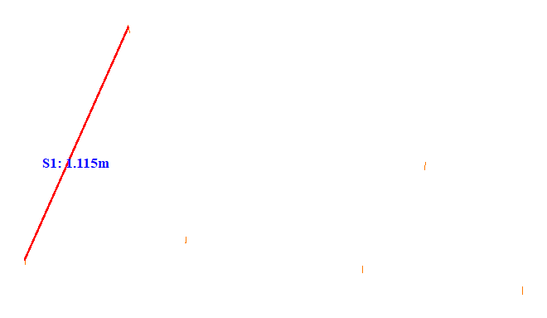

No. | Span | ID dan Lokasi Fasa | Nilai (m) (m) | Jarak Ke Menara Kecil (m)
2 | 1-2(1_2) | S2(RightUpFasaPowerLineAndRightDownFasaPowerLine) | 0.693 | 24.815
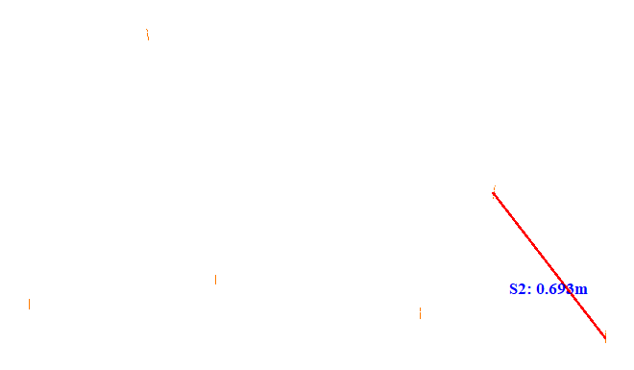

No. | Span | ID dan Lokasi Fasa | Nilai (m) (m) | Jarak Ke Menara Kecil (m)
3 | 1-2(1_2) | S3(LeftUpFasaPowerLineAndRightUpFasaPowerLine) | 1.195 | 42.204
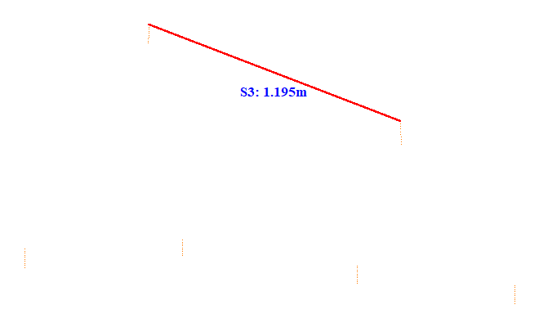

No. | Span | ID dan Lokasi Fasa | Nilai (m) (m) | Jarak Ke Menara Kecil (m)
4 | 1-2(1_2) | S4(RightUpFasaPowerLineAndLeftDownFasaPowerLine) | 1.759 | 39.103
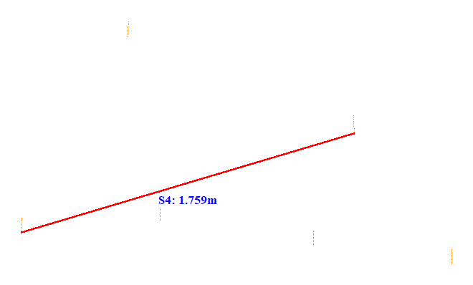

No. | Span | ID dan Lokasi Fasa | Nilai (m) (m) | Jarak Ke Menara Kecil (m)
5 | 1-2(1_2) | S5(Fasa Kiri Atas ke Fasa Kiri Tengah) | 0.946 | 32.807
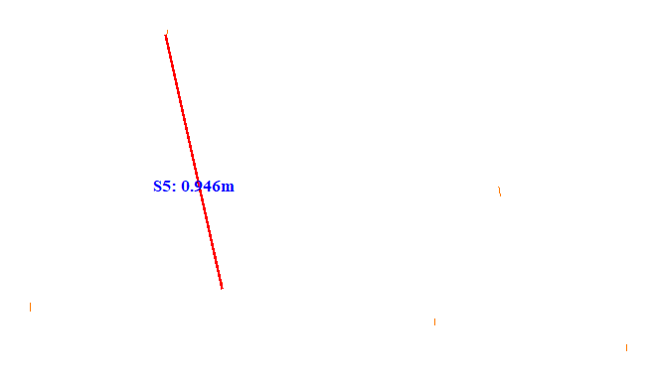

No. | Span | ID dan Lokasi Fasa | Nilai (m) (m) | Jarak Ke Menara Kecil (m)
6 | 1-2(1_2) | S6(Fasa Kiri Tengah ke Fasa Kiri Bawah) | 0.703 | 39.009
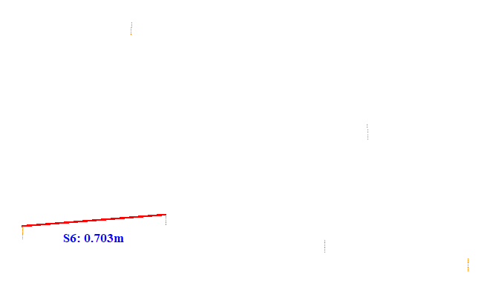

No. | Span | ID dan Lokasi Fasa | Nilai (m) (m) | Jarak Ke Menara Kecil (m)
7 | 1-2(1_2) | S7(LeftMiddleFasaPowerLineAndRightMiddleFasaPowerLine) | 0.783 | 17.900
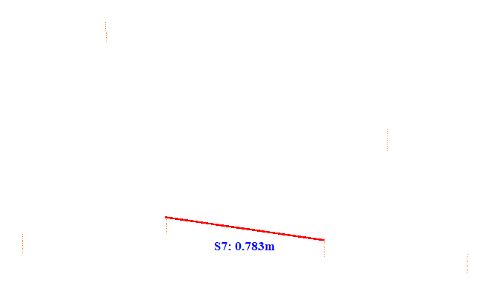

No. | Span | ID dan Lokasi Fasa | Nilai (m) (m) | Jarak Ke Menara Kecil (m)
8 | 1-2(1_2) | S8(Fasa Kanan Atas ke Fasa Kanan Tengah) | 0.549 | 34.904
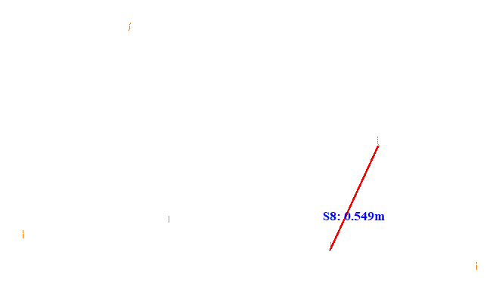

No. | Span | ID dan Lokasi Fasa | Nilai (m) (m) | Jarak Ke Menara Kecil (m)
9 | 1-2(1_2) | S9(LeftDownFasaPowerLineAndRightMiddleFasaPowerLine) | 1.479 | 34.803
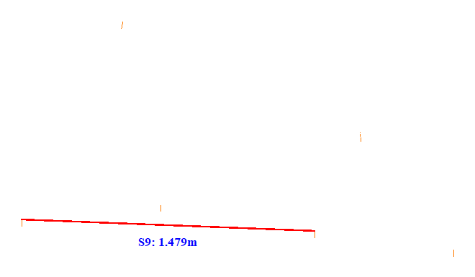

No. | Span | ID dan Lokasi Fasa | Nilai (m) (m) | Jarak Ke Menara Kecil (m)
10 | 2-3(2_3) | S1(LeftUpFasaPowerLineAndLeftDownFasaPowerLine) | 1.183 | 21.118
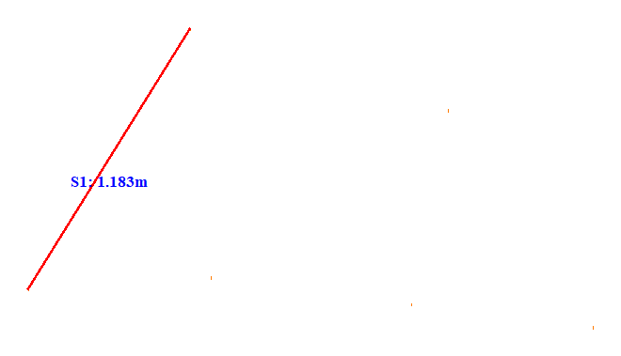

No. | Span | ID dan Lokasi Fasa | Nilai (m) (m) | Jarak Ke Menara Kecil (m)
11 | 2-3(2_3) | S2(RightUpFasaPowerLineAndRightDownFasaPowerLine) | 1.006 | 23.711
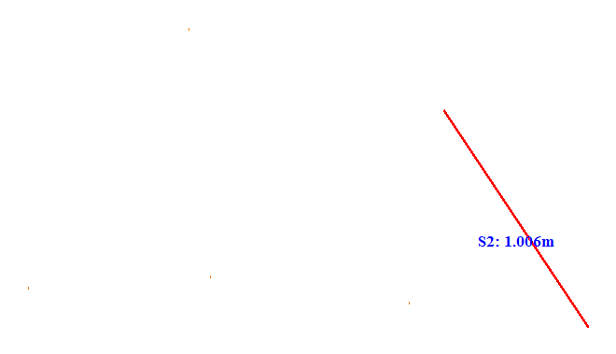

No. | Span | ID dan Lokasi Fasa | Nilai (m) (m) | Jarak Ke Menara Kecil (m)
12 | 3-4(3_4) | S1(Fasa Kiri Atas ke Fasa Kiri Tengah) | 1.234 | 5.122
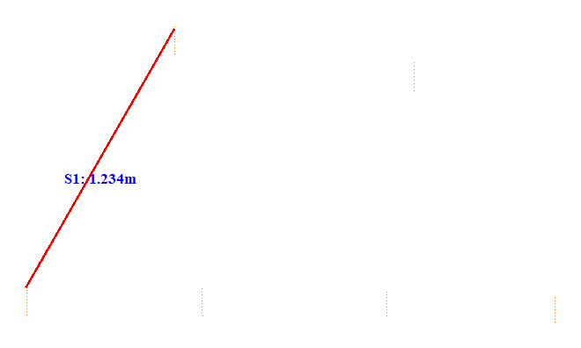

No. | Span | ID dan Lokasi Fasa | Nilai (m) (m) | Jarak Ke Menara Kecil (m)
13 | 3-4(3_4) | S2(RightUpFasaPowerLineAndRightDownFasaPowerLine) | 1.010 | 23.211
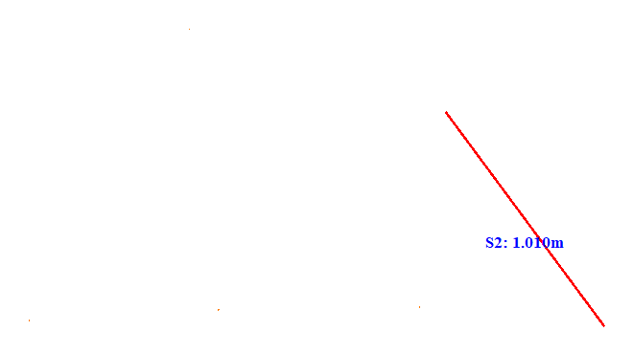

No. | Span | ID dan Lokasi Fasa | Nilai (m) (m) | Jarak Ke Menara Kecil (m)
14 | 4-5(4_5) | S1(Fasa Kiri Atas ke Fasa Kiri Tengah) | 1.112 | 26.311
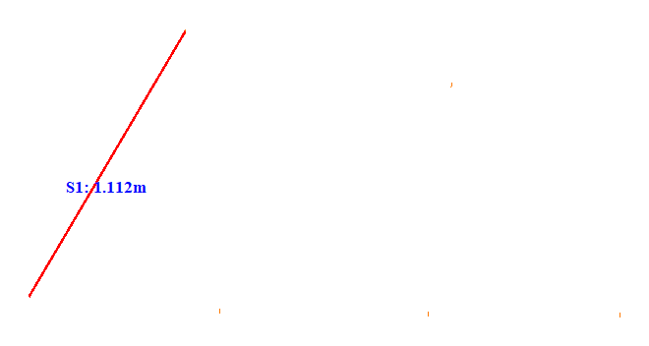

No. | Span | ID dan Lokasi Fasa | Nilai (m) (m) | Jarak Ke Menara Kecil (m)
15 | 4-5(4_5) | S2(Fasa Kanan Atas ke Fasa Kanan Tengah) | 1.034 | 23.215
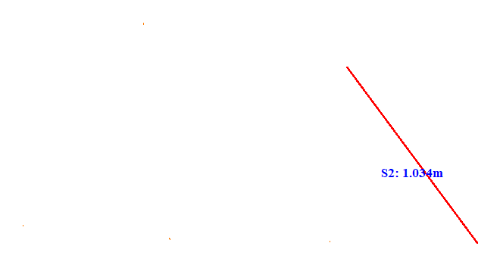

No. | Span | ID dan Lokasi Fasa | Nilai (m) (m) | Jarak Ke Menara Kecil (m)
16 | 5-6(5_6) | S1(Fasa Kiri Atas ke Fasa Kiri Tengah) | 1.057 | 22.612
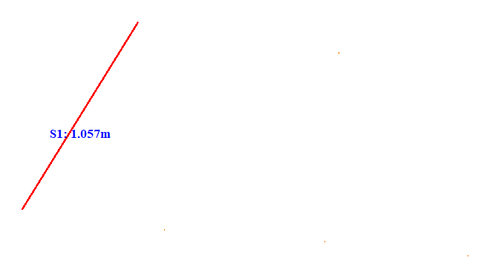

No. | Span | ID dan Lokasi Fasa | Nilai (m) (m) | Jarak Ke Menara Kecil (m)
17 | 5-6(5_6) | S2(RightUpFasaPowerLineAndRightDownFasaPowerLine) | 1.158 | 19.017
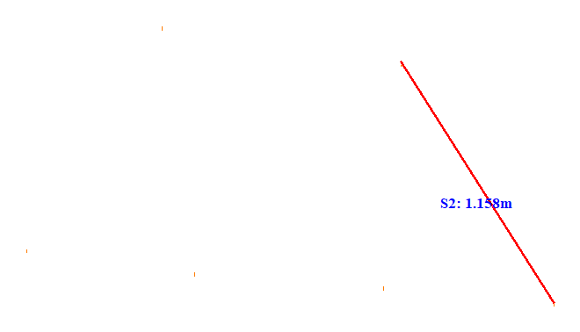

No. | Span | ID dan Lokasi Fasa | Nilai (m) (m) | Jarak Ke Menara Kecil (m)
18 | 6-7(6_7) | S1(Fasa Kiri Atas ke Fasa Kiri Tengah) | 1.159 | 8.883
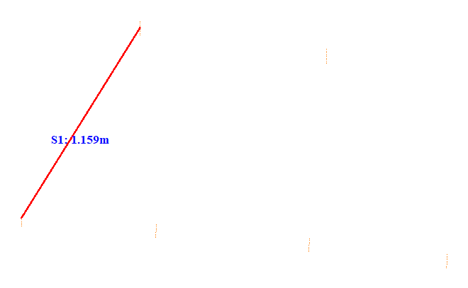

No. | Span | ID dan Lokasi Fasa | Nilai (m) (m) | Jarak Ke Menara Kecil (m)
19 | 6-7(6_7) | S2(RightUpFasaPowerLineAndRightDownFasaPowerLine) | 1.110 | 37.959
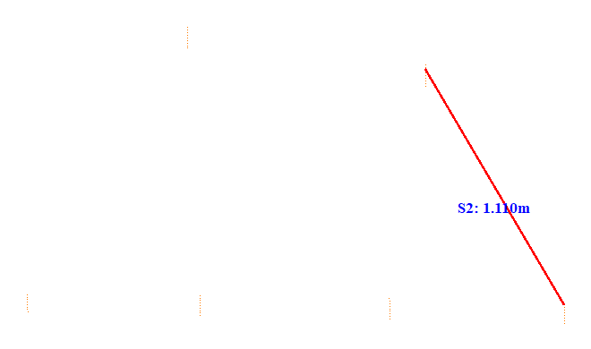

No. | Span | ID dan Lokasi Fasa | Nilai (m) (m) | Jarak Ke Menara Kecil (m)
20 | 7-8(7_8) | S1(Fasa Kiri Atas ke Fasa Kiri Tengah) | 1.226 | 27.114
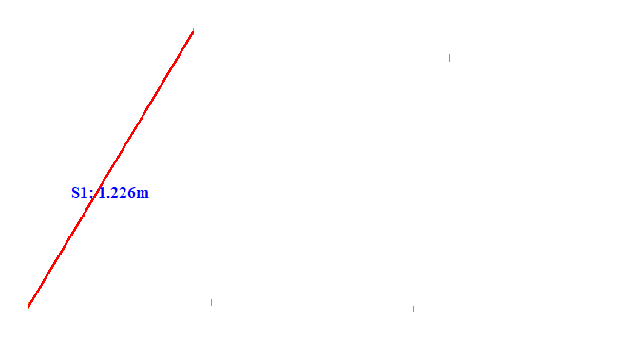

No. | Span | ID dan Lokasi Fasa | Nilai (m) (m) | Jarak Ke Menara Kecil (m)
21 | 7-8(7_8) | S2(RightUpFasaPowerLineAndRightDownFasaPowerLine) | 1.120 | 21.012
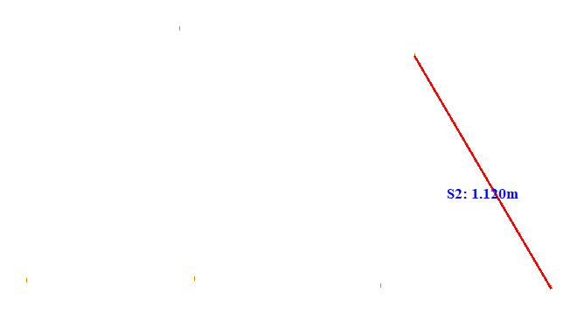

No. | Span | ID dan Lokasi Fasa | Nilai (m) (m) | Jarak Ke Menara Kecil (m)
22 | 8-9(8_9) | S1(LeftUpFasaPowerLineAndLeftDownFasaPowerLine) | 1.212 | 23.413
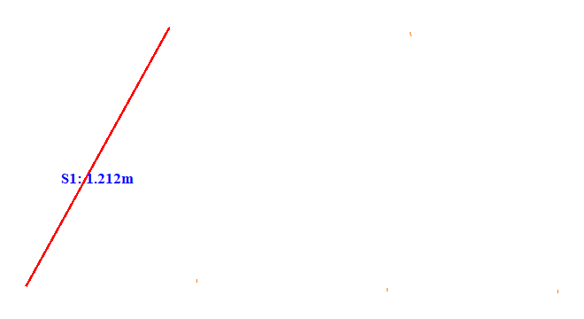

No. | Span | ID dan Lokasi Fasa | Nilai (m) (m) | Jarak Ke Menara Kecil (m)
23 | 8-9(8_9) | S2(RightUpFasaPowerLineAndRightDownFasaPowerLine) | 1.213 | 5.114
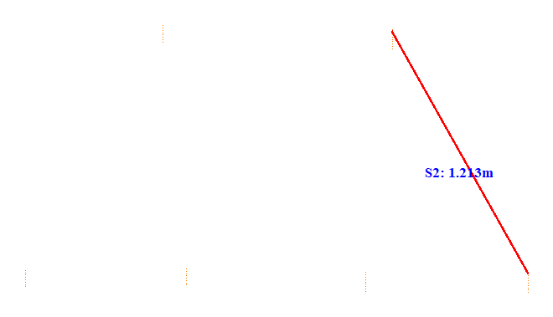

No. | Span | ID dan Lokasi Fasa | Nilai (m) (m) | Jarak Ke Menara Kecil (m)
24 | 9-10(9_10) | S1(LeftUpFasaPowerLineAndLeftDownFasaPowerLine) | 1.218 | 5.215
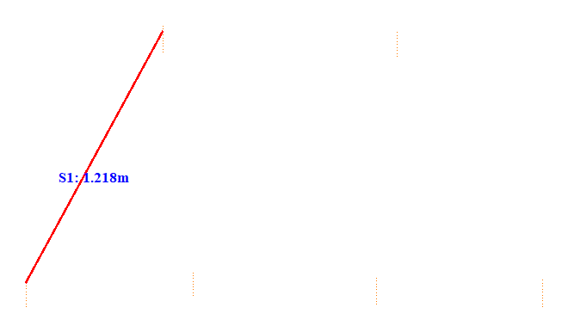

No. | Span | ID dan Lokasi Fasa | Nilai (m) (m) | Jarak Ke Menara Kecil (m)
25 | 9-10(9_10) | S2(RightUpFasaPowerLineAndRightDownFasaPowerLine) | 1.224 | 12.873
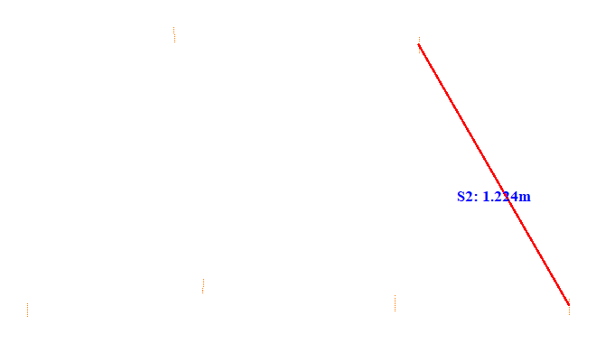

No. | Span | ID dan Lokasi Fasa | Nilai (m) (m) | Jarak Ke Menara Kecil (m)
26 | 10-11(10_11) | S1(Fasa Kiri Atas ke Fasa Kiri Tengah) | 1.215 | 6.011
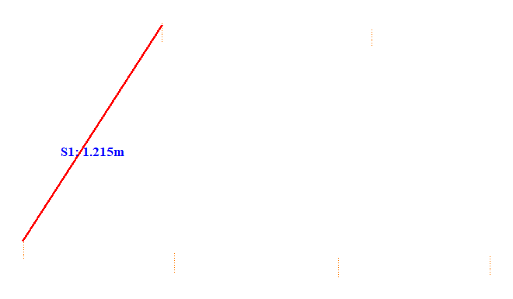

No. | Span | ID dan Lokasi Fasa | Nilai (m) (m) | Jarak Ke Menara Kecil (m)
27 | 10-11(10_11) | S2(Fasa Kanan Atas ke Fasa Kanan Tengah) | 1.184 | 38.357
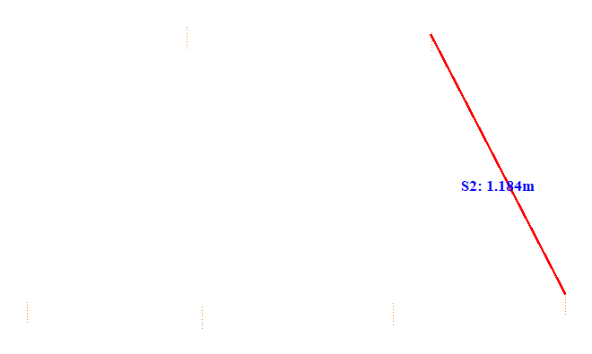

No. | Span | ID dan Lokasi Fasa | Nilai (m) (m) | Jarak Ke Menara Kecil (m)
28 | 11-12(11_12) | S1(LeftUpFasaPowerLineAndLeftDownFasaPowerLine) | 1.265 | 40.659
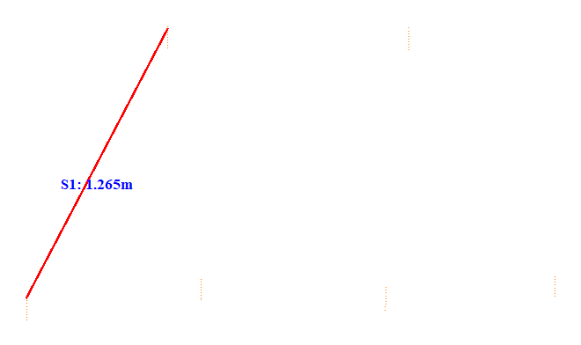

No. | Span | ID dan Lokasi Fasa | Nilai (m) (m) | Jarak Ke Menara Kecil (m)
29 | 11-12(11_12) | S2(Fasa Kanan Atas ke Fasa Kanan Tengah) | 1.192 | 40.657
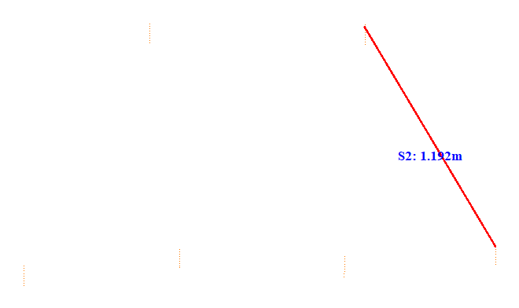

No. | Span | ID dan Lokasi Fasa | Nilai (m) (m) | Jarak Ke Menara Kecil (m)
30 | 13-14(13_14) | S1(Fasa Kiri Atas ke Fasa Kiri Tengah) | 0.939 | 6.897
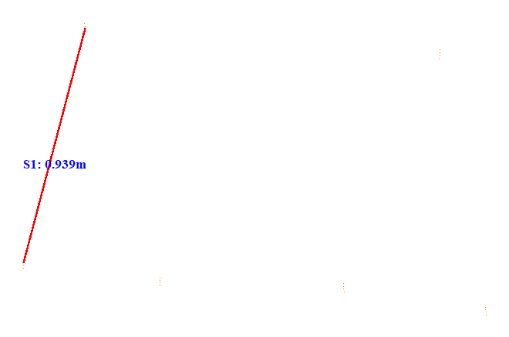

No. | Span | ID dan Lokasi Fasa | Nilai (m) (m) | Jarak Ke Menara Kecil (m)
31 | 13-14(13_14) | S2(RightUpFasaPowerLineAndRightDownFasaPowerLine) | 0.972 | 12.321
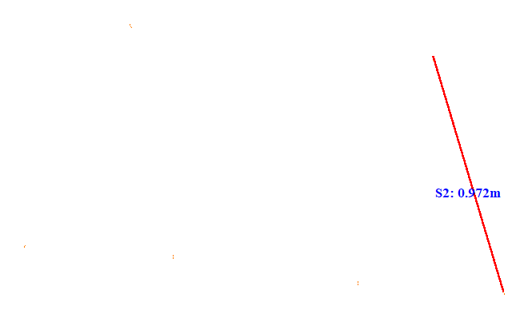

No. | Span | ID dan Lokasi Fasa | Nilai (m) (m) | Jarak Ke Menara Kecil (m)
32 | 15-16(15_16) | S1(Fasa Kiri Atas ke Fasa Kiri Tengah) | 0.780 | 5.232
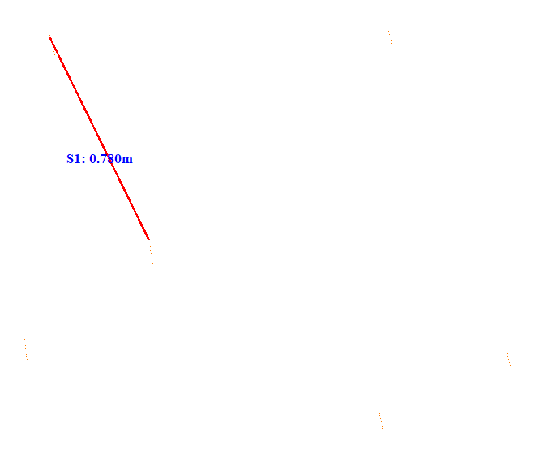

No. | Span | ID dan Lokasi Fasa | Nilai (m) (m) | Jarak Ke Menara Kecil (m)
33 | 15-16(15_16) | S2(RightUpFasaPowerLineAndLeftMiddleFasaPowerLine) | 1.105 | 5.108
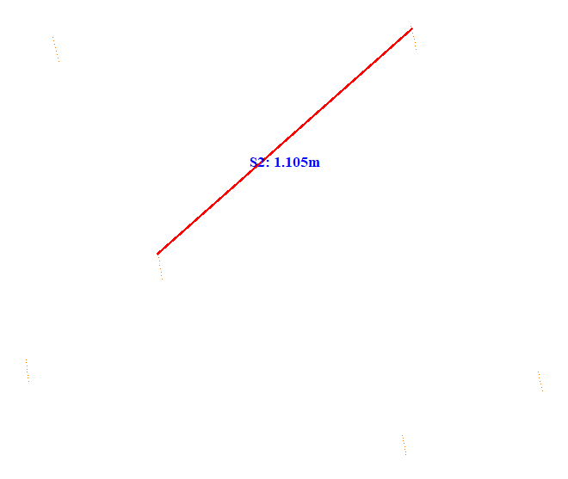

No. | Span | ID dan Lokasi Fasa | Nilai (m) (m) | Jarak Ke Menara Kecil (m)
34 | 15-16(15_16) | S3(Fasa Kiri Tengah ke Fasa Kiri Bawah) | 0.547 | 5.860
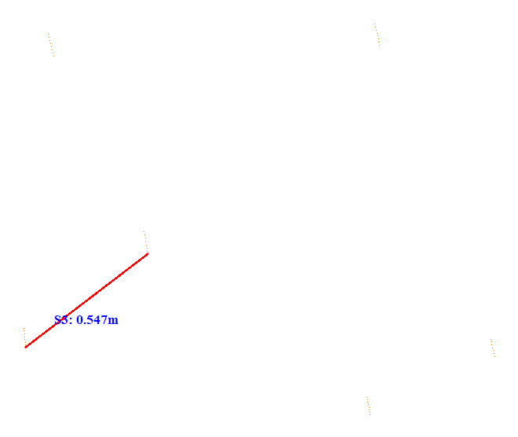

No. | Span | ID dan Lokasi Fasa | Nilai (m) (m) | Jarak Ke Menara Kecil (m)
35 | 15-16(15_16) | S4(LeftMiddleFasaPowerLineAndRightMiddleFasaPowerLine) | 1.287 | 5.130
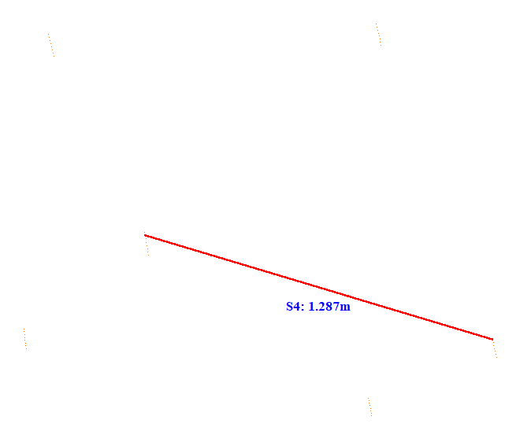

No. | Span | ID dan Lokasi Fasa | Nilai (m) (m) | Jarak Ke Menara Kecil (m)
36 | 15-16(15_16) | S5(LeftMiddleFasaPowerLineAndRightDownFasaPowerLine) | 0.976 | 5.752
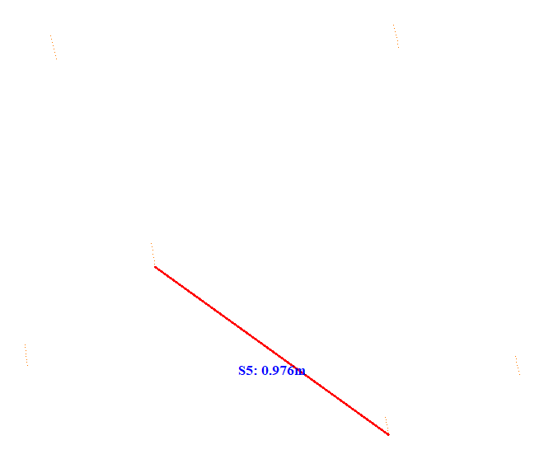

No. | Span | ID dan Lokasi Fasa | Nilai (m) (m) | Jarak Ke Menara Kecil (m)
37 | 15-16(15_16) | S6(LeftUpFasaPowerLineAndLeftDownFasaPowerLine) | 1.011 | 13.788
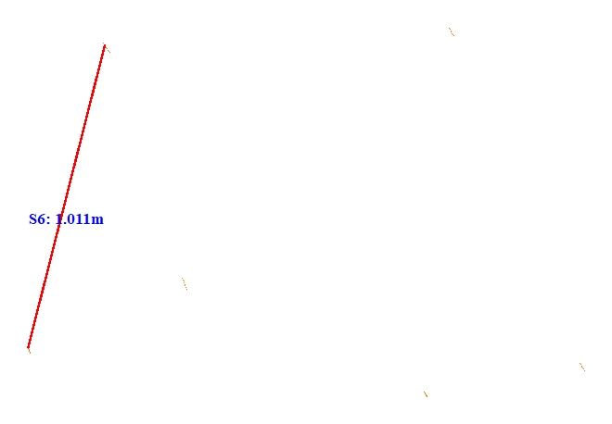

No. | Span | ID dan Lokasi Fasa | Nilai (m) (m) | Jarak Ke Menara Kecil (m)
38 | 15-16(15_16) | S7(LeftDownFasaPowerLineAndRightDownFasaPowerLine) | 1.251 | 5.877
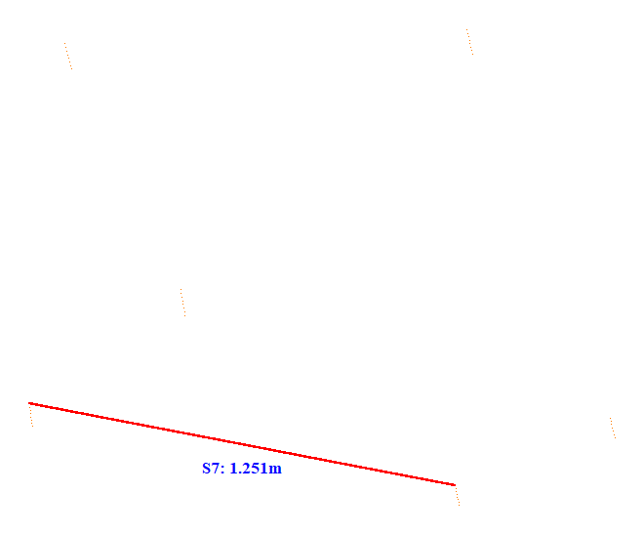

No. | Span | ID dan Lokasi Fasa | Nilai (m) (m) | Jarak Ke Menara Kecil (m)
39 | 15-16(15_16) | S8(Fasa Kanan Atas ke Fasa Kanan Tengah) | 1.152 | 33.550
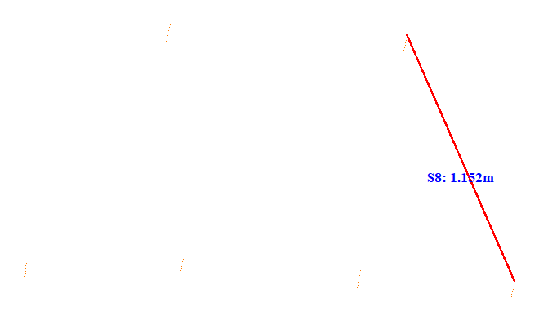

No. | Span | ID dan Lokasi Fasa | Nilai (m) (m) | Jarak Ke Menara Kecil (m)
40 | 15-16(15_16) | S9(Fasa Kanan Tengah ke Fasa Kanan Bawah) | 0.492 | 8.201
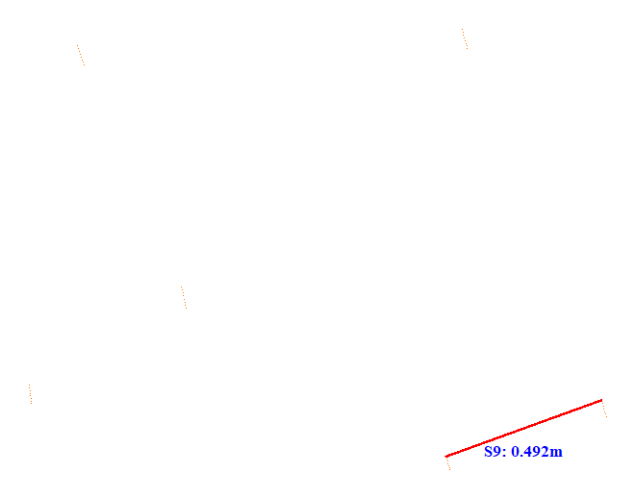

No. | Span | ID dan Lokasi Fasa | Nilai (m) (m) | Jarak Ke Menara Kecil (m)
41 | 16-17(16_17) | S1(LeftUpFasaPowerLineAndLeftDownFasaPowerLine) | 1.206 | 23.113
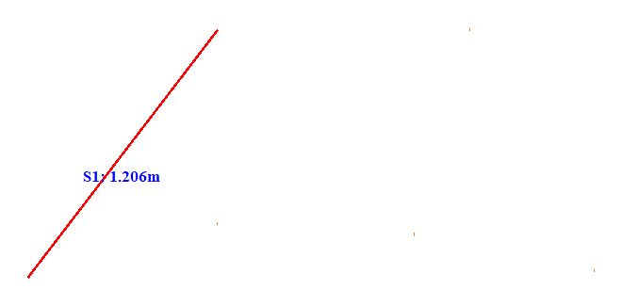

No. | Span | ID dan Lokasi Fasa | Nilai (m) (m) | Jarak Ke Menara Kecil (m)
42 | 16-17(16_17) | S2(RightUpFasaPowerLineAndRightDownFasaPowerLine) | 1.054 | 20.315
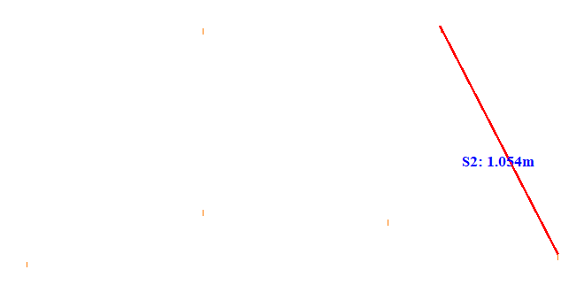

No. | Span | ID dan Lokasi Fasa | Nilai (m) (m) | Jarak Ke Menara Kecil (m)
43 | 17-18(17_18) | S1(LeftUpFasaPowerLineAndLeftDownFasaPowerLine) | 1.072 | 22.616
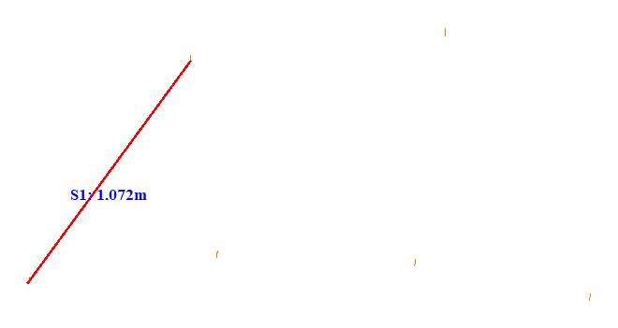

No. | Span | ID dan Lokasi Fasa | Nilai (m) (m) | Jarak Ke Menara Kecil (m)
44 | 17-18(17_18) | S2(RightUpFasaPowerLineAndRightDownFasaPowerLine) | 1.163 | 5.205
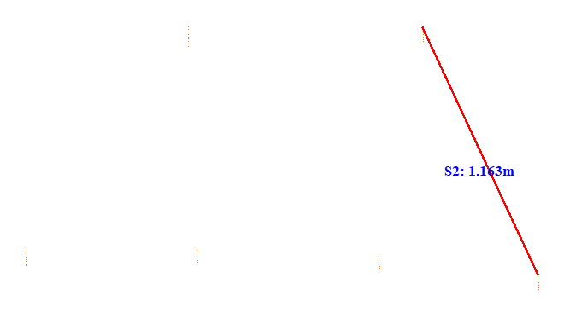

No. | Span | ID dan Lokasi Fasa | Nilai (m) (m) | Jarak Ke Menara Kecil (m)
45 | 18-19(18_19) | S1(RightUpFasaPowerLineAndLeftDownFasaPowerLine) | 1.819 | 14.380
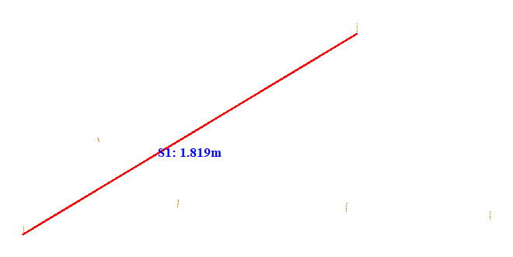

No. | Span | ID dan Lokasi Fasa | Nilai (m) (m) | Jarak Ke Menara Kecil (m)
46 | 18-19(18_19) | S2(RightUpFasaPowerLineAndRightDownFasaPowerLine) | 1.033 | 23.223
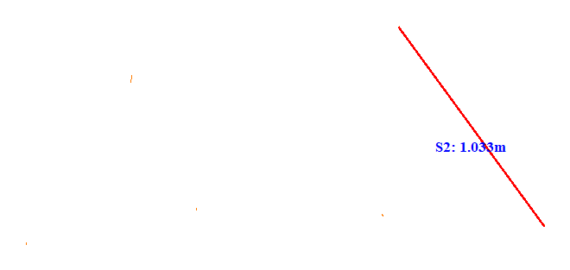

No. | Span | ID dan Lokasi Fasa | Nilai (m) (m) | Jarak Ke Menara Kecil (m)
47 | 18-19(18_19) | S3(RightUpFasaPowerLineAndLeftMiddleFasaPowerLine) | 1.164 | 14.382
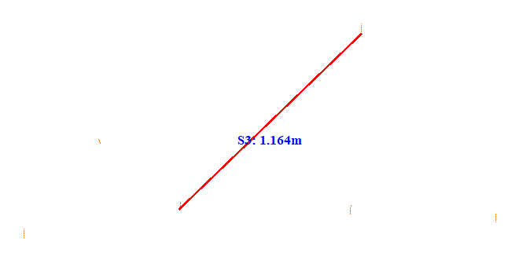

No. | Span | ID dan Lokasi Fasa | Nilai (m) (m) | Jarak Ke Menara Kecil (m)
48 | 18-19(18_19) | S4(RightUpFasaPowerLineAndLeftUpFasaPowerLine) | 1.269 | 16.100
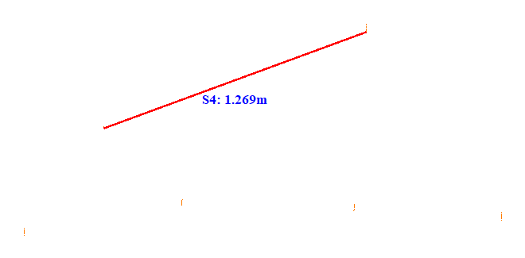

No. | Span | ID dan Lokasi Fasa | Nilai (m) (m) | Jarak Ke Menara Kecil (m)
49 | 18-19(18_19) | S5(LeftUpFasaPowerLineAndLeftDownFasaPowerLine) | 0.565 | 14.504
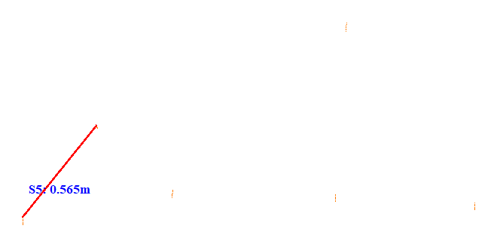

No. | Span | ID dan Lokasi Fasa | Nilai (m) (m) | Jarak Ke Menara Kecil (m)
50 | 18-19(18_19) | S6(RightDownFasaPowerLineAndLeftDownFasaPowerLine) | 2.179 | 16.037
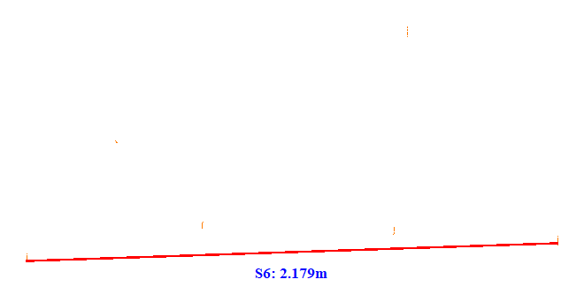

No. | Span | ID dan Lokasi Fasa | Nilai (m) (m) | Jarak Ke Menara Kecil (m)
51 | 19-20(19_20) | S1(LeftUpFasaPowerLineAndLeftDownFasaPowerLine) | 1.014 | 21.014
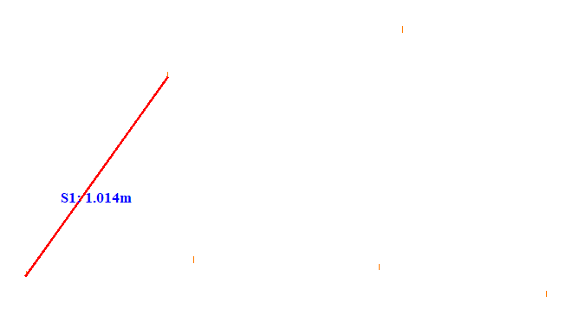

No. | Span | ID dan Lokasi Fasa | Nilai (m) (m) | Jarak Ke Menara Kecil (m)
52 | 19-20(19_20) | S2(RightUpFasaPowerLineAndRightDownFasaPowerLine) | 1.222 | 38.758
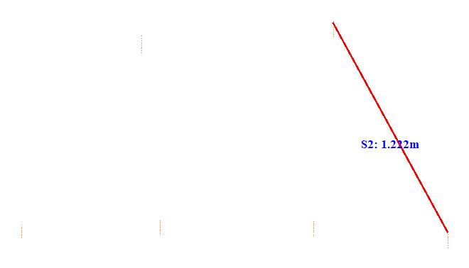

No. | Span | ID dan Lokasi Fasa | Nilai (m) (m) | Jarak Ke Menara Kecil (m)
53 | 20-21(20_21) | S1(LeftUpFasaPowerLineAndLeftDownFasaPowerLine) | 1.060 | 26.865
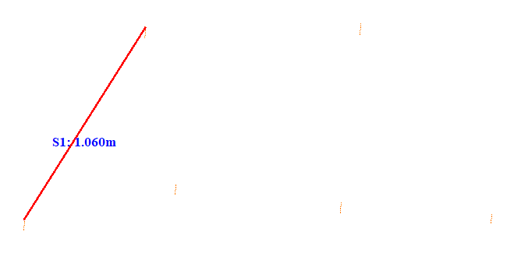

No. | Span | ID dan Lokasi Fasa | Nilai (m) (m) | Jarak Ke Menara Kecil (m)
54 | 20-21(20_21) | S2(RightUpFasaPowerLineAndRightDownFasaPowerLine) | 1.049 | 17.614
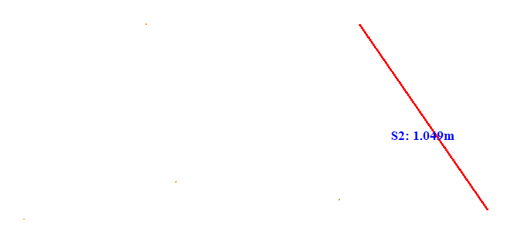

No. | Span | ID dan Lokasi Fasa | Nilai (m) (m) | Jarak Ke Menara Kecil (m)
55 | 21-22(21_22) | S1(LeftUpFasaPowerLineAndLeftDownFasaPowerLine) | 0.980 | 22.313
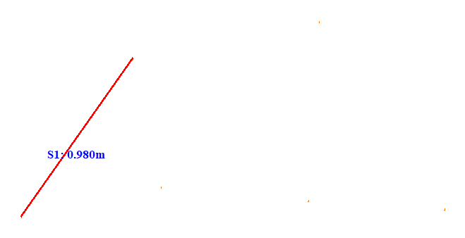

No. | Span | ID dan Lokasi Fasa | Nilai (m) (m) | Jarak Ke Menara Kecil (m)
56 | 21-22(21_22) | S2(RightUpFasaPowerLineAndRightDownFasaPowerLine) | 1.142 | 24.214
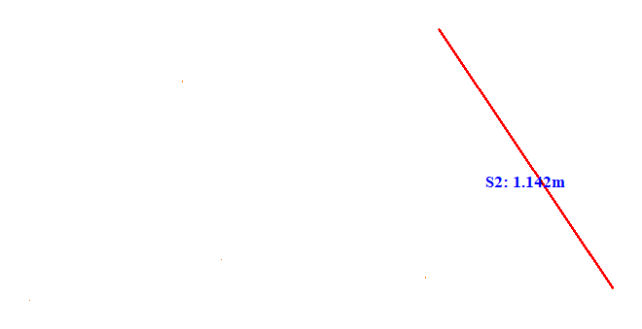

No. | Span | ID dan Lokasi Fasa | Nilai (m) (m) | Jarak Ke Menara Kecil (m)
57 | 22-23(22_23) | S1(LeftUpFasaPowerLineAndLeftDownFasaPowerLine) | 1.072 | 17.818
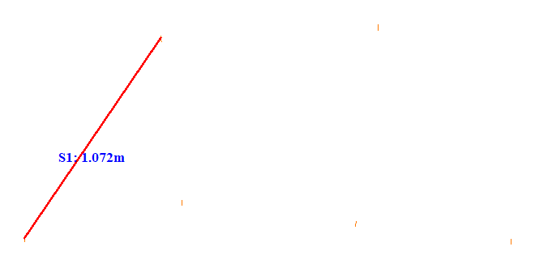

No. | Span | ID dan Lokasi Fasa | Nilai (m) (m) | Jarak Ke Menara Kecil (m)
58 | 22-23(22_23) | S2(RightUpFasaPowerLineAndRightDownFasaPowerLine) | 1.101 | 25.311
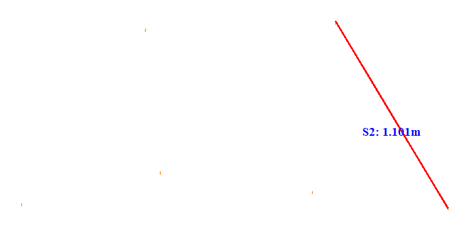

No. | Span | ID dan Lokasi Fasa | Nilai (m) (m) | Jarak Ke Menara Kecil (m)
59 | 23-24(23_24) | S1(LeftUpFasaPowerLineAndLeftDownFasaPowerLine) | 1.105 | 24.713
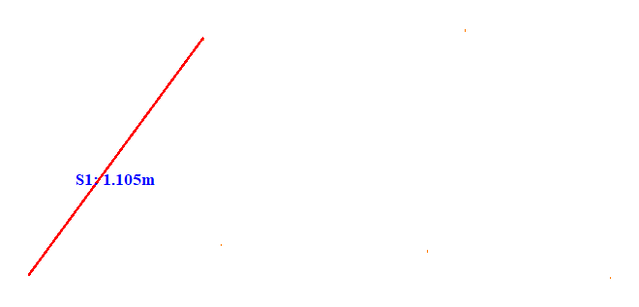

No. | Span | ID dan Lokasi Fasa | Nilai (m) (m) | Jarak Ke Menara Kecil (m)
60 | 23-24(23_24) | S2(RightUpFasaPowerLineAndRightDownFasaPowerLine) | 1.081 | 22.814
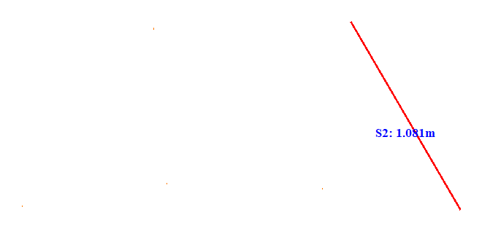

No. | Span | ID dan Lokasi Fasa | Nilai (m) (m) | Jarak Ke Menara Kecil (m)
61 | 24-25(24_25) | S1(LeftUpFasaPowerLineAndLeftDownFasaPowerLine) | 1.089 | 19.813
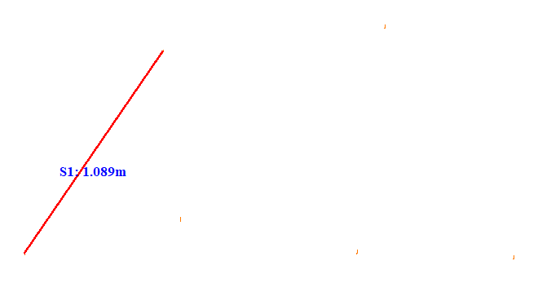

No. | Span | ID dan Lokasi Fasa | Nilai (m) (m) | Jarak Ke Menara Kecil (m)
62 | 24-25(24_25) | S2(RightUpFasaPowerLineAndRightDownFasaPowerLine) | 1.180 | 22.717
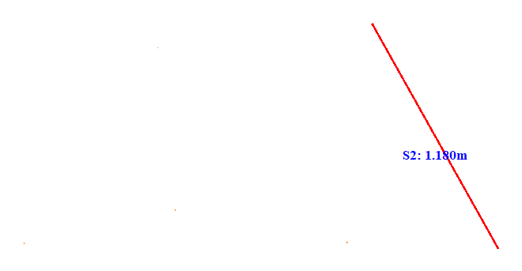

No. | Span | ID dan Lokasi Fasa | Nilai (m) (m) | Jarak Ke Menara Kecil (m)
63 | 25-26(25_26) | S1(LeftUpFasaPowerLineAndLeftDownFasaPowerLine) | 1.173 | 20.413
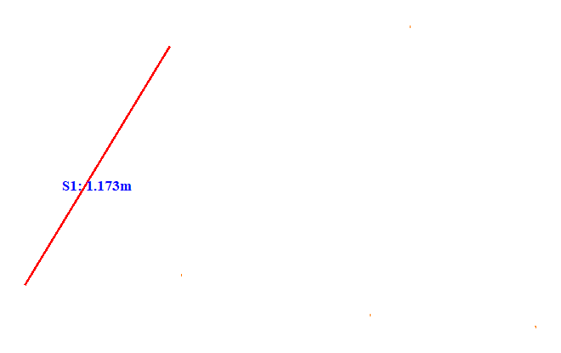

No. | Span | ID dan Lokasi Fasa | Nilai (m) (m) | Jarak Ke Menara Kecil (m)
64 | 25-26(25_26) | S2(RightUpFasaPowerLineAndRightDownFasaPowerLine) | 1.247 | 37.860
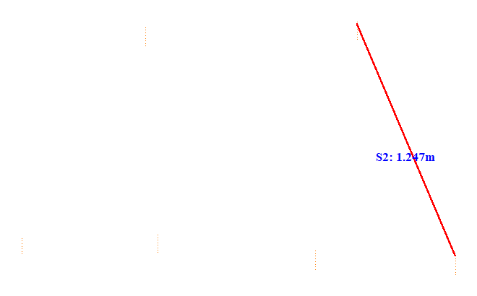

No. | Span | ID dan Lokasi Fasa | Nilai (m) (m) | Jarak Ke Menara Kecil (m)
65 | 26-27(26_27) | S1(Fasa Kiri Atas ke Fasa Kiri Tengah) | 1.184 | 5.115
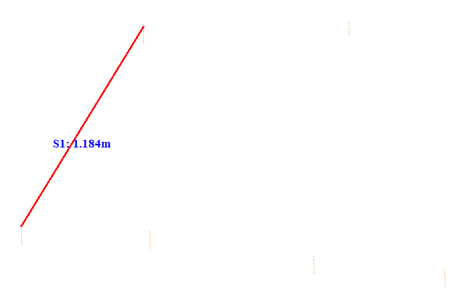

No. | Span | ID dan Lokasi Fasa | Nilai (m) (m) | Jarak Ke Menara Kecil (m)
66 | 26-27(26_27) | S2(RightUpFasaPowerLineAndRightDownFasaPowerLine) | 1.337 | 5.207
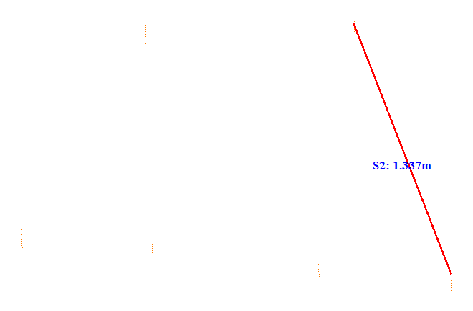

No. | Span | ID dan Lokasi Fasa | Nilai (m) (m) | Jarak Ke Menara Kecil (m)
67 | 27-28(27_28) | S1(Fasa Kiri Atas ke Fasa Kiri Tengah) | 1.171 | 37.557
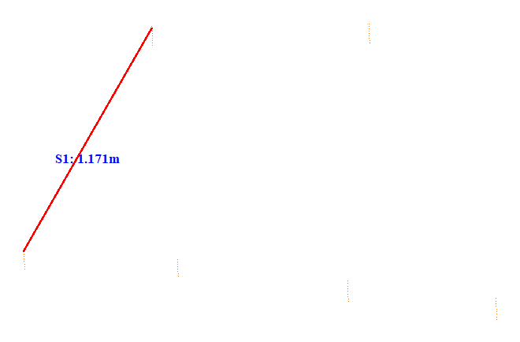

No. | Span | ID dan Lokasi Fasa | Nilai (m) (m) | Jarak Ke Menara Kecil (m)
68 | 27-28(27_28) | S2(RightUpFasaPowerLineAndRightDownFasaPowerLine) | 1.333 | 5.122
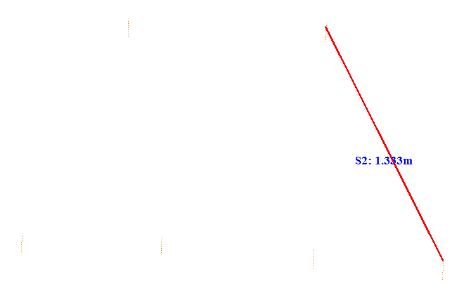

No. | Span | ID dan Lokasi Fasa | Nilai (m) (m) | Jarak Ke Menara Kecil (m)
69 | 28-29(28_29) | S1(LeftUpFasaPowerLineAndLeftDownFasaPowerLine) | 1.243 | 5.215
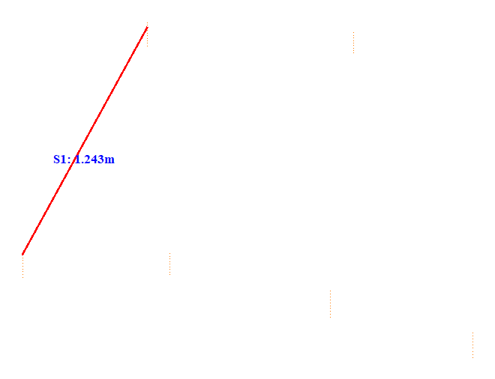

No. | Span | ID dan Lokasi Fasa | Nilai (m) (m) | Jarak Ke Menara Kecil (m)
70 | 28-29(28_29) | S2(RightUpFasaPowerLineAndRightDownFasaPowerLine) | 1.461 | 41.607
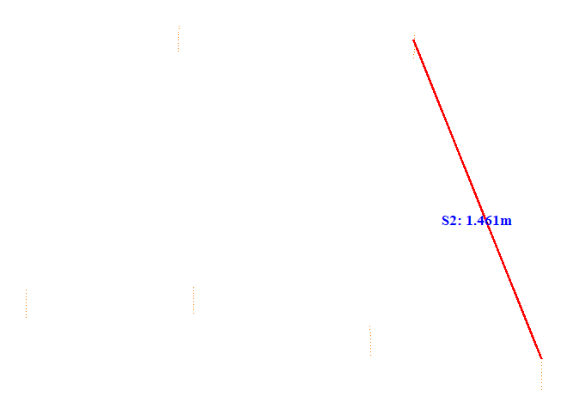

No. | Span | ID dan Lokasi Fasa | Nilai (m) (m) | Jarak Ke Menara Kecil (m)
71 | 28-29(28_29) | S3(Fasa Kanan Atas ke Fasa Kanan Tengah) | 1.295 | 7.960
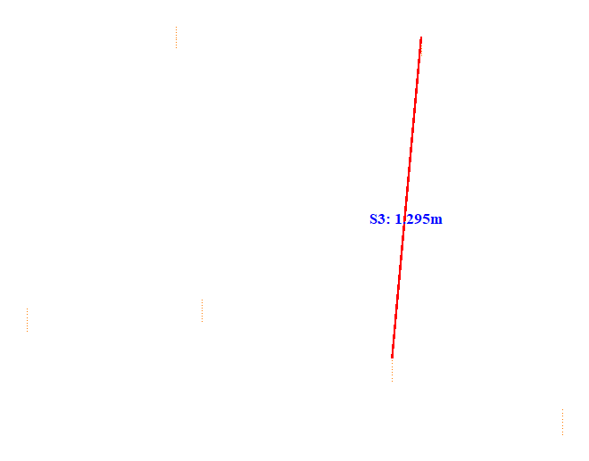

No. | Span | ID dan Lokasi Fasa | Nilai (m) (m) | Jarak Ke Menara Kecil (m)
72 | 28-29(28_29) | S4(Fasa Kiri Atas ke Fasa Kiri Tengah) | 1.099 | 7.964
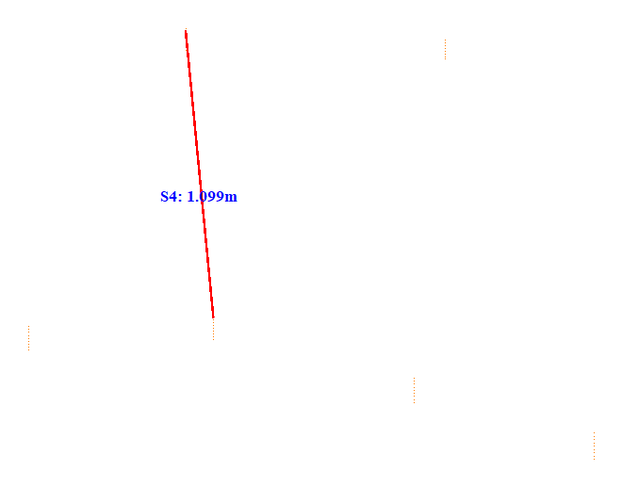

No. | Span | ID dan Lokasi Fasa | Nilai (m) (m) | Jarak Ke Menara Kecil (m)
73 | 28-29(28_29) | S5(RightUpFasaPowerLineAndLeftMiddleFasaPowerLine) | 1.379 | 7.950
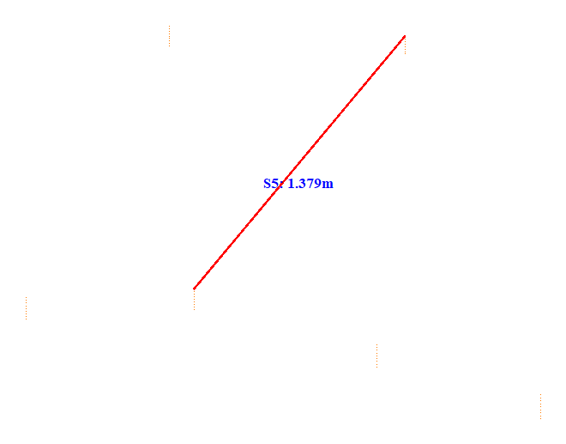

No. | Span | ID dan Lokasi Fasa | Nilai (m) (m) | Jarak Ke Menara Kecil (m)
74 | 28-29(28_29) | S6(LeftDownFasaPowerLineAndRightDownFasaPowerLine) | 2.192 | 7.900
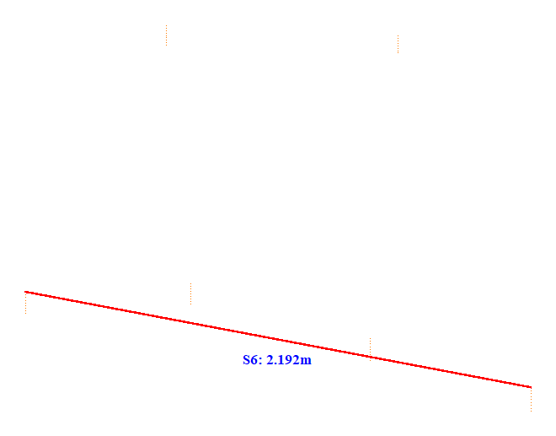

No. | Span | ID dan Lokasi Fasa | Nilai (m) (m) | Jarak Ke Menara Kecil (m)
75 | 28-29(28_29) | S7(Fasa Kanan Tengah ke Fasa Kanan Bawah) | 0.716 | 7.930
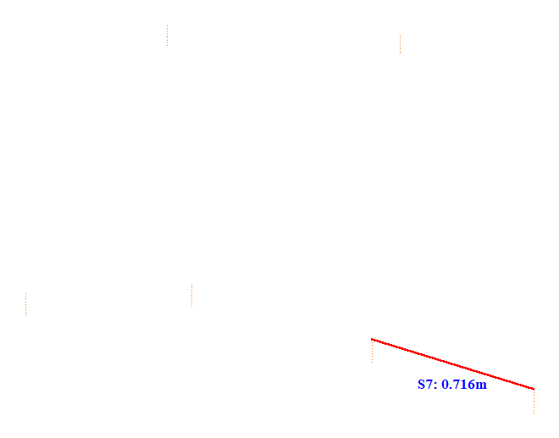

No. | Span | ID dan Lokasi Fasa | Nilai (m) (m) | Jarak Ke Menara Kecil (m)
76 | 29-30(29_30) | S1(Fasa Kiri Atas ke Fasa Kiri Tengah) | 1.299 | 5.111
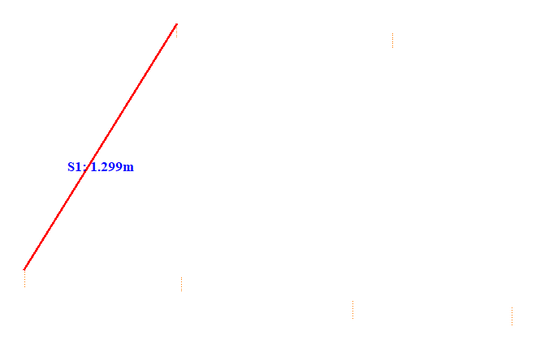

No. | Span | ID dan Lokasi Fasa | Nilai (m) (m) | Jarak Ke Menara Kecil (m)
77 | 29-30(29_30) | S2(RightUpFasaPowerLineAndRightDownFasaPowerLine) | 1.338 | 5.112
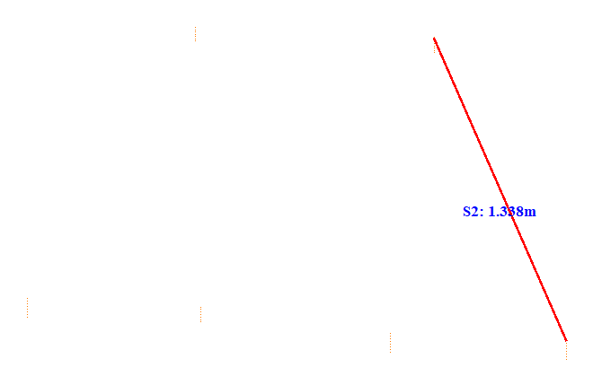

No. | Span | ID dan Lokasi Fasa | Nilai (m) (m) | Jarak Ke Menara Kecil (m)
78 | 30-31(30_31) | S1(Fasa Kiri Atas ke Fasa Kiri Tengah) | 1.139 | 17.306
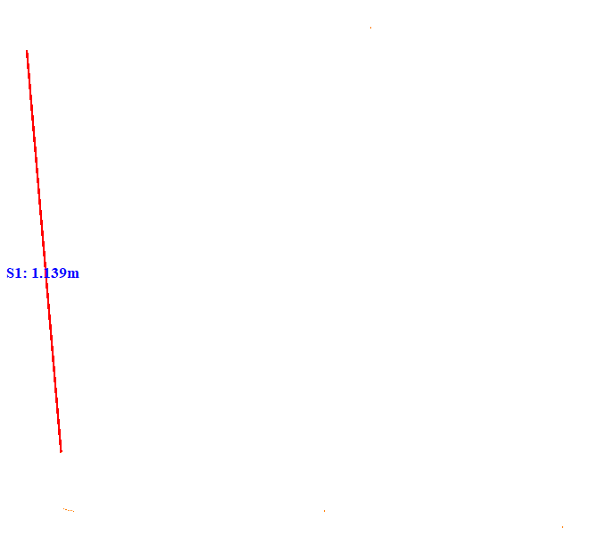

No. | Span | ID dan Lokasi Fasa | Nilai (m) (m) | Jarak Ke Menara Kecil (m)
79 | 30-31(30_31) | S2(RightUpFasaPowerLineAndRightDownFasaPowerLine) | 1.335 | 31.059
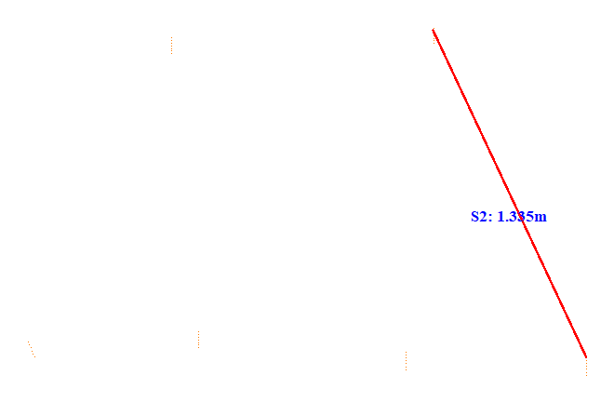

No. | Span | ID dan Lokasi Fasa | Nilai (m) (m) | Jarak Ke Menara Kecil (m)
80 | 30-31(30_31) | S3(LeftUpFasaPowerLineAndLeftDownFasaPowerLine) | 1.211 | 26.353
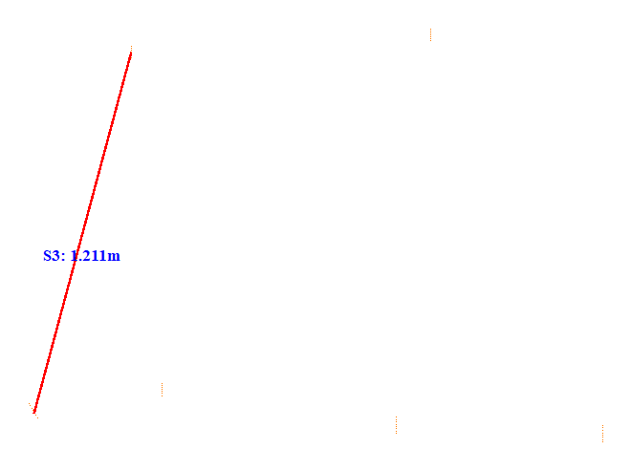

No. | Span | ID dan Lokasi Fasa | Nilai (m) (m) | Jarak Ke Menara Kecil (m)
81 | 31-32(31_32) | S1(Fasa Kiri Atas ke Fasa Kiri Tengah) | 1.203 | 5.169
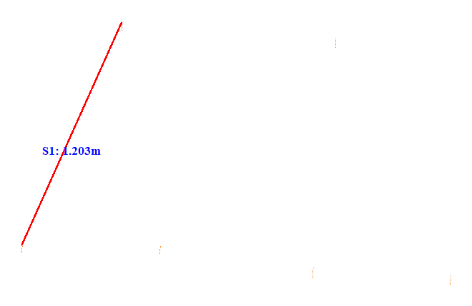

No. | Span | ID dan Lokasi Fasa | Nilai (m) (m) | Jarak Ke Menara Kecil (m)
82 | 31-32(31_32) | S2(RightUpFasaPowerLineAndRightDownFasaPowerLine) | 1.257 | 26.564
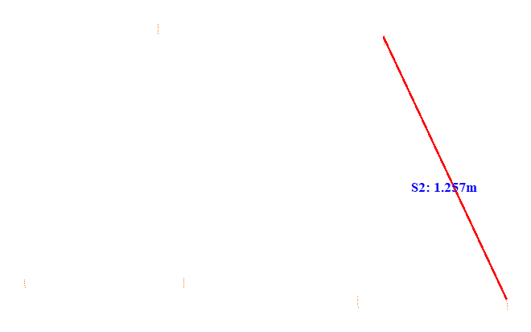

No. | Span | ID dan Lokasi Fasa | Nilai (m) (m) | Jarak Ke Menara Kecil (m)
83 | 32-33(32_33) | S1(LeftUpFasaPowerLineAndLeftDownFasaPowerLine) | 1.233 | 5.208
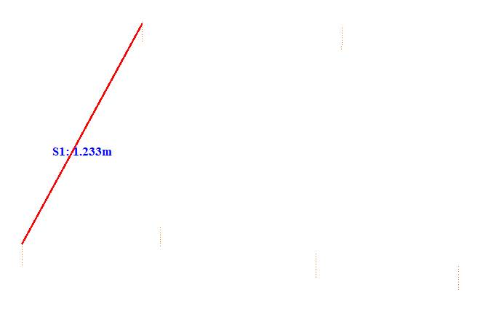

No. | Span | ID dan Lokasi Fasa | Nilai (m) (m) | Jarak Ke Menara Kecil (m)
84 | 32-33(32_33) | S2(RightUpFasaPowerLineAndRightDownFasaPowerLine) | 1.296 | 5.111
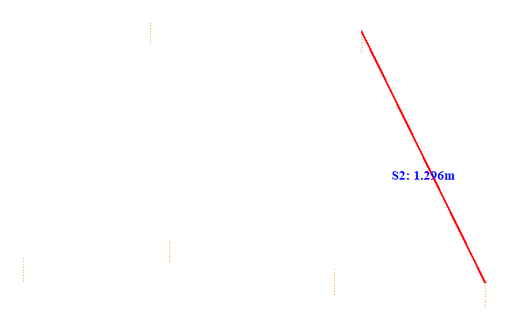

No. | Span | ID dan Lokasi Fasa | Nilai (m) (m) | Jarak Ke Menara Kecil (m)
85 | 33-34(33_34) | S1(LeftUpFasaPowerLineAndLeftDownFasaPowerLine) | 1.215 | 5.226
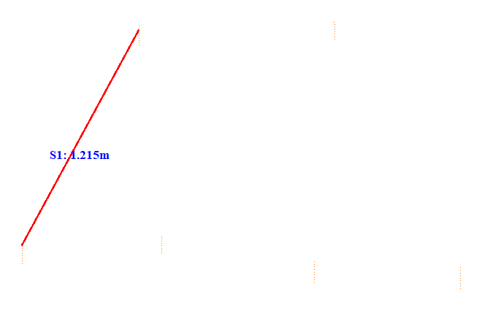

No. | Span | ID dan Lokasi Fasa | Nilai (m) (m) | Jarak Ke Menara Kecil (m)
86 | 33-34(33_34) | S2(RightUpFasaPowerLineAndRightDownFasaPowerLine) | 1.316 | 37.056
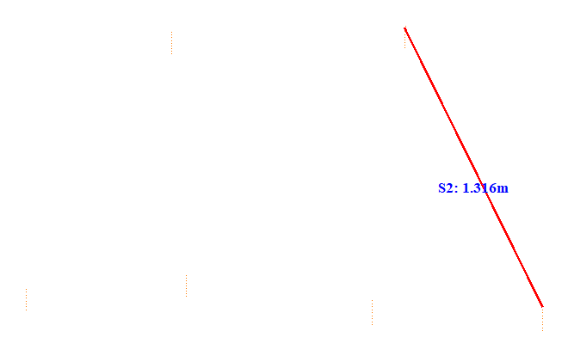

No. | Span | ID dan Lokasi Fasa | Nilai (m) (m) | Jarak Ke Menara Kecil (m)
87 | 34-35(34_35) | S1(Fasa Kiri Atas ke Fasa Kiri Tengah) | 1.322 | 41.610
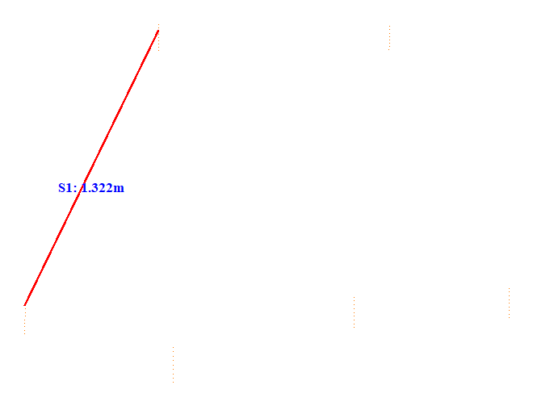

No. | Span | ID dan Lokasi Fasa | Nilai (m) (m) | Jarak Ke Menara Kecil (m)
88 | 34-35(34_35) | S2(Fasa Kanan Atas ke Fasa Kanan Tengah) | 1.224 | 41.606
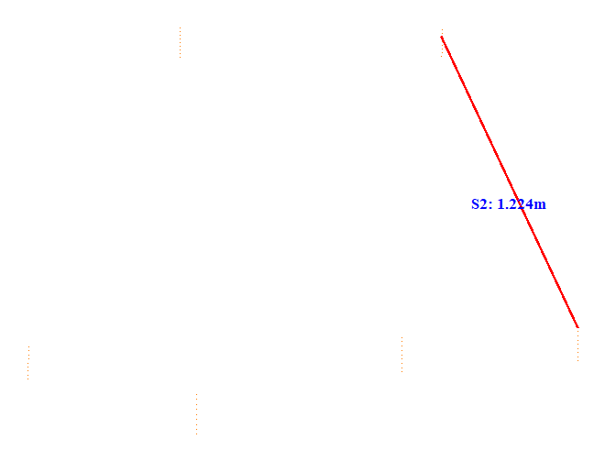

No. | Span | ID dan Lokasi Fasa | Nilai (m) (m) | Jarak Ke Menara Kecil (m)
89 | 34-35(34_35) | S3(LeftUpFasaPowerLineAndRightDownFasaPowerLine) | 1.538 | 35.050
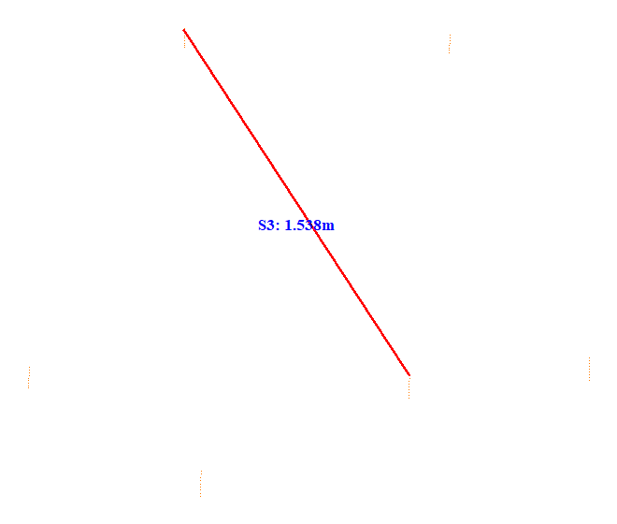

No. | Span | ID dan Lokasi Fasa | Nilai (m) (m) | Jarak Ke Menara Kecil (m)
90 | 34-35(34_35) | S4(RightUpFasaPowerLineAndRightDownFasaPowerLine) | 1.271 | 35.051
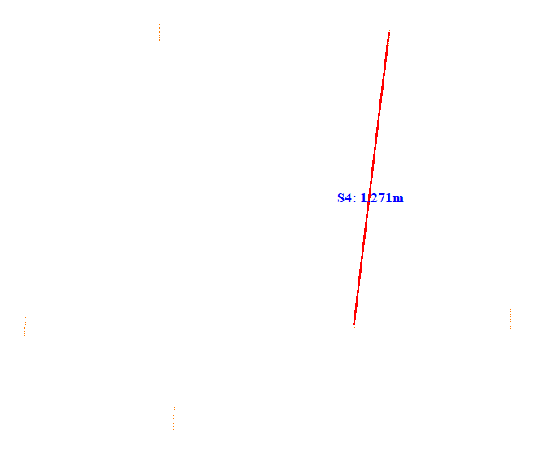

No. | Span | ID dan Lokasi Fasa | Nilai (m) (m) | Jarak Ke Menara Kecil (m)
91 | 34-35(34_35) | S5(Fasa Kiri Tengah ke Fasa Kiri Bawah) | 0.748 | 35.111
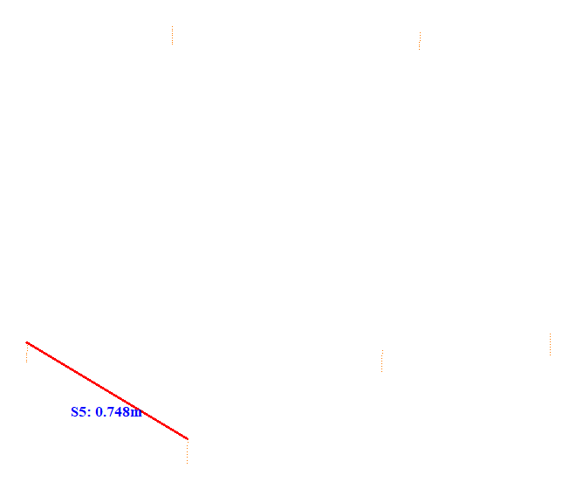

No. | Span | ID dan Lokasi Fasa | Nilai (m) (m) | Jarak Ke Menara Kecil (m)
92 | 34-35(34_35) | S6(RightMiddleFasaPowerLineAndLeftDownFasaPowerLine) | 1.509 | 35.101
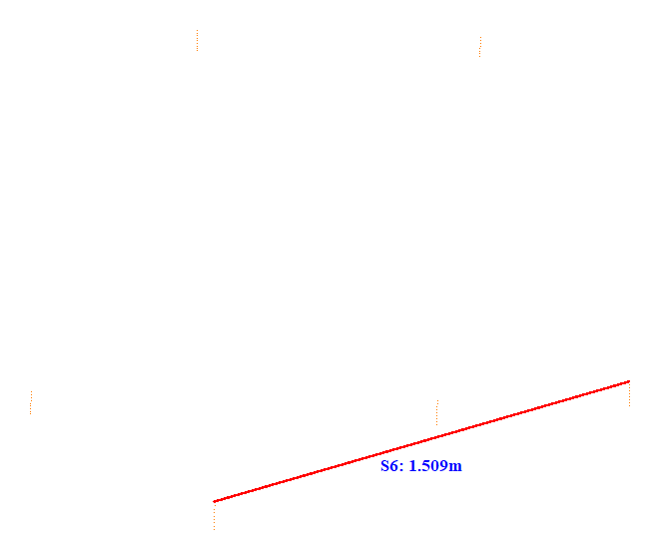

No. | Span | ID dan Lokasi Fasa | Nilai (m) (m) | Jarak Ke Menara Kecil (m)
93 | 35-36(35_36) | S1(Fasa Kiri Atas ke Fasa Kiri Tengah) | 0.738 | 32.458
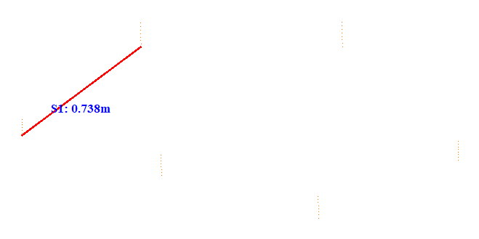

No. | Span | ID dan Lokasi Fasa | Nilai (m) (m) | Jarak Ke Menara Kecil (m)
94 | 35-36(35_36) | S2(Fasa Kanan Atas ke Fasa Kanan Tengah) | 0.656 | 16.119
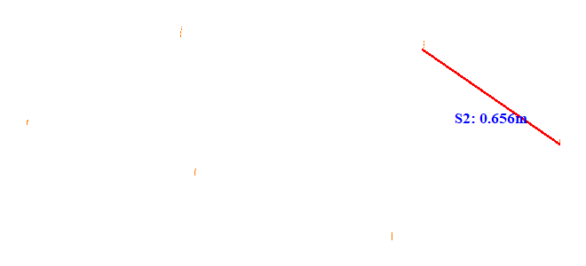

No. | Span | ID dan Lokasi Fasa | Nilai (m) (m) | Jarak Ke Menara Kecil (m)
95 | 35-36(35_36) | S3(Fasa Kiri Tengah ke Fasa Kiri Bawah) | 0.687 | 13.718
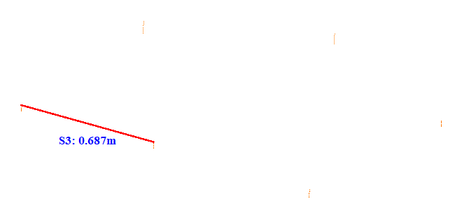

No. | Span | ID dan Lokasi Fasa | Nilai (m) (m) | Jarak Ke Menara Kecil (m)
96 | 35-36(35_36) | S4(LeftMiddleFasaPowerLineAndRightDownFasaPowerLine) | 1.504 | 13.703
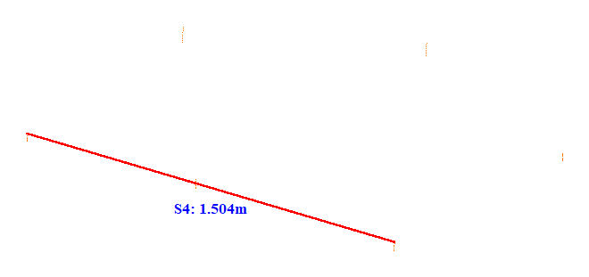

No. | Span | ID dan Lokasi Fasa | Nilai (m) (m) | Jarak Ke Menara Kecil (m)
97 | 35-36(35_36) | S5(RightUpFasaPowerLineAndRightDownFasaPowerLine) | 0.763 | 16.107
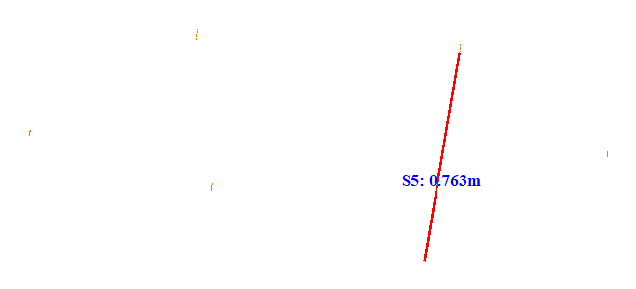

No. | Span | ID dan Lokasi Fasa | Nilai (m) (m) | Jarak Ke Menara Kecil (m)
98 | 35-36(35_36) | S6(Fasa Kanan Tengah ke Fasa Kanan Bawah) | 0.766 | 16.216
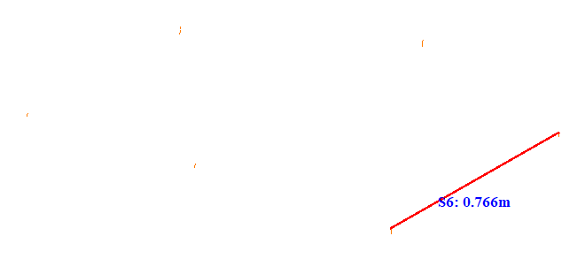

No. | Span | ID dan Lokasi Fasa | Nilai (m) (m) | Jarak Ke Menara Kecil (m)
99 | 37-38(37_38) | S1(Fasa Kiri Atas ke Fasa Kiri Tengah) | 0.800 | 24.657
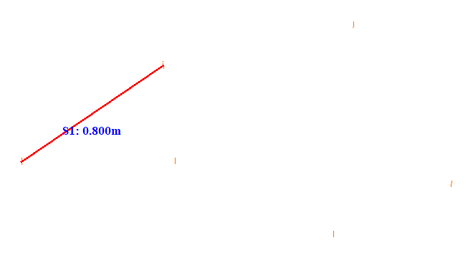

No. | Span | ID dan Lokasi Fasa | Nilai (m) (m) | Jarak Ke Menara Kecil (m)
100 | 37-38(37_38) | S2(Fasa Kanan Atas ke Fasa Kanan Tengah) | 0.874 | 23.897
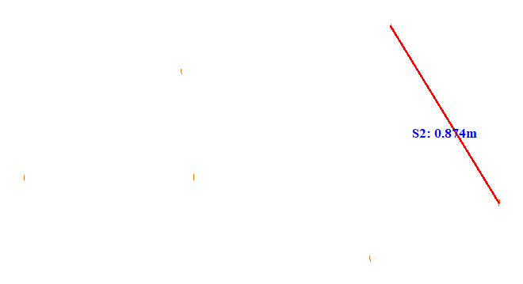

No. | Span | ID dan Lokasi Fasa | Nilai (m) (m) | Jarak Ke Menara Kecil (m)
101 | 38-39(38_39) | S1(Fasa Kiri Atas ke Fasa Kiri Tengah) | 1.053 | 22.711
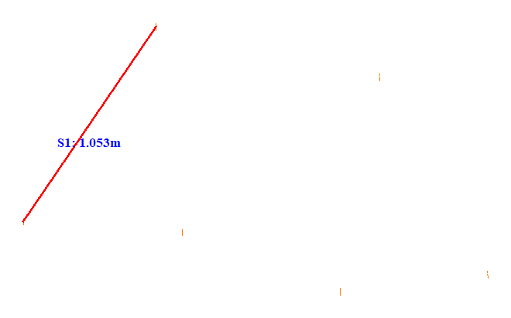

No. | Span | ID dan Lokasi Fasa | Nilai (m) (m) | Jarak Ke Menara Kecil (m)
102 | 38-39(38_39) | S2(RightUpFasaPowerLineAndRightDownFasaPowerLine) | 1.002 | 23.418
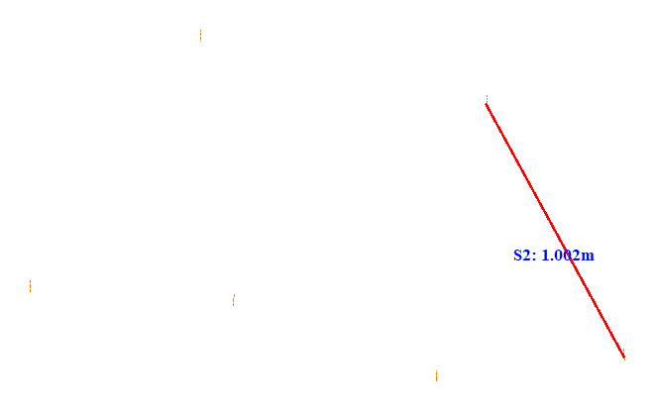

No. | Span | ID dan Lokasi Fasa | Nilai (m) (m) | Jarak Ke Menara Kecil (m)
103 | 39-40(39_40) | S1(Fasa Kiri Atas ke Fasa Kiri Tengah) | 1.046 | 23.506
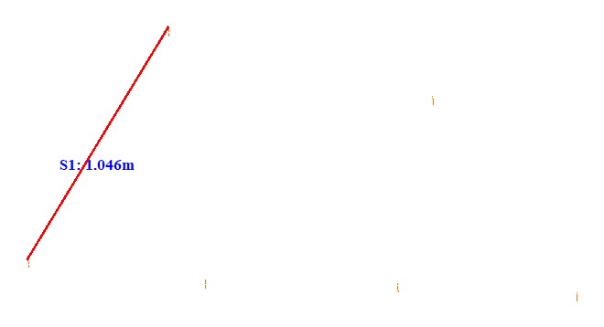

No. | Span | ID dan Lokasi Fasa | Nilai (m) (m) | Jarak Ke Menara Kecil (m)
104 | 39-40(39_40) | S2(Fasa Kanan Atas ke Fasa Kanan Tengah) | 0.934 | 20.520
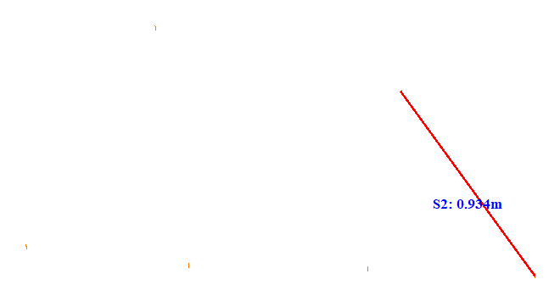

No. | Span | ID dan Lokasi Fasa | Nilai (m) (m) | Jarak Ke Menara Kecil (m)
105 | 40-41(40_41) | S1(Fasa Kiri Atas ke Fasa Kiri Tengah) | 1.083 | 16.018
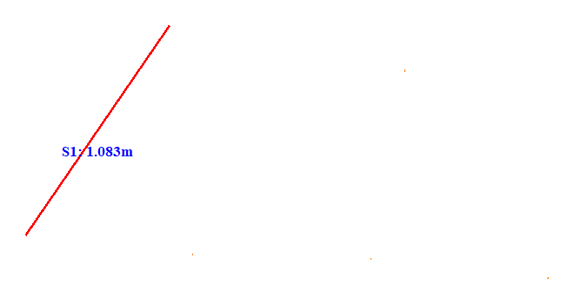

No. | Span | ID dan Lokasi Fasa | Nilai (m) (m) | Jarak Ke Menara Kecil (m)
106 | 40-41(40_41) | S2(RightUpFasaPowerLineAndRightDownFasaPowerLine) | 1.043 | 25.416
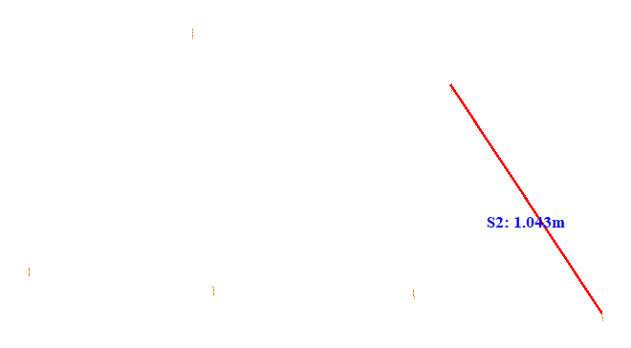

No. | Span | ID dan Lokasi Fasa | Nilai (m) (m) | Jarak Ke Menara Kecil (m)
107 | 41-42(41_42) | S1(Fasa Kiri Atas ke Fasa Kiri Tengah) | 1.066 | 25.313
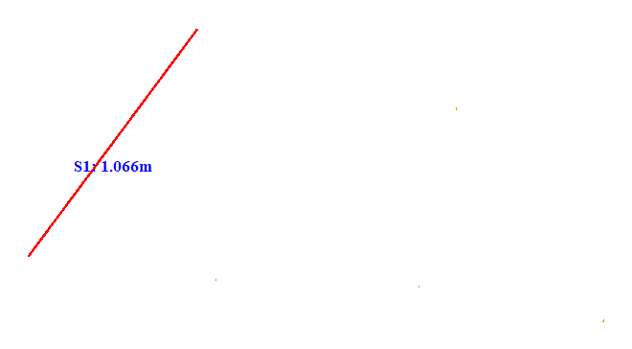

No. | Span | ID dan Lokasi Fasa | Nilai (m) (m) | Jarak Ke Menara Kecil (m)
108 | 41-42(41_42) | S2(RightUpFasaPowerLineAndRightDownFasaPowerLine) | 0.974 | 22.213
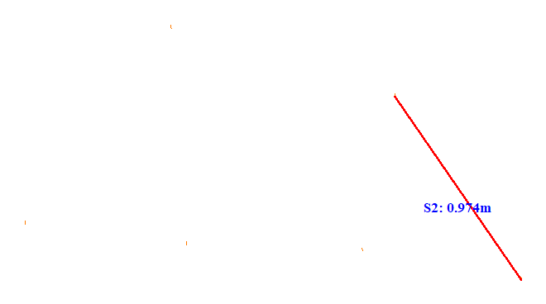

No. | Span | ID dan Lokasi Fasa | Nilai (m) (m) | Jarak Ke Menara Kecil (m)
109 | 42-43(42_43) | S1(Fasa Kiri Atas ke Fasa Kiri Tengah) | 1.098 | 18.614
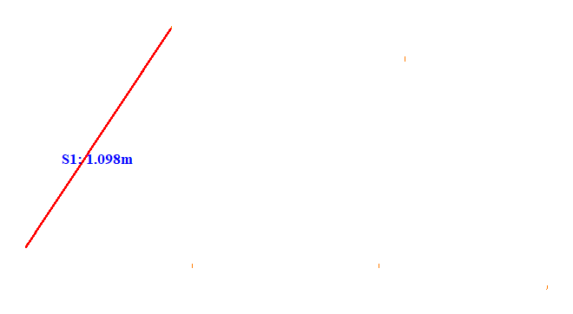

No. | Span | ID dan Lokasi Fasa | Nilai (m) (m) | Jarak Ke Menara Kecil (m)
110 | 42-43(42_43) | S2(RightUpFasaPowerLineAndRightDownFasaPowerLine) | 1.130 | 19.120
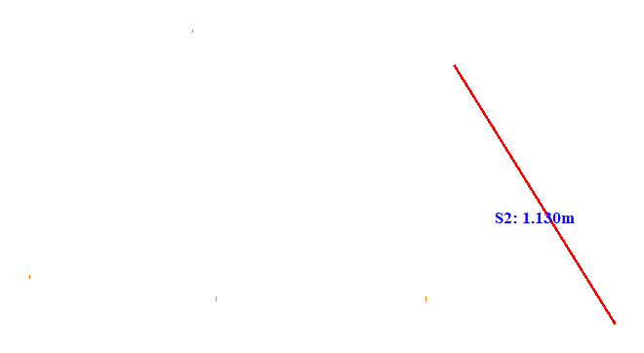

No. | Span | ID dan Lokasi Fasa | Nilai (m) (m) | Jarak Ke Menara Kecil (m)
111 | 43-44(43_44) | S1(LeftUpFasaPowerLineAndLeftDownFasaPowerLine) | 1.081 | 21.766
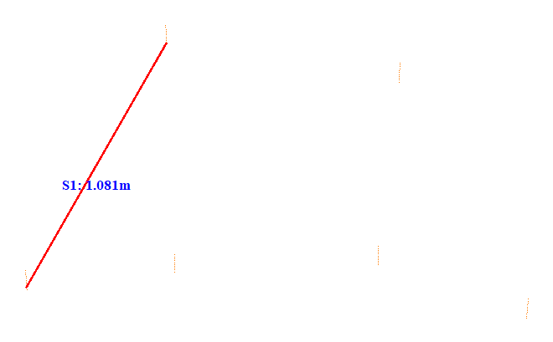

No. | Span | ID dan Lokasi Fasa | Nilai (m) (m) | Jarak Ke Menara Kecil (m)
112 | 43-44(43_44) | S2(RightUpFasaPowerLineAndRightDownFasaPowerLine) | 1.019 | 26.311
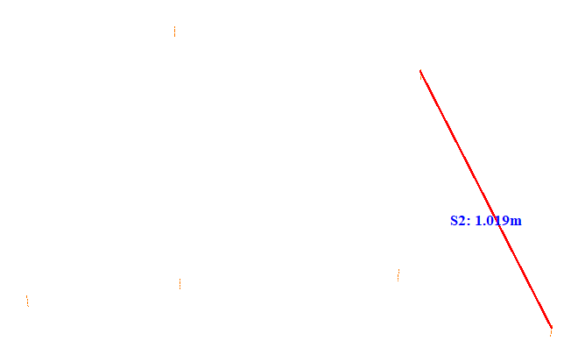

No. | Span | ID dan Lokasi Fasa | Nilai (m) (m) | Jarak Ke Menara Kecil (m)
113 | 44-45(44_45) | S1(Fasa Kiri Atas ke Fasa Kiri Tengah) | 1.283 | 31.910
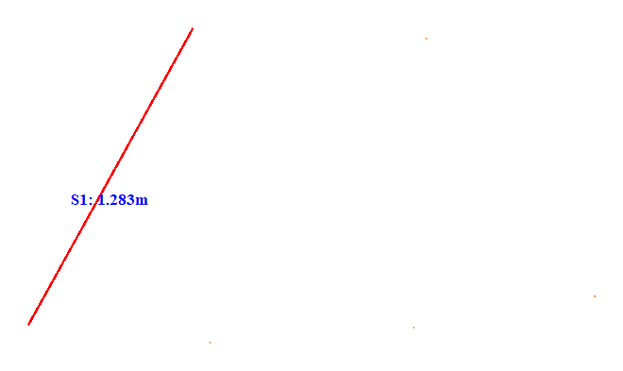

No. | Span | ID dan Lokasi Fasa | Nilai (m) (m) | Jarak Ke Menara Kecil (m)
114 | 44-45(44_45) | S2(Fasa Kanan Atas ke Fasa Kanan Tengah) | 1.167 | 27.208
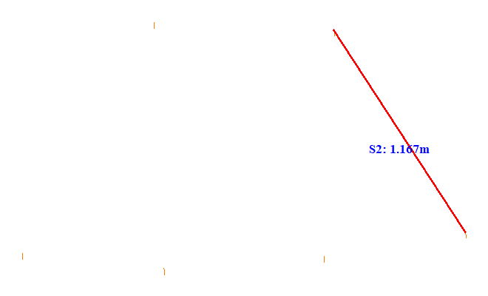

No. | Span | ID dan Lokasi Fasa | Nilai (m) (m) | Jarak Ke Menara Kecil (m)
115 | 45-46(45_46) | S1(LeftUpFasaPowerLineAndLeftDownFasaPowerLine) | 1.199 | 36.158
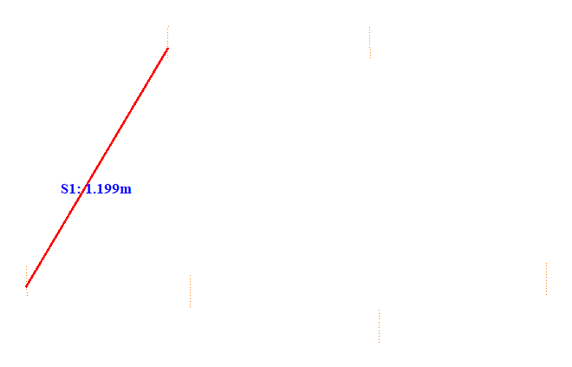

No. | Span | ID dan Lokasi Fasa | Nilai (m) (m) | Jarak Ke Menara Kecil (m)
116 | 45-46(45_46) | S2(Fasa Kanan Atas ke Fasa Kanan Tengah) | 1.268 | 34.859
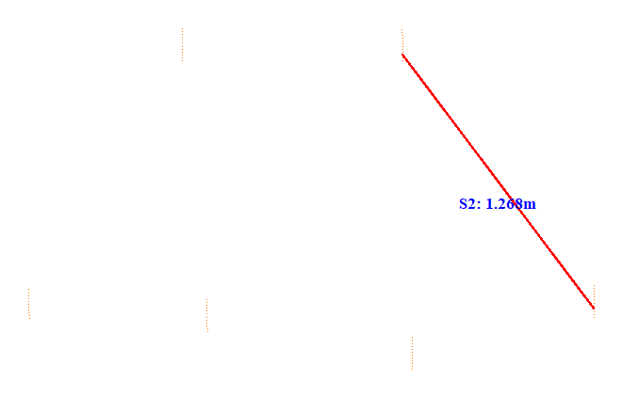

No. | Span | ID dan Lokasi Fasa | Nilai (m) (m) | Jarak Ke Menara Kecil (m)
117 | 47-48(47_48) | S1(Fasa Kiri Atas ke Fasa Kiri Tengah) | 0.888 | 24.244
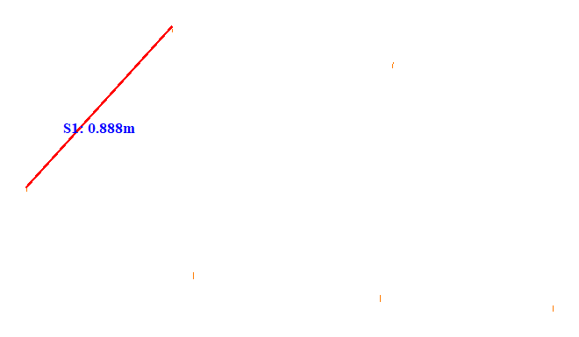

No. | Span | ID dan Lokasi Fasa | Nilai (m) (m) | Jarak Ke Menara Kecil (m)
118 | 47-48(47_48) | S2(Fasa Kanan Atas ke Fasa Kanan Tengah) | 1.200 | 29.640
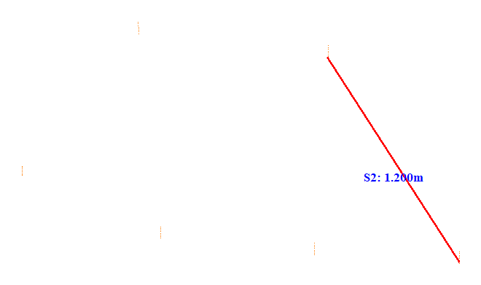

No. | Span | ID dan Lokasi Fasa | Nilai (m) (m) | Jarak Ke Menara Kecil (m)
119 | 47-48(47_48) | S3(RightUpFasaPowerLineAndRightDownFasaPowerLine) | 0.962 | 26.216
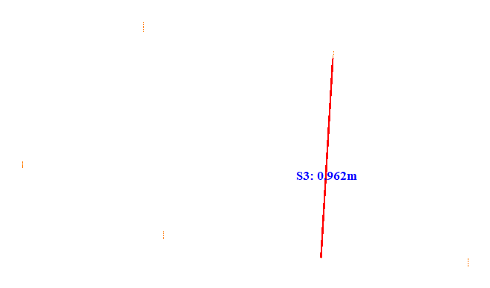

No. | Span | ID dan Lokasi Fasa | Nilai (m) (m) | Jarak Ke Menara Kecil (m)
120 | 47-48(47_48) | S4(LeftUpFasaPowerLineAndLeftDownFasaPowerLine) | 1.015 | 28.456
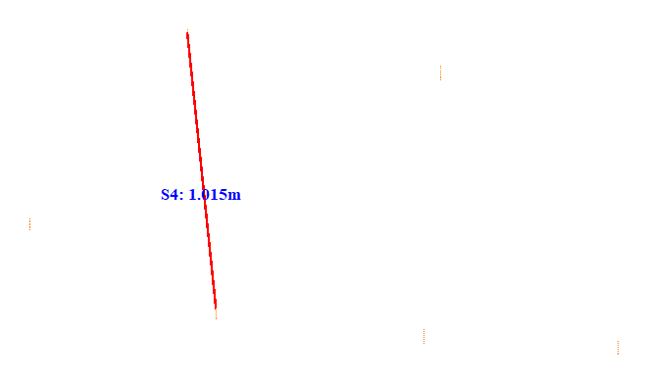

No. | Span | ID dan Lokasi Fasa | Nilai (m) (m) | Jarak Ke Menara Kecil (m)
121 | 47-48(47_48) | S5(RightUpFasaPowerLineAndLeftDownFasaPowerLine) | 1.192 | 22.375
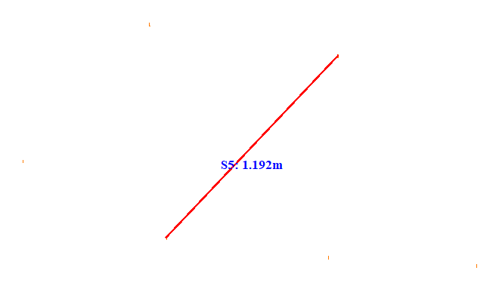

No. | Span | ID dan Lokasi Fasa | Nilai (m) (m) | Jarak Ke Menara Kecil (m)
122 | 47-48(47_48) | S6(LeftMiddleFasaPowerLineAndRightMiddleFasaPowerLine) | 2.201 | 29.455
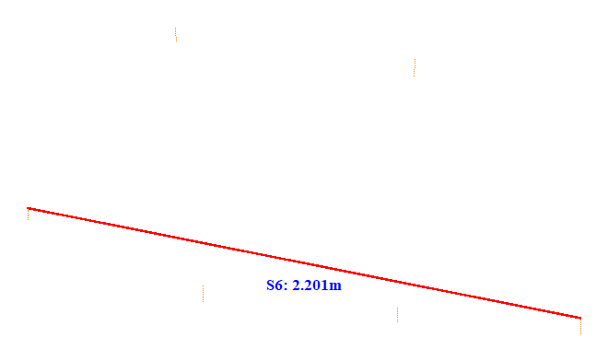

No. | Span | ID dan Lokasi Fasa | Nilai (m) (m) | Jarak Ke Menara Kecil (m)
123 | 47-48(47_48) | S7(RightDownFasaPowerLineAndRightMiddleFasaPowerLine) | 0.699 | 14.383
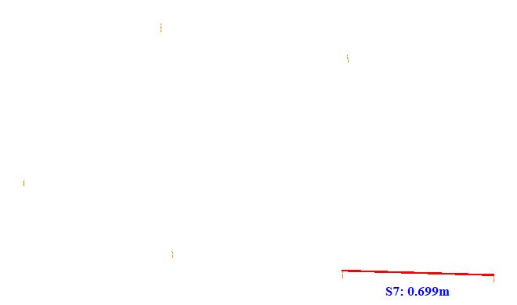

No. | Span | ID dan Lokasi Fasa | Nilai (m) (m) | Jarak Ke Menara Kecil (m)
124 | 47-48(47_48) | S8(LeftMiddleFasaPowerLineAndRightDownFasaPowerLine) | 1.513 | 26.040
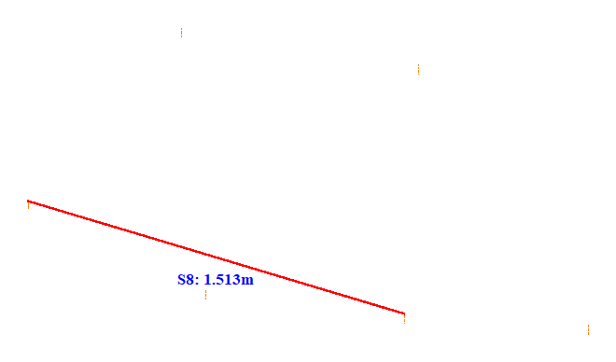

No. | Span | ID dan Lokasi Fasa | Nilai (m) (m) | Jarak Ke Menara Kecil (m)
125 | 47-48(47_48) | S9(LeftDownFasaPowerLineAndRightMiddleFasaPowerLine) | 1.482 | 26.079
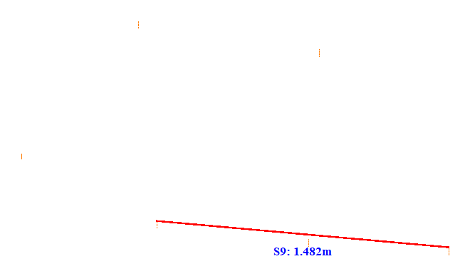

No. | Span | ID dan Lokasi Fasa | Nilai (m) (m) | Jarak Ke Menara Kecil (m)
126 | 48-49(48_49) | S1(Fasa Kiri Atas ke Fasa Kiri Tengah) | 1.031 | 15.721
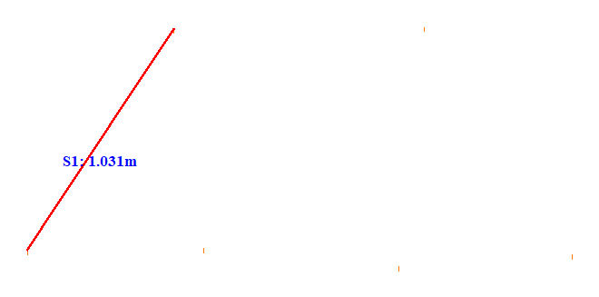

No. | Span | ID dan Lokasi Fasa | Nilai (m) (m) | Jarak Ke Menara Kecil (m)
127 | 48-49(48_49) | S2(Fasa Kanan Atas ke Fasa Kanan Tengah) | 1.044 | 20.015
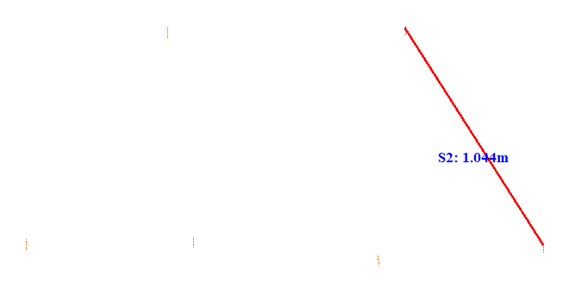

No. | Span | ID dan Lokasi Fasa | Nilai (m) (m) | Jarak Ke Menara Kecil (m)
128 | 49-50(49_50) | S1(RightMiddleFasaPowerLineAndLeftUpFasaPowerLine) | 1.747 | 29.802
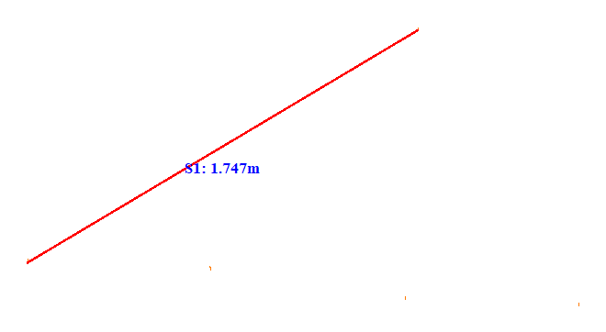

No. | Span | ID dan Lokasi Fasa | Nilai (m) (m) | Jarak Ke Menara Kecil (m)
129 | 49-50(49_50) | S2(Fasa Kanan Tengah ke Fasa Kanan Bawah) | 1.219 | 25.512
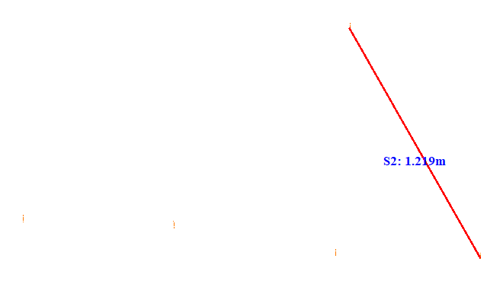

No. | Span | ID dan Lokasi Fasa | Nilai (m) (m) | Jarak Ke Menara Kecil (m)
130 | 50-51(50_51) | S1(LeftUpFasaPowerLineAndLeftDownFasaPowerLine) | 0.951 | 20.663
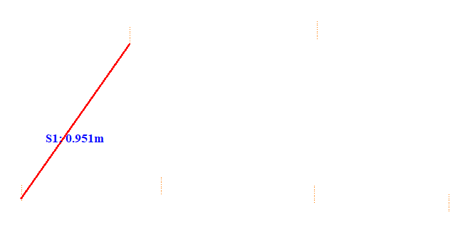

No. | Span | ID dan Lokasi Fasa | Nilai (m) (m) | Jarak Ke Menara Kecil (m)
131 | 50-51(50_51) | S2(RightUpFasaPowerLineAndRightDownFasaPowerLine) | 1.078 | 26.312
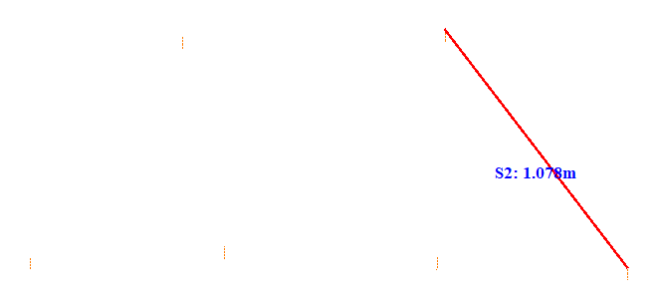

No. | Span | ID dan Lokasi Fasa | Nilai (m) (m) | Jarak Ke Menara Kecil (m)
132 | 51-52(51_52) | S1(Fasa Kiri Atas ke Fasa Kiri Tengah) | 0.969 | 25.379
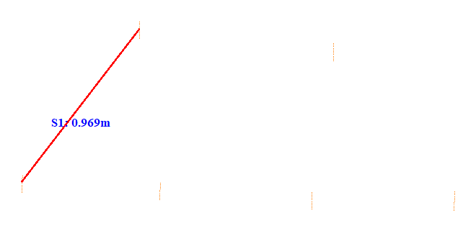

No. | Span | ID dan Lokasi Fasa | Nilai (m) (m) | Jarak Ke Menara Kecil (m)
133 | 51-52(51_52) | S2(Fasa Kanan Atas ke Fasa Kanan Tengah) | 0.960 | 27.612
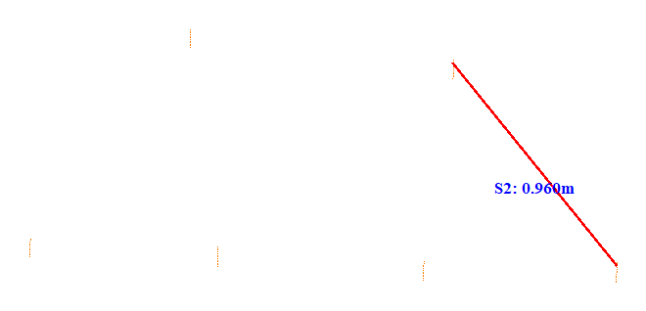

No. | Span | ID dan Lokasi Fasa | Nilai (m) (m) | Jarak Ke Menara Kecil (m)
134 | 52-53(52_53) | S1(LeftUpFasaPowerLineAndLeftDownFasaPowerLine) | 1.073 | 33.709
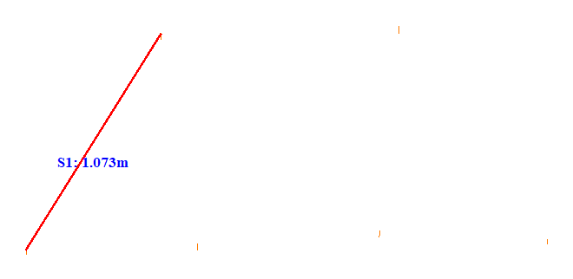

No. | Span | ID dan Lokasi Fasa | Nilai (m) (m) | Jarak Ke Menara Kecil (m)
135 | 52-53(52_53) | S2(Fasa Kanan Atas ke Fasa Kanan Tengah) | 1.081 | 27.411
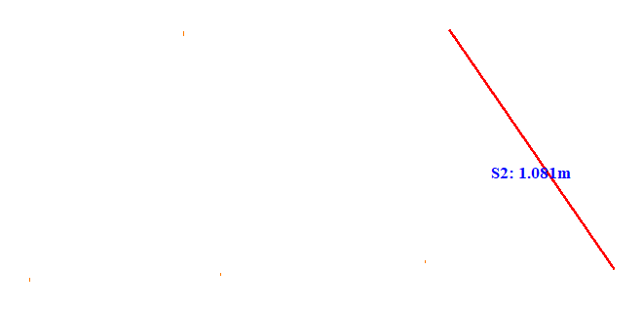

No. | Span | ID dan Lokasi Fasa | Nilai (m) (m) | Jarak Ke Menara Kecil (m)
136 | 53-54(53_54) | S1(LeftUpFasaPowerLineAndLeftDownFasaPowerLine) | 1.012 | 19.866
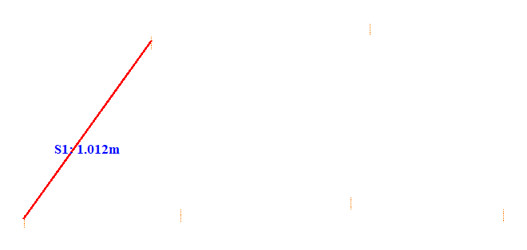

No. | Span | ID dan Lokasi Fasa | Nilai (m) (m) | Jarak Ke Menara Kecil (m)
137 | 53-54(53_54) | S2(RightUpFasaPowerLineAndRightDownFasaPowerLine) | 1.048 | 26.213
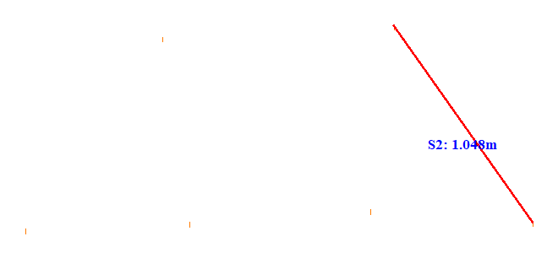

No. | Span | ID dan Lokasi Fasa | Nilai (m) (m) | Jarak Ke Menara Kecil (m)
138 | 54-55(54_55) | S1(LeftUpFasaPowerLineAndLeftDownFasaPowerLine) | 1.064 | 24.012
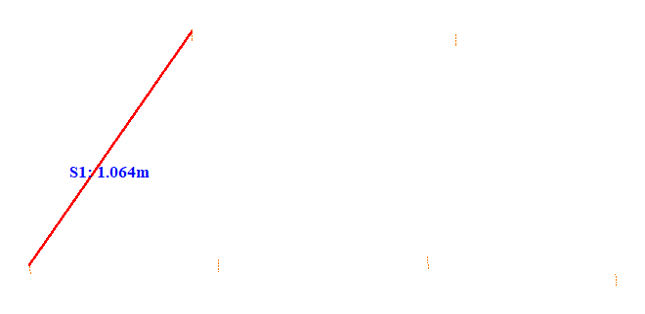

No. | Span | ID dan Lokasi Fasa | Nilai (m) (m) | Jarak Ke Menara Kecil (m)
139 | 54-55(54_55) | S2(RightUpFasaPowerLineAndRightDownFasaPowerLine) | 1.058 | 17.070
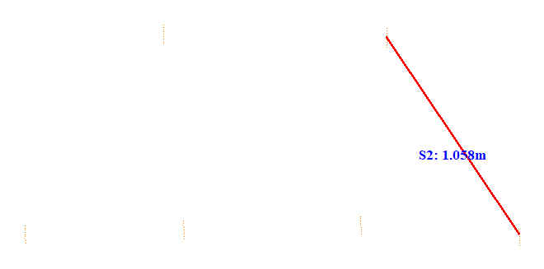

No. | Span | ID dan Lokasi Fasa | Nilai (m) (m) | Jarak Ke Menara Kecil (m)
140 | 55-56(55_56) | S1(LeftUpFasaPowerLineAndLeftDownFasaPowerLine) | 1.120 | 18.711
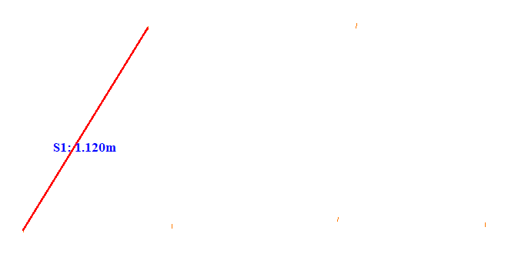

No. | Span | ID dan Lokasi Fasa | Nilai (m) (m) | Jarak Ke Menara Kecil (m)
141 | 55-56(55_56) | S2(RightUpFasaPowerLineAndRightDownFasaPowerLine) | 1.108 | 24.518
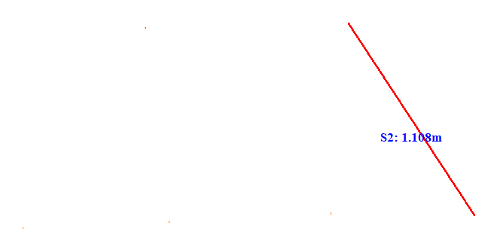

No. | Span | ID dan Lokasi Fasa | Nilai (m) (m) | Jarak Ke Menara Kecil (m)
142 | 56-57(56_57) | S1(LeftUpFasaPowerLineAndLeftDownFasaPowerLine) | 1.062 | 20.114
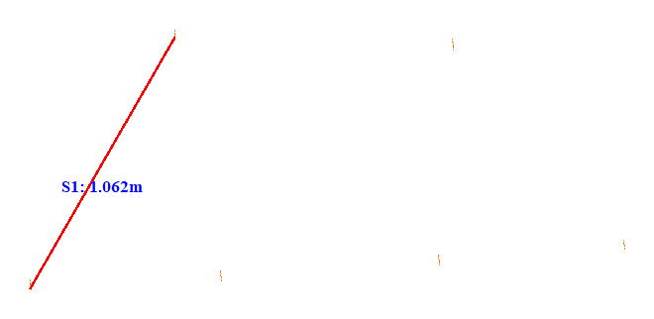

No. | Span | ID dan Lokasi Fasa | Nilai (m) (m) | Jarak Ke Menara Kecil (m)
143 | 56-57(56_57) | S2(Fasa Kanan Atas ke Fasa Kanan Tengah) | 0.967 | 20.716
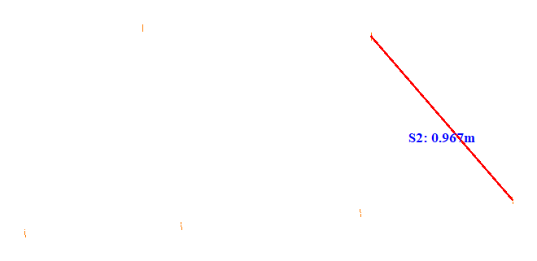

No. | Span | ID dan Lokasi Fasa | Nilai (m) (m) | Jarak Ke Menara Kecil (m)
144 | 57-58(57_58) | S1(Fasa Kiri Atas ke Fasa Kiri Tengah) | 0.920 | 21.711
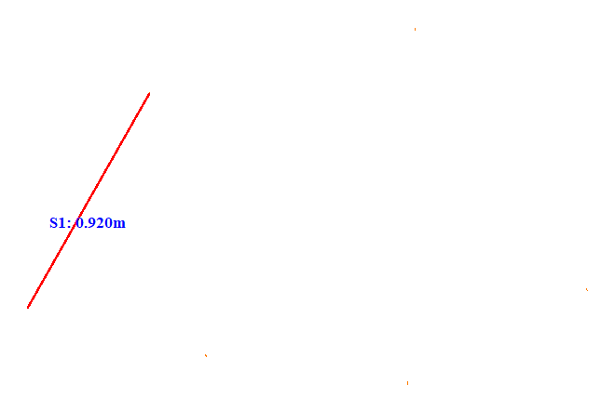

No. | Span | ID dan Lokasi Fasa | Nilai (m) (m) | Jarak Ke Menara Kecil (m)
145 | 57-58(57_58) | S2(Fasa Kanan Atas ke Fasa Kanan Tengah) | 1.170 | 20.222
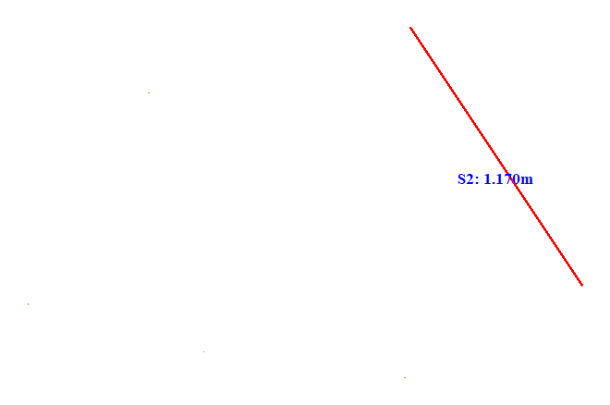

No. | Span | ID dan Lokasi Fasa | Nilai (m) (m) | Jarak Ke Menara Kecil (m)
146 | 58-59(58_59) | S1(Fasa Kiri Atas ke Fasa Kiri Tengah) | 0.883 | 22.511
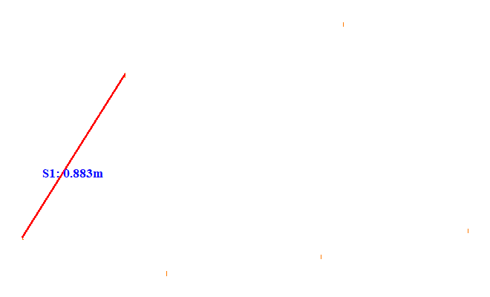

No. | Span | ID dan Lokasi Fasa | Nilai (m) (m) | Jarak Ke Menara Kecil (m)
147 | 58-59(58_59) | S2(Fasa Kanan Atas ke Fasa Kanan Tengah) | 1.109 | 22.914
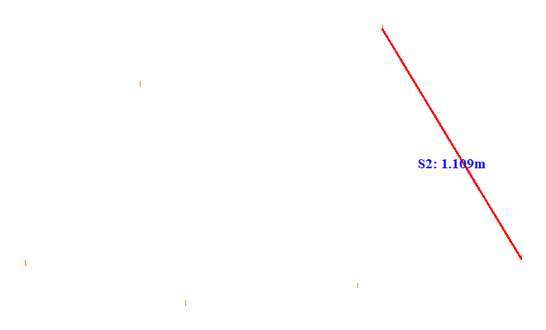

No. | Span | ID dan Lokasi Fasa | Nilai (m) (m) | Jarak Ke Menara Kecil (m)
148 | 59-60(59_60) | S1(Fasa Kiri Atas ke Fasa Kiri Tengah) | 0.884 | 22.513
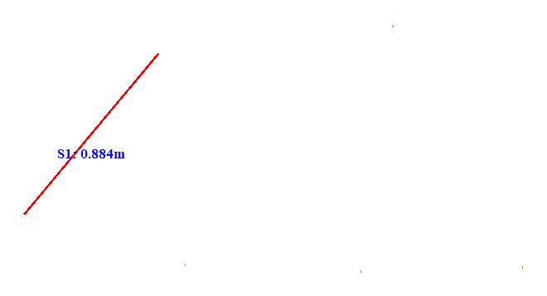

No. | Span | ID dan Lokasi Fasa | Nilai (m) (m) | Jarak Ke Menara Kecil (m)
149 | 59-60(59_60) | S2(RightUpFasaPowerLineAndRightDownFasaPowerLine) | 1.168 | 25.112
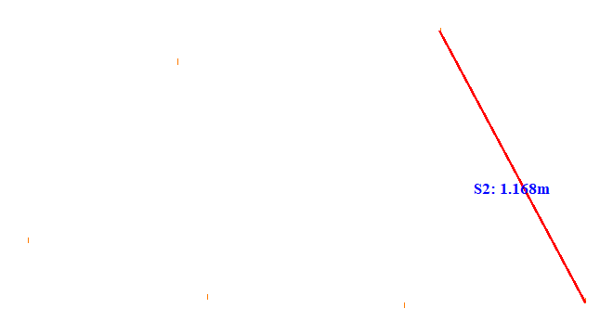

No. | Span | ID dan Lokasi Fasa | Nilai (m) (m) | Jarak Ke Menara Kecil (m)
150 | 60-61(60_61) | S1(Fasa Kiri Atas ke Fasa Kiri Tengah) | 0.973 | 23.511
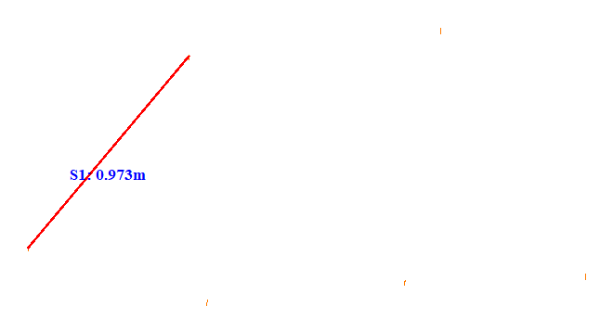

No. | Span | ID dan Lokasi Fasa | Nilai (m) (m) | Jarak Ke Menara Kecil (m)
151 | 60-61(60_61) | S2(Fasa Kanan Atas ke Fasa Kanan Tengah) | 1.111 | 25.014
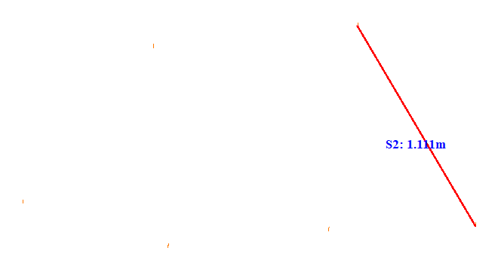

No. | Span | ID dan Lokasi Fasa | Nilai (m) (m) | Jarak Ke Menara Kecil (m)
152 | 61-62(61_62) | S1(Fasa Kiri Atas ke Fasa Kiri Tengah) | 0.906 | 23.214
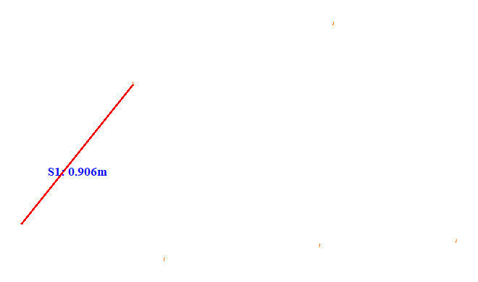

No. | Span | ID dan Lokasi Fasa | Nilai (m) (m) | Jarak Ke Menara Kecil (m)
153 | 61-62(61_62) | S2(RightUpFasaPowerLineAndRightDownFasaPowerLine) | 1.240 | 5.212
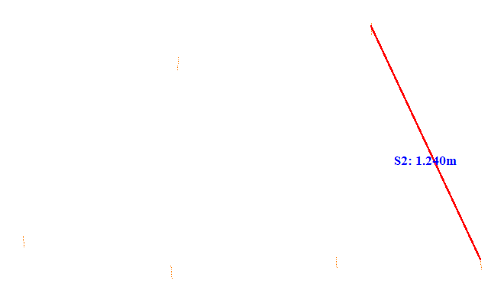

No. | Span | ID dan Lokasi Fasa | Nilai (m) (m) | Jarak Ke Menara Kecil (m)
154 | 62-63(62_63) | S1(Fasa Kiri Atas ke Fasa Kiri Tengah) | 0.846 | 21.312
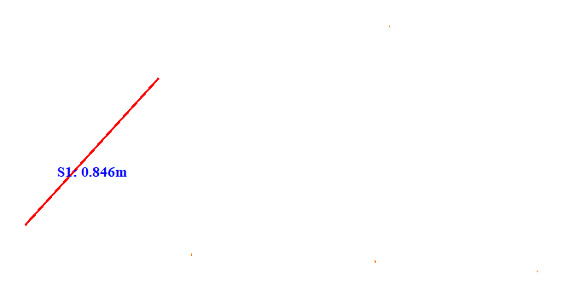

No. | Span | ID dan Lokasi Fasa | Nilai (m) (m) | Jarak Ke Menara Kecil (m)
155 | 62-63(62_63) | S2(RightUpFasaPowerLineAndRightDownFasaPowerLine) | 1.222 | 33.062
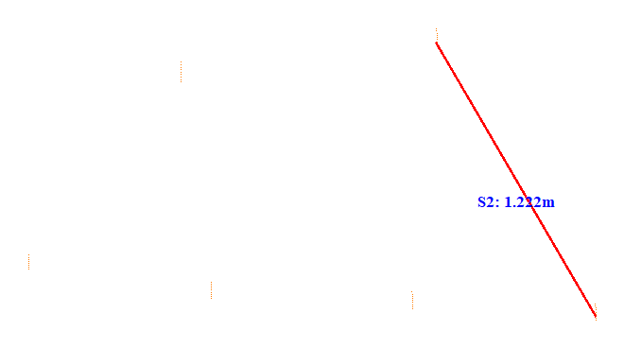

No. | Span | ID dan Lokasi Fasa | Nilai (m) (m) | Jarak Ke Menara Kecil (m)
156 | 63-64(63_64) | S1(Fasa Kiri Atas ke Fasa Kiri Tengah) | 0.963 | 18.017
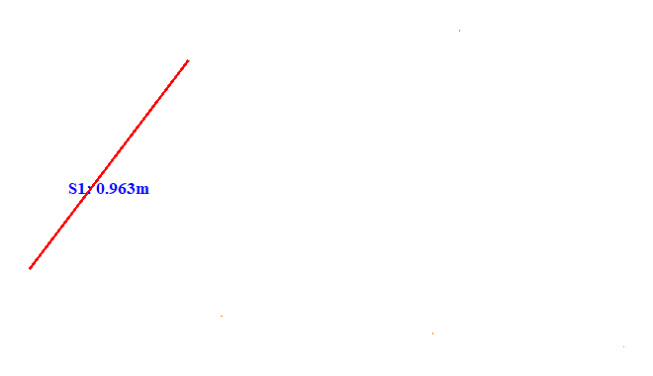

No. | Span | ID dan Lokasi Fasa | Nilai (m) (m) | Jarak Ke Menara Kecil (m)
157 | 63-64(63_64) | S2(RightUpFasaPowerLineAndRightDownFasaPowerLine) | 1.279 | 5.216
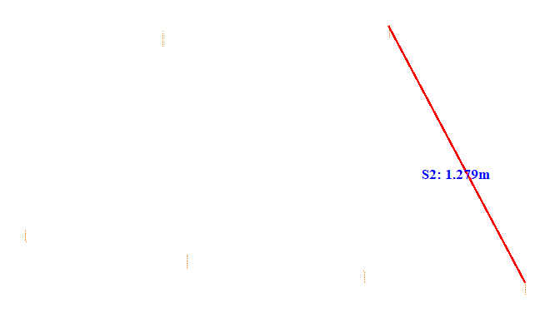

No. | Span | ID dan Lokasi Fasa | Nilai (m) (m) | Jarak Ke Menara Kecil (m)
158 | 64-65(64_65) | S1(Fasa Kiri Atas ke Fasa Kiri Tengah) | 0.940 | 22.910
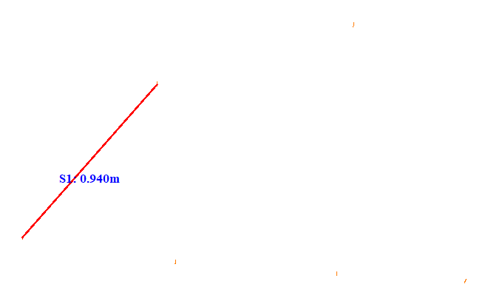

No. | Span | ID dan Lokasi Fasa | Nilai (m) (m) | Jarak Ke Menara Kecil (m)
159 | 64-65(64_65) | S2(RightUpFasaPowerLineAndRightDownFasaPowerLine) | 1.216 | 42.160
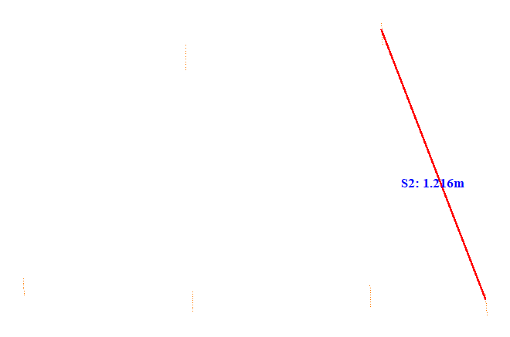

No. | Span | ID dan Lokasi Fasa | Nilai (m) (m) | Jarak Ke Menara Kecil (m)
160 | 65-66(65_66) | S1(LeftUpFasaPowerLineAndLeftDownFasaPowerLine) | 0.905 | 28.309
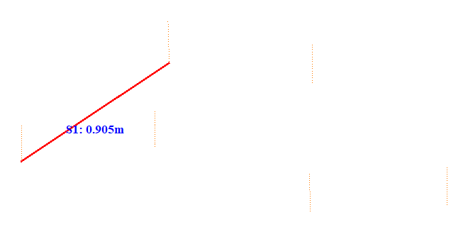

No. | Span | ID dan Lokasi Fasa | Nilai (m) (m) | Jarak Ke Menara Kecil (m)
161 | 65-66(65_66) | S2(Fasa Kanan Atas ke Fasa Kanan Tengah) | 0.887 | 41.707
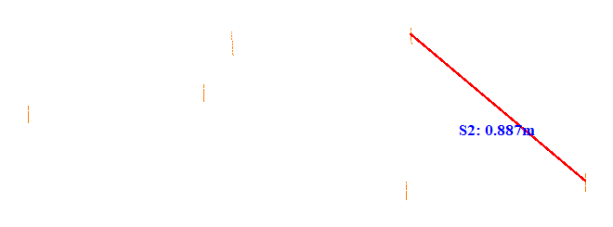

No. | Span | ID dan Lokasi Fasa | Nilai (m) (m) | Jarak Ke Menara Kecil (m)
162 | 65-66(65_66) | S3(Fasa Kiri Tengah ke Fasa Kiri Bawah) | 0.687 | 28.410
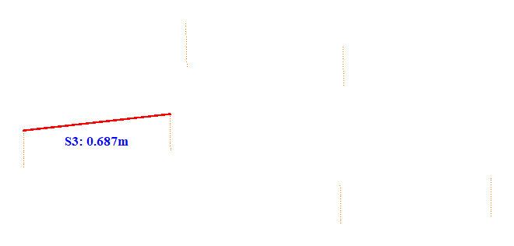

No. | Span | ID dan Lokasi Fasa | Nilai (m) (m) | Jarak Ke Menara Kecil (m)
163 | 65-66(65_66) | S4(LeftMiddleFasaPowerLineAndRightDownFasaPowerLine) | 0.850 | 62.400
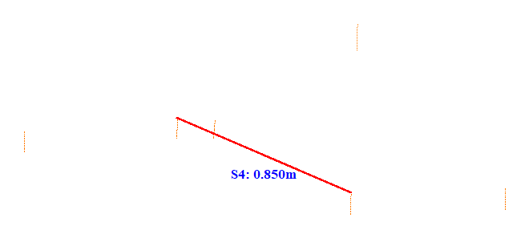

No. | Span | ID dan Lokasi Fasa | Nilai (m) (m) | Jarak Ke Menara Kecil (m)
164 | 65-66(65_66) | S5(RightUpFasaPowerLineAndRightDownFasaPowerLine) | 0.631 | 31.853
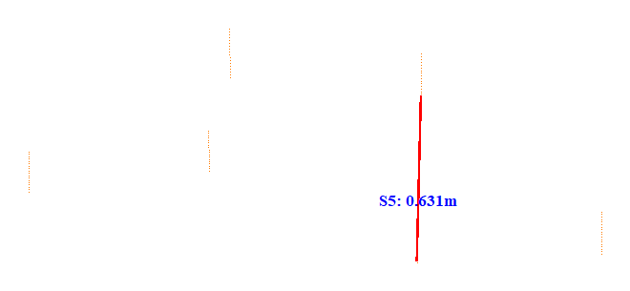

No. | Span | ID dan Lokasi Fasa | Nilai (m) (m) | Jarak Ke Menara Kecil (m)
165 | 65-66(65_66) | S6(LeftDownFasaPowerLineAndRightDownFasaPowerLine) | 1.496 | 58.801
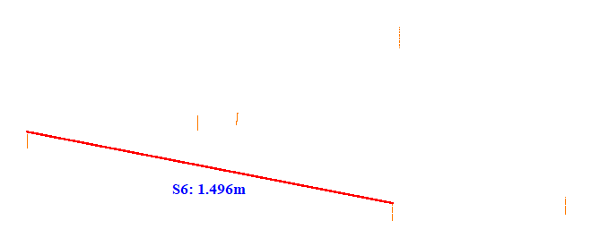

No. | Span | ID dan Lokasi Fasa | Nilai (m) (m) | Jarak Ke Menara Kecil (m)
166 | 65-66(65_66) | S7(RightUpFasaPowerLineAndLeftDownFasaPowerLine) | 1.574 | 62.601
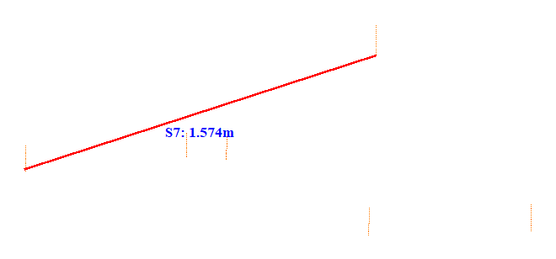

No. | Span | ID dan Lokasi Fasa | Nilai (m) (m) | Jarak Ke Menara Kecil (m)
167 | 65-66(65_66) | S8(RightUpFasaPowerLineAndLeftUpFasaPowerLine) | 0.776 | 62.600
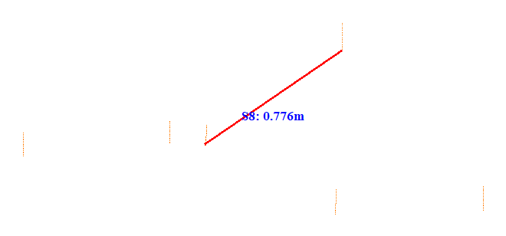

No. | Span | ID dan Lokasi Fasa | Nilai (m) (m) | Jarak Ke Menara Kecil (m)
168 | 66-67(66_67) | S1(LeftUpFasaPowerLineAndLeftDownFasaPowerLine) | 1.442 | 14.619
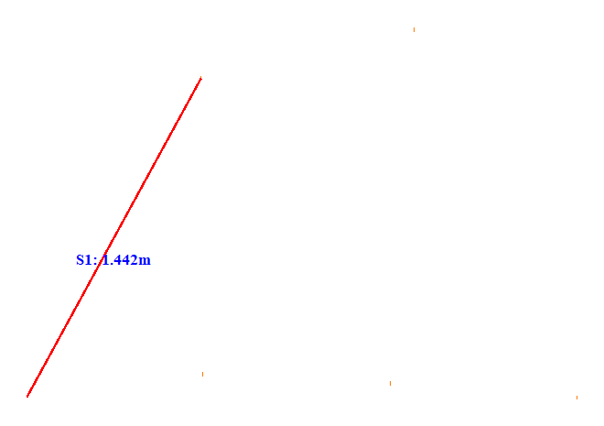

No. | Span | ID dan Lokasi Fasa | Nilai (m) (m) | Jarak Ke Menara Kecil (m)
169 | 66-67(66_67) | S2(RightUpFasaPowerLineAndRightDownFasaPowerLine) | 1.490 | 37.607
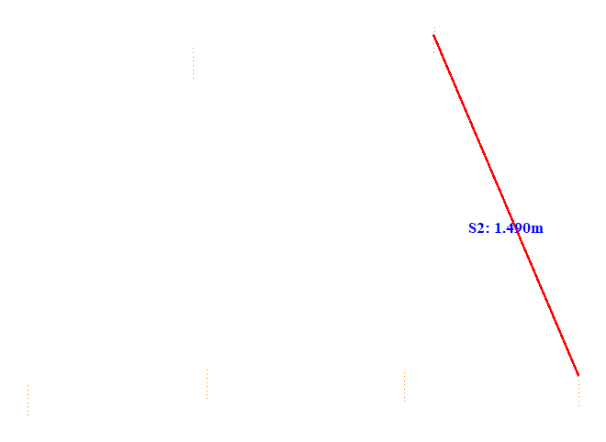

No. | Span | ID dan Lokasi Fasa | Nilai (m) (m) | Jarak Ke Menara Kecil (m)
170 | 67-68(67_68) | S1(LeftUpFasaPowerLineAndLeftDownFasaPowerLine) | 1.239 | 41.506
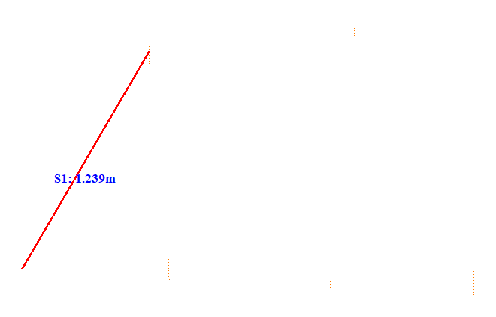

No. | Span | ID dan Lokasi Fasa | Nilai (m) (m) | Jarak Ke Menara Kecil (m)
171 | 67-68(67_68) | S2(RightUpFasaPowerLineAndRightDownFasaPowerLine) | 1.337 | 41.509
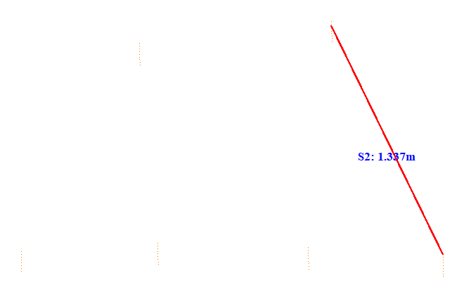

No. | Span | ID dan Lokasi Fasa | Nilai (m) (m) | Jarak Ke Menara Kecil (m)
172 | 68-69(68_69) | S1(Fasa Kiri Atas ke Fasa Kiri Tengah) | 1.066 | 17.105
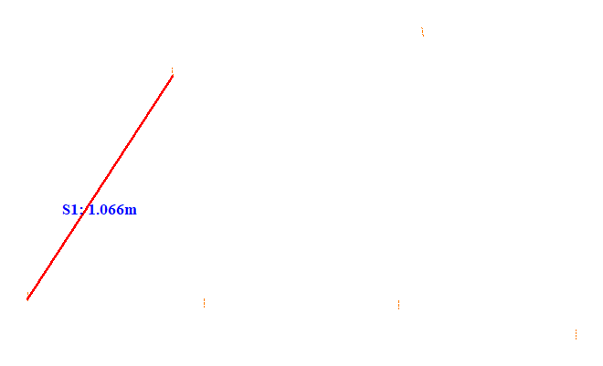

No. | Span | ID dan Lokasi Fasa | Nilai (m) (m) | Jarak Ke Menara Kecil (m)
173 | 68-69(68_69) | S2(RightUpFasaPowerLineAndRightDownFasaPowerLine) | 1.233 | 37.953
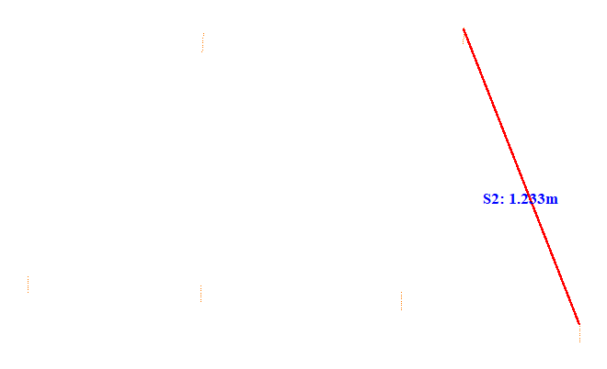

No. | Span | ID dan Lokasi Fasa | Nilai (m) (m) | Jarak Ke Menara Kecil (m)
174 | 69-70(69_70) | S1(Fasa Kiri Atas ke Fasa Kiri Tengah) | 0.814 | 27.012
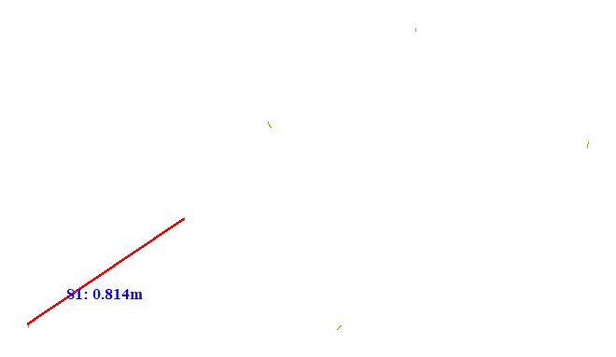

No. | Span | ID dan Lokasi Fasa | Nilai (m) (m) | Jarak Ke Menara Kecil (m)
175 | 69-70(69_70) | S2(RightUpFasaPowerLineAndRightDownFasaPowerLine) | 0.899 | 27.009
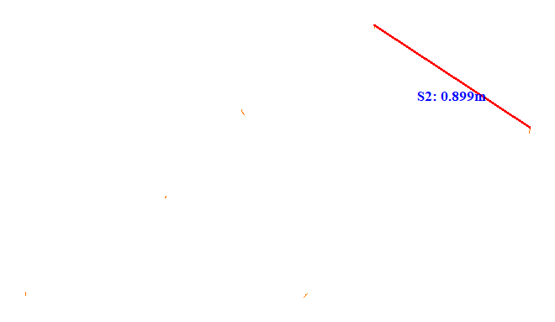

No. | Span | ID dan Lokasi Fasa | Nilai (m) (m) | Jarak Ke Menara Kecil (m)
176 | 69-70(69_70) | S3(RightMiddleFasaPowerLineAndLeftUpFasaPowerLine) | 0.497 | 23.902
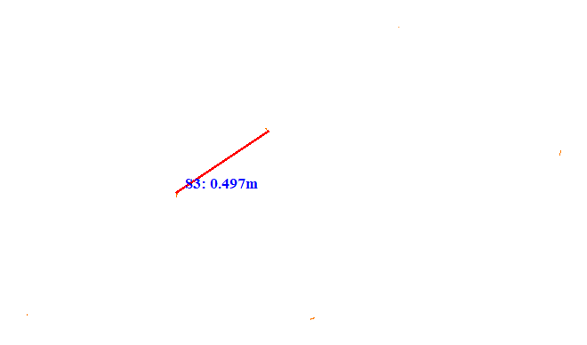

No. | Span | ID dan Lokasi Fasa | Nilai (m) (m) | Jarak Ke Menara Kecil (m)
177 | 69-70(69_70) | S4(Fasa Kanan Atas ke Fasa Kanan Tengah) | 0.757 | 23.801
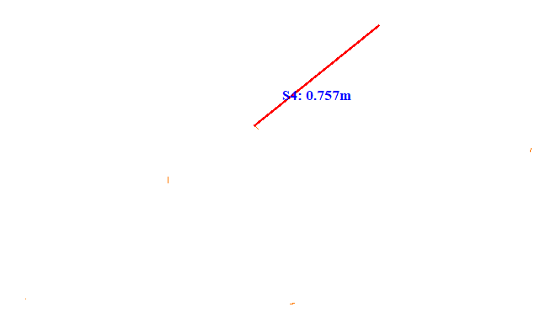

No. | Span | ID dan Lokasi Fasa | Nilai (m) (m) | Jarak Ke Menara Kecil (m)
178 | 69-70(69_70) | S5(Fasa Kiri Tengah ke Fasa Kiri Bawah) | 0.915 | 9.230
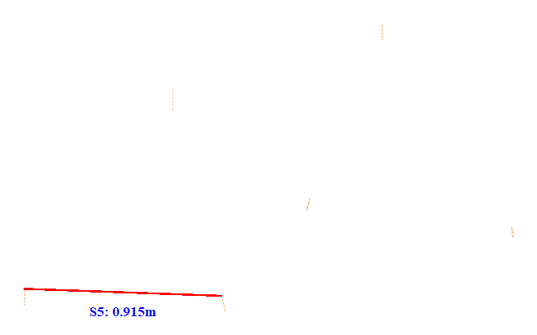

No. | Span | ID dan Lokasi Fasa | Nilai (m) (m) | Jarak Ke Menara Kecil (m)
179 | 69-70(69_70) | S6(RightDownFasaPowerLineAndLeftDownFasaPowerLine) | 1.320 | 35.155
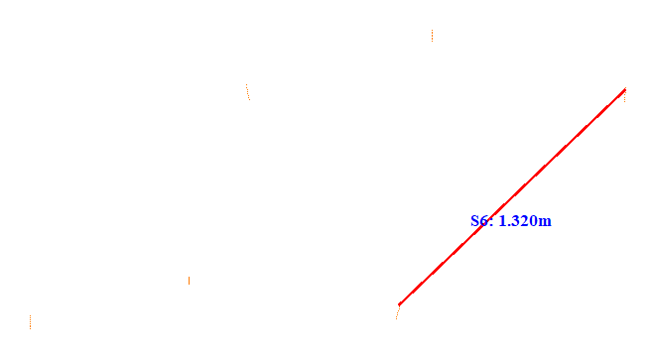

No. | Span | ID dan Lokasi Fasa | Nilai (m) (m) | Jarak Ke Menara Kecil (m)
180 | 69-70(69_70) | S7(RightMiddleFasaPowerLineAndLeftMiddleFasaPowerLine) | 1.336 | 35.157
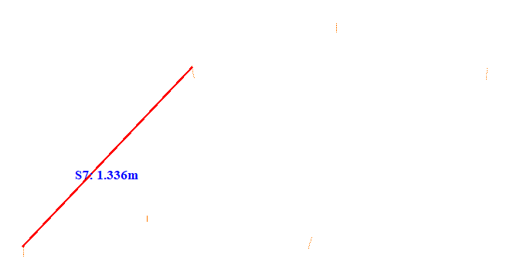

No. | Span | ID dan Lokasi Fasa | Nilai (m) (m) | Jarak Ke Menara Kecil (m)
181 | 69-70(69_70) | S8(RightUpFasaPowerLineAndLeftUpFasaPowerLine) | 1.084 | 13.999
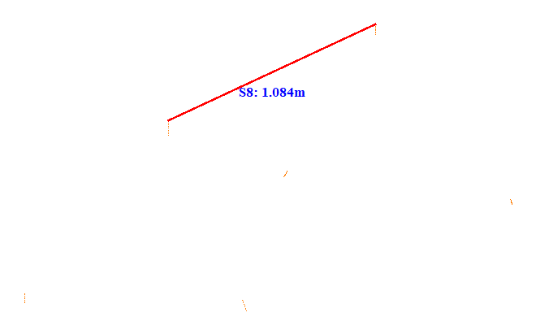

No. | Span | ID dan Lokasi Fasa | Nilai (m) (m) | Jarak Ke Menara Kecil (m)
182 | 69-70(69_70) | S9(RightDownFasaPowerLineAndLeftUpFasaPowerLine) | 1.799 | 27.197
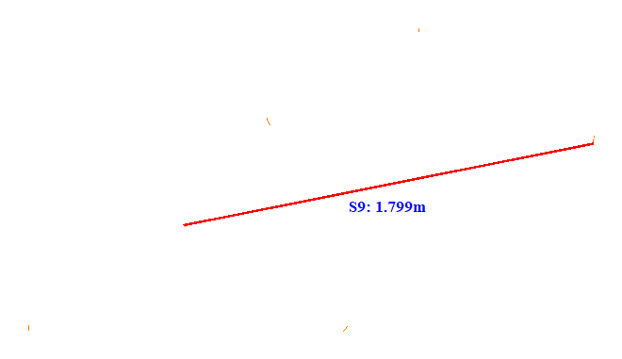

No. | Span | ID dan Lokasi Fasa | Nilai (m) (m) | Jarak Ke Menara Kecil (m)
183 | 70-71(70_71) | S1(LeftUpFasaPowerLineAndLeftDownFasaPowerLine) | 1.377 | 50.856
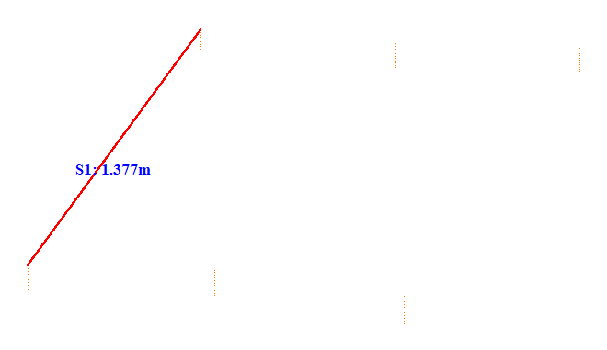

No. | Span | ID dan Lokasi Fasa | Nilai (m) (m) | Jarak Ke Menara Kecil (m)
184 | 70-71(70_71) | S2(Fasa Kanan Tengah ke Fasa Kanan Bawah) | 1.327 | 5.231
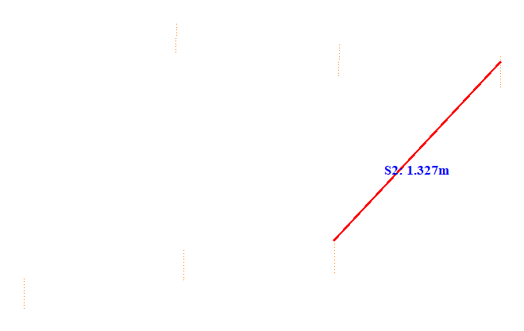

No. | Span | ID dan Lokasi Fasa | Nilai (m) (m) | Jarak Ke Menara Kecil (m)
185 | 70-71(70_71) | S3(Fasa Kiri Atas ke Fasa Kiri Tengah) | 1.135 | 50.851
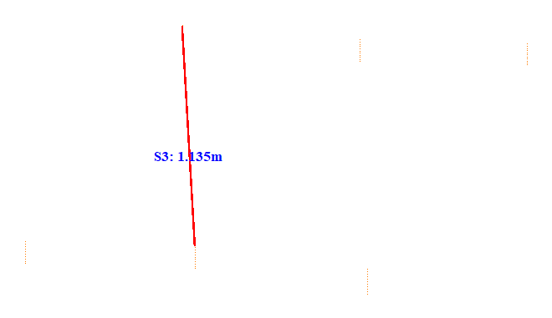

No. | Span | ID dan Lokasi Fasa | Nilai (m) (m) | Jarak Ke Menara Kecil (m)
186 | 70-71(70_71) | S4(RightMiddleFasaPowerLineAndLeftMiddleFasaPowerLine) | 2.005 | 50.853
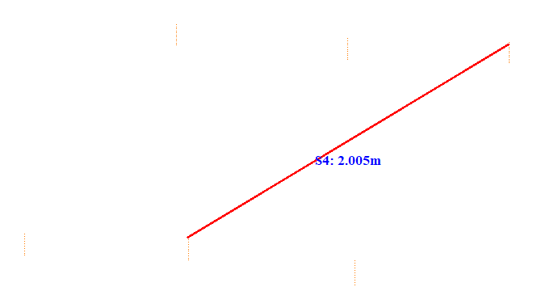

No. | Span | ID dan Lokasi Fasa | Nilai (m) (m) | Jarak Ke Menara Kecil (m)
187 | 71-72(71_72) | S1(Fasa Kiri Atas ke Fasa Kiri Tengah) | 1.375 | 5.224
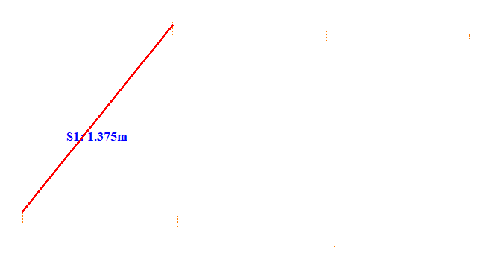

No. | Span | ID dan Lokasi Fasa | Nilai (m) (m) | Jarak Ke Menara Kecil (m)
188 | 71-72(71_72) | S2(RightUpFasaPowerLineAndRightDownFasaPowerLine) | 1.317 | 36.661
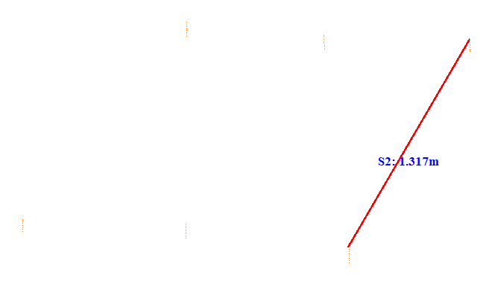

No. | Span | ID dan Lokasi Fasa | Nilai (m) (m) | Jarak Ke Menara Kecil (m)
189 | 71-72(71_72) | S3(LeftUpFasaPowerLineAndLeftDownFasaPowerLine) | 1.099 | 36.653
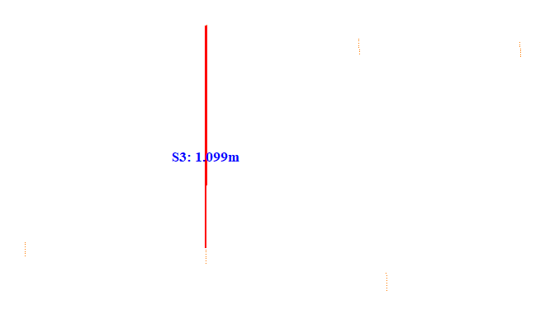

No. | Span | ID dan Lokasi Fasa | Nilai (m) (m) | Jarak Ke Menara Kecil (m)
190 | 71-72(71_72) | S4(RightUpFasaPowerLineAndLeftDownFasaPowerLine) | 1.857 | 36.654
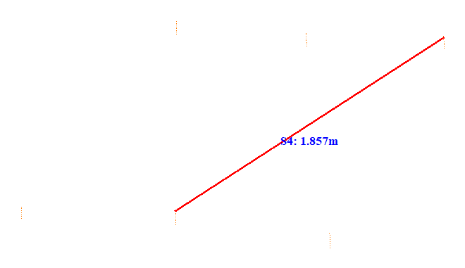

No. | Span | ID dan Lokasi Fasa | Nilai (m) (m) | Jarak Ke Menara Kecil (m)
191 | 72-73(72_73) | S1(Fasa Kiri Atas ke Fasa Kiri Tengah) | 1.490 | 5.128
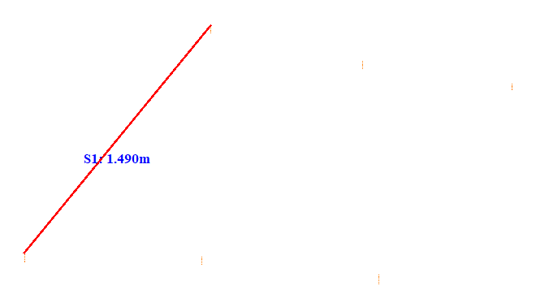

No. | Span | ID dan Lokasi Fasa | Nilai (m) (m) | Jarak Ke Menara Kecil (m)
192 | 72-73(72_73) | S2(Fasa Kanan Tengah ke Fasa Kanan Bawah) | 1.178 | 5.106
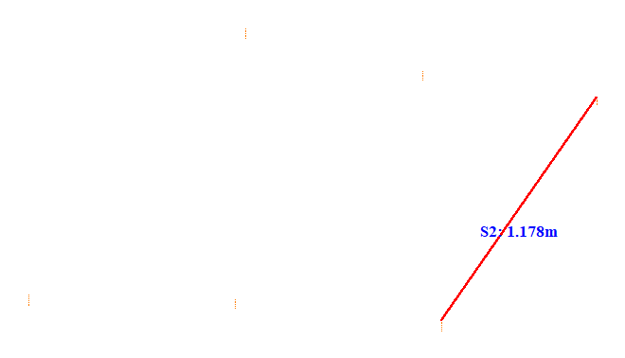

No. | Span | ID dan Lokasi Fasa | Nilai (m) (m) | Jarak Ke Menara Kecil (m)
193 | 72-73(72_73) | S3(LeftUpFasaPowerLineAndLeftDownFasaPowerLine) | 1.145 | 29.153
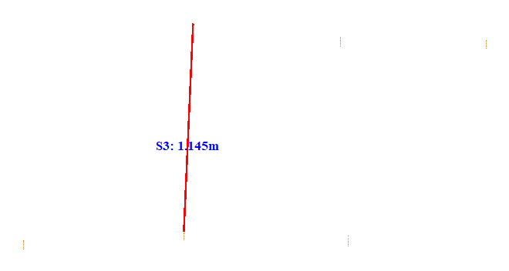

No. | Span | ID dan Lokasi Fasa | Nilai (m) (m) | Jarak Ke Menara Kecil (m)
194 | 72-73(72_73) | S4(RightMiddleFasaPowerLineAndLeftDownFasaPowerLine) | 1.798 | 5.108
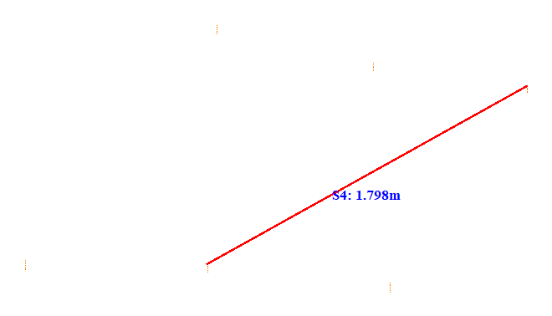

No. | Span | ID dan Lokasi Fasa | Nilai (m) (m) | Jarak Ke Menara Kecil (m)
195 | 73-74(73_74) | S1(LeftUpFasaPowerLineAndLeftDownFasaPowerLine) | 1.589 | 42.910
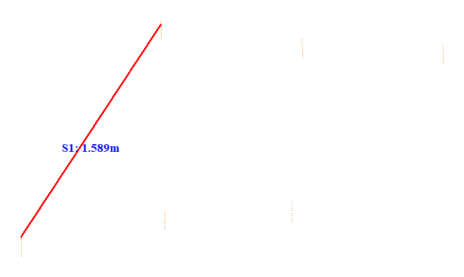

No. | Span | ID dan Lokasi Fasa | Nilai (m) (m) | Jarak Ke Menara Kecil (m)
196 | 73-74(73_74) | S2(Fasa Kanan Tengah ke Fasa Kanan Bawah) | 1.288 | 5.116
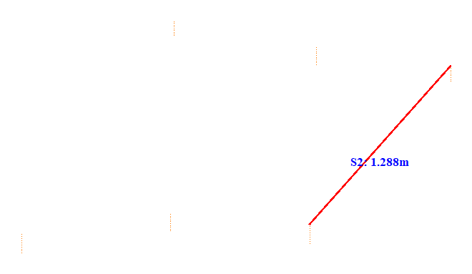

No. | Span | ID dan Lokasi Fasa | Nilai (m) (m) | Jarak Ke Menara Kecil (m)
197 | 73-74(73_74) | S3(Fasa Kiri Atas ke Fasa Kiri Tengah) | 1.172 | 5.069
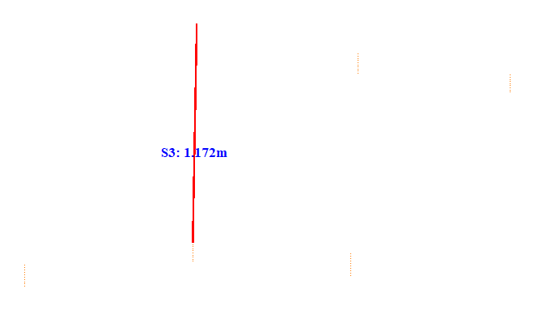

No. | Span | ID dan Lokasi Fasa | Nilai (m) (m) | Jarak Ke Menara Kecil (m)
198 | 73-74(73_74) | S4(RightMiddleFasaPowerLineAndLeftMiddleFasaPowerLine) | 1.924 | 5.065
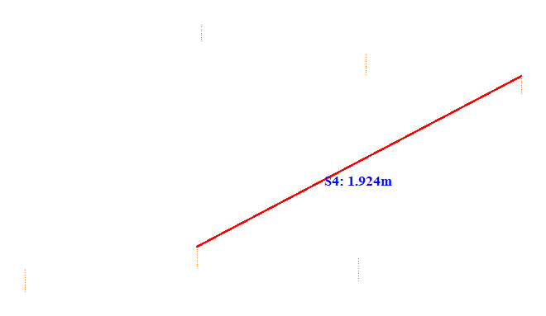

No. | Span | ID dan Lokasi Fasa | Nilai (m) (m) | Jarak Ke Menara Kecil (m)
199 | 74-75(74_75) | S1(LeftUpFasaPowerLineAndLeftDownFasaPowerLine) | 1.438 | 38.161
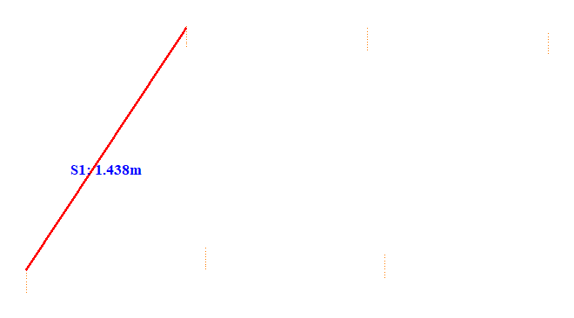

No. | Span | ID dan Lokasi Fasa | Nilai (m) (m) | Jarak Ke Menara Kecil (m)
200 | 74-75(74_75) | S2(Fasa Kanan Tengah ke Fasa Kanan Bawah) | 1.253 | 5.223
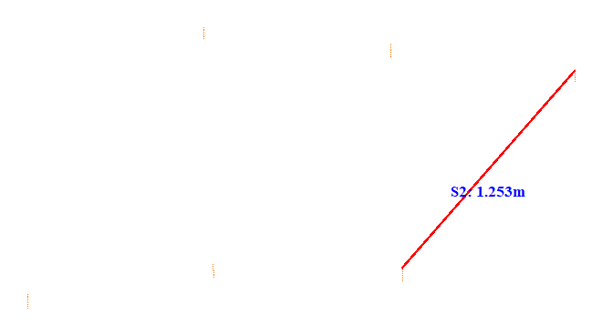

No. | Span | ID dan Lokasi Fasa | Nilai (m) (m) | Jarak Ke Menara Kecil (m)
201 | 74-75(74_75) | S3(Fasa Kiri Atas ke Fasa Kiri Tengah) | 1.098 | 38.153
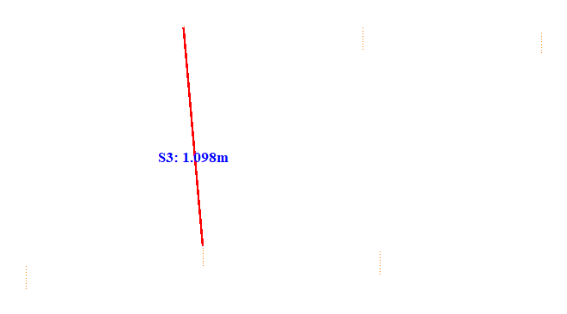

No. | Span | ID dan Lokasi Fasa | Nilai (m) (m) | Jarak Ke Menara Kecil (m)
202 | 74-75(74_75) | S4(RightMiddleFasaPowerLineAndLeftMiddleFasaPowerLine) | 1.944 | 17.805
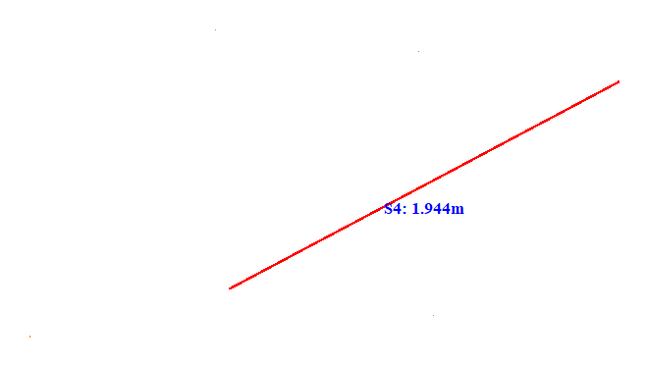

No. | Span | ID dan Lokasi Fasa | Nilai (m) (m) | Jarak Ke Menara Kecil (m)
203 | 75-76(75_76) | S1(LeftUpFasaPowerLineAndLeftDownFasaPowerLine) | 1.470 | 5.225
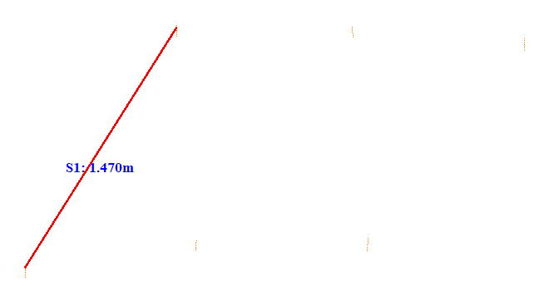

No. | Span | ID dan Lokasi Fasa | Nilai (m) (m) | Jarak Ke Menara Kecil (m)
204 | 75-76(75_76) | S2(Fasa Kanan Tengah ke Fasa Kanan Bawah) | 1.295 | 20.120
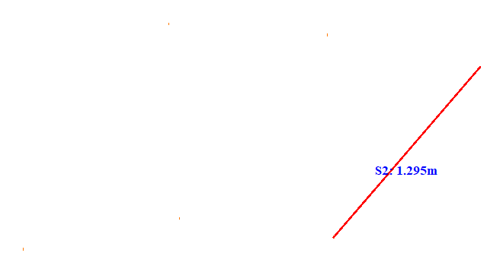

No. | Span | ID dan Lokasi Fasa | Nilai (m) (m) | Jarak Ke Menara Kecil (m)
205 | 75-76(75_76) | S3(Fasa Kiri Atas ke Fasa Kiri Tengah) | 1.107 | 34.153
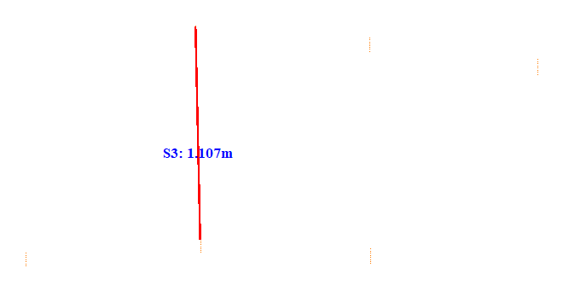

No. | Span | ID dan Lokasi Fasa | Nilai (m) (m) | Jarak Ke Menara Kecil (m)
206 | 75-76(75_76) | S4(RightMiddleFasaPowerLineAndLeftMiddleFasaPowerLine) | 1.940 | 19.505
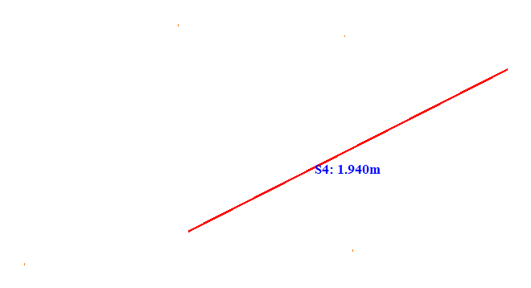

No. | Span | ID dan Lokasi Fasa | Nilai (m) (m) | Jarak Ke Menara Kecil (m)
207 | 76-77(76_77) | S1(LeftUpFasaPowerLineAndLeftDownFasaPowerLine) | 1.494 | 39.461
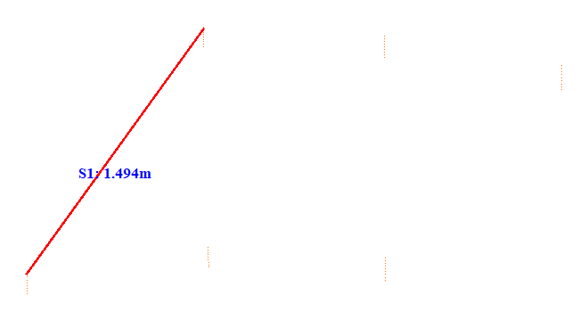

No. | Span | ID dan Lokasi Fasa | Nilai (m) (m) | Jarak Ke Menara Kecil (m)
208 | 76-77(76_77) | S2(Fasa Kanan Tengah ke Fasa Kanan Bawah) | 1.193 | 19.919
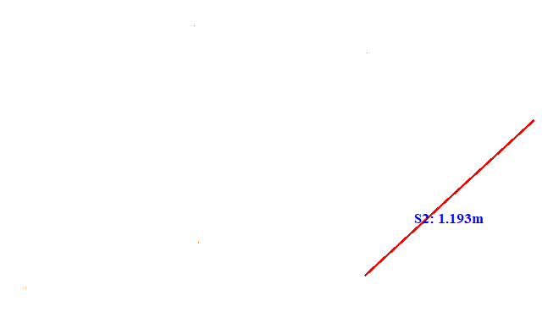

No. | Span | ID dan Lokasi Fasa | Nilai (m) (m) | Jarak Ke Menara Kecil (m)
209 | 76-77(76_77) | S3(Fasa Kiri Atas ke Fasa Kiri Tengah) | 1.079 | 39.453
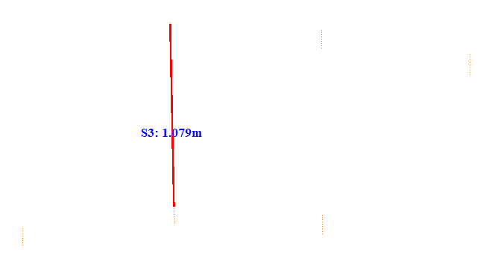

No. | Span | ID dan Lokasi Fasa | Nilai (m) (m) | Jarak Ke Menara Kecil (m)
210 | 76-77(76_77) | S4(RightMiddleFasaPowerLineAndLeftMiddleFasaPowerLine) | 1.866 | 21.805
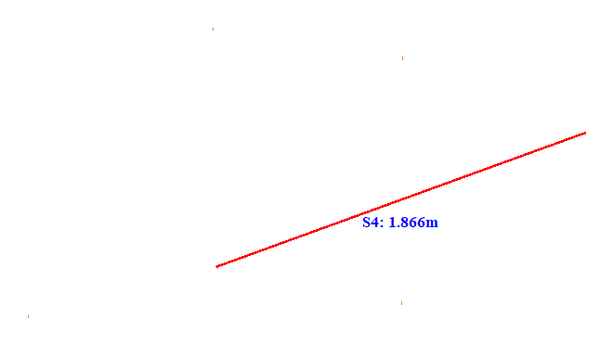

No. | Span | ID dan Lokasi Fasa | Nilai (m) (m) | Jarak Ke Menara Kecil (m)
211 | 77-78(77_78) | S1(LeftUpFasaPowerLineAndLeftDownFasaPowerLine) | 1.344 | 36.864
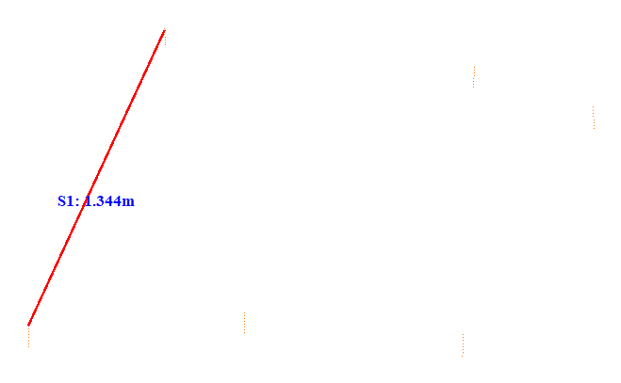

No. | Span | ID dan Lokasi Fasa | Nilai (m) (m) | Jarak Ke Menara Kecil (m)
212 | 77-78(77_78) | S2(Fasa Kanan Tengah ke Fasa Kanan Bawah) | 1.076 | 36.860
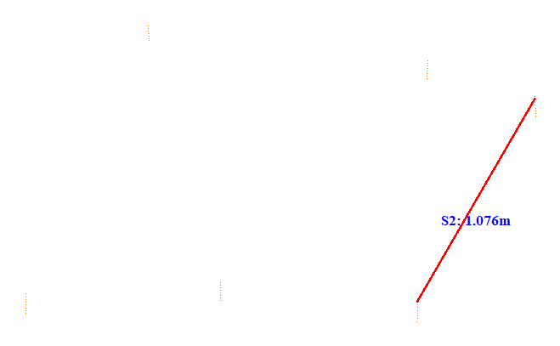

No. | Span | ID dan Lokasi Fasa | Nilai (m) (m) | Jarak Ke Menara Kecil (m)
213 | 77-78(77_78) | S3(Fasa Kiri Atas ke Fasa Kiri Tengah) | 1.114 | 5.077
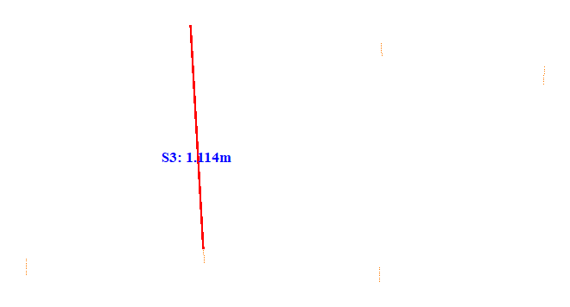

No. | Span | ID dan Lokasi Fasa | Nilai (m) (m) | Jarak Ke Menara Kecil (m)
214 | 77-78(77_78) | S4(RightMiddleFasaPowerLineAndLeftMiddleFasaPowerLine) | 1.670 | 36.855
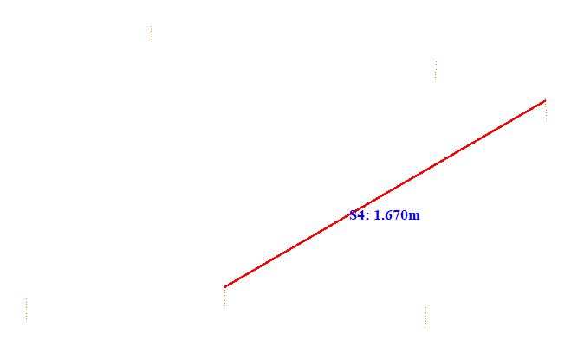

No. | Span | ID dan Lokasi Fasa | Nilai (m) (m) | Jarak Ke Menara Kecil (m)
215 | 78-79(78_79) | S1(LeftUpFasaPowerLineAndLeftDownFasaPowerLine) | 1.360 | 5.155
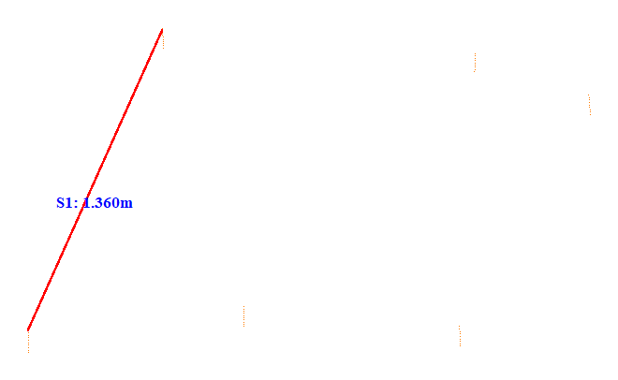

No. | Span | ID dan Lokasi Fasa | Nilai (m) (m) | Jarak Ke Menara Kecil (m)
216 | 78-79(78_79) | S2(Fasa Kanan Tengah ke Fasa Kanan Bawah) | 1.090 | 5.201
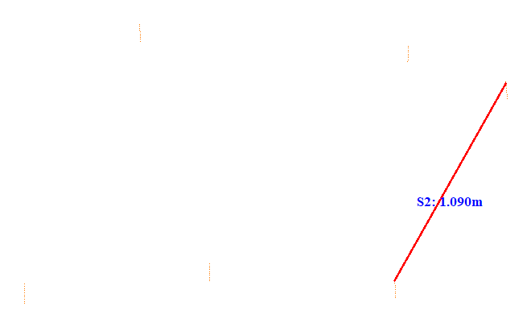

No. | Span | ID dan Lokasi Fasa | Nilai (m) (m) | Jarak Ke Menara Kecil (m)
217 | 78-79(78_79) | S3(Fasa Kiri Atas ke Fasa Kiri Tengah) | 1.032 | 41.855
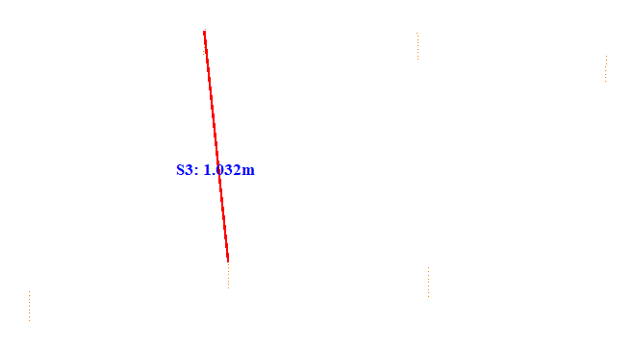

No. | Span | ID dan Lokasi Fasa | Nilai (m) (m) | Jarak Ke Menara Kecil (m)
218 | 78-79(78_79) | S4(RightMiddleFasaPowerLineAndLeftMiddleFasaPowerLine) | 1.674 | 5.056
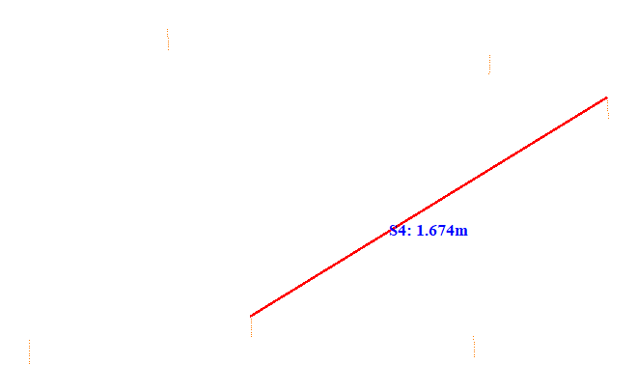

No. | Span | ID dan Lokasi Fasa | Nilai (m) (m) | Jarak Ke Menara Kecil (m)
219 | 79-80(79_80) | S1(LeftUpFasaPowerLineAndLeftDownFasaPowerLine) | 1.352 | 5.223
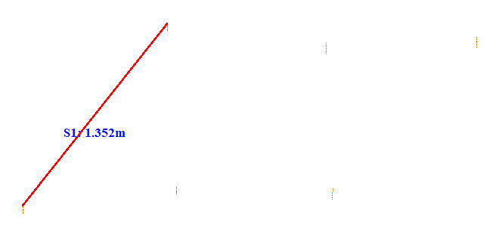

No. | Span | ID dan Lokasi Fasa | Nilai (m) (m) | Jarak Ke Menara Kecil (m)
220 | 79-80(79_80) | S2(RightUpFasaPowerLineAndRightDownFasaPowerLine) | 1.211 | 5.134
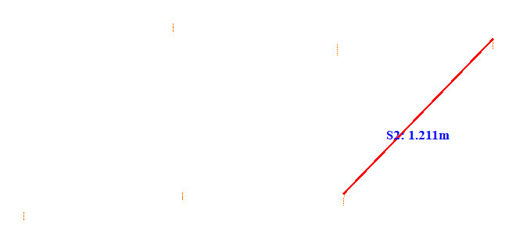

No. | Span | ID dan Lokasi Fasa | Nilai (m) (m) | Jarak Ke Menara Kecil (m)
221 | 79-80(79_80) | S3(Fasa Kiri Atas ke Fasa Kiri Tengah) | 0.944 | 12.907
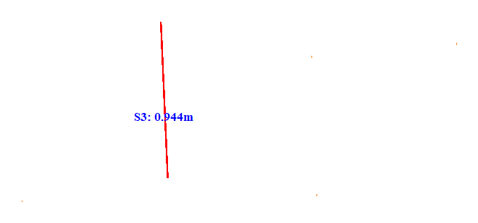

No. | Span | ID dan Lokasi Fasa | Nilai (m) (m) | Jarak Ke Menara Kecil (m)
222 | 79-80(79_80) | S4(RightUpFasaPowerLineAndLeftMiddleFasaPowerLine) | 1.933 | 15.007
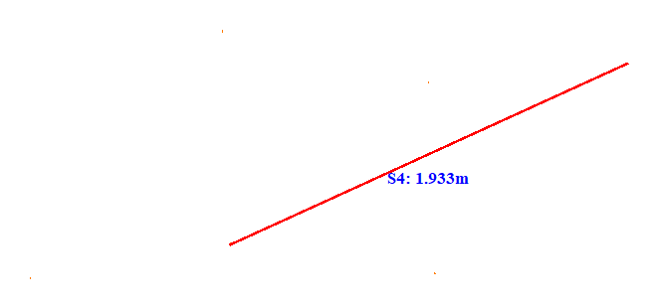

No. | Span | ID dan Lokasi Fasa | Nilai (m) (m) | Jarak Ke Menara Kecil (m)
223 | 80-81(80_81) | S1(LeftUpFasaPowerLineAndLeftDownFasaPowerLine) | 1.313 | 37.812
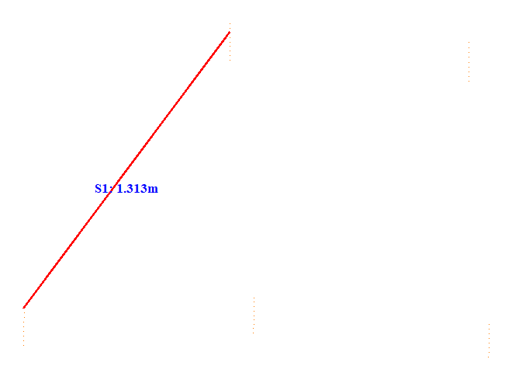

No. | Span | ID dan Lokasi Fasa | Nilai (m) (m) | Jarak Ke Menara Kecil (m)
224 | 80-81(80_81) | S2(Fasa Kanan Tengah ke Fasa Kanan Bawah) | 0.985 | 11.408
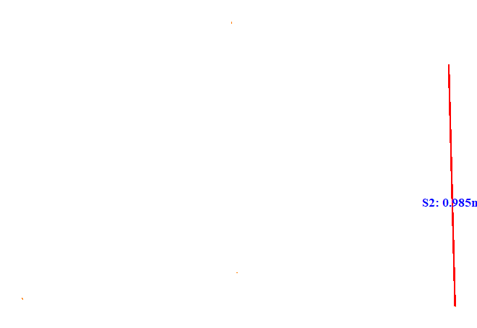

No. | Span | ID dan Lokasi Fasa | Nilai (m) (m) | Jarak Ke Menara Kecil (m)
225 | 80-81(80_81) | S3(Fasa Kiri Atas ke Fasa Kiri Tengah) | 0.997 | 25.155
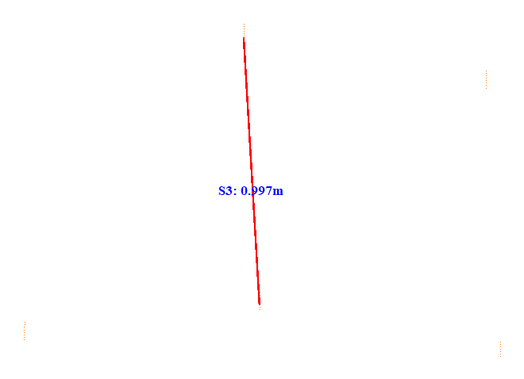

No. | Span | ID dan Lokasi Fasa | Nilai (m) (m) | Jarak Ke Menara Kecil (m)
226 | 80-81(80_81) | S4(RightMiddleFasaPowerLineAndLeftMiddleFasaPowerLine) | 1.174 | 23.251
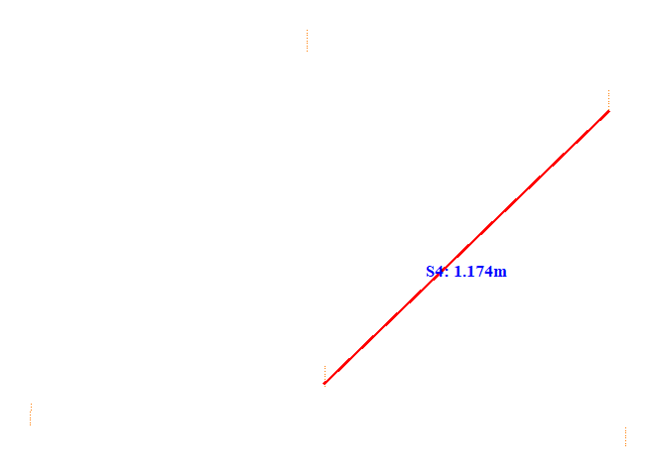

No. | Span | ID dan Lokasi Fasa | Nilai (m) (m) | Jarak Ke Menara Kecil (m)
227 | 81-82(81_82) | S1(LeftUpFasaPowerLineAndLeftDownFasaPowerLine) | 1.328 | 37.560
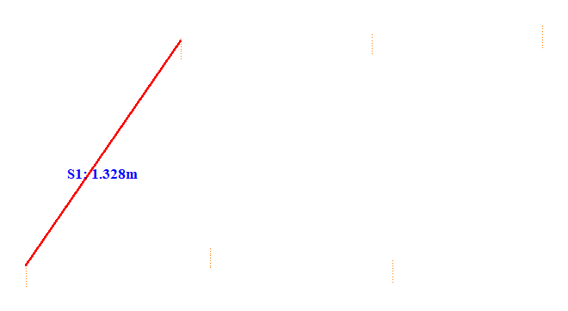

No. | Span | ID dan Lokasi Fasa | Nilai (m) (m) | Jarak Ke Menara Kecil (m)
228 | 81-82(81_82) | S2(Fasa Kanan Tengah ke Fasa Kanan Bawah) | 1.297 | 5.227
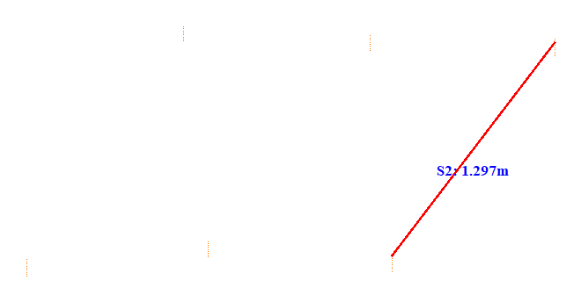

No. | Span | ID dan Lokasi Fasa | Nilai (m) (m) | Jarak Ke Menara Kecil (m)
229 | 81-82(81_82) | S3(Fasa Kiri Atas ke Fasa Kiri Tengah) | 1.014 | 24.904
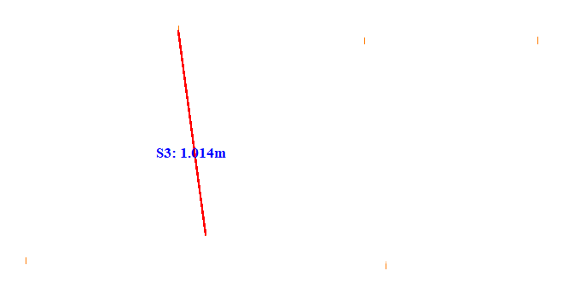

No. | Span | ID dan Lokasi Fasa | Nilai (m) (m) | Jarak Ke Menara Kecil (m)
230 | 81-82(81_82) | S4(RightMiddleFasaPowerLineAndLeftMiddleFasaPowerLine) | 1.887 | 21.305
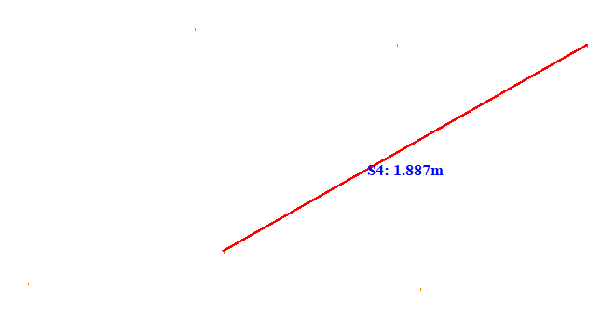

No. | Span | ID dan Lokasi Fasa | Nilai (m) (m) | Jarak Ke Menara Kecil (m)
231 | 82-83(82_83) | S1(LeftUpFasaPowerLineAndLeftDownFasaPowerLine) | 1.153 | 22.568
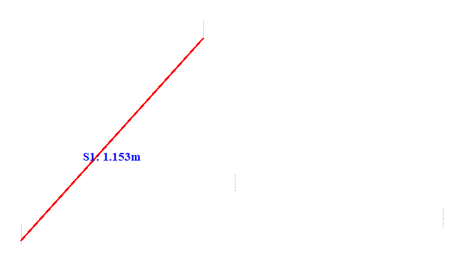

No. | Span | ID dan Lokasi Fasa | Nilai (m) (m) | Jarak Ke Menara Kecil (m)
232 | 82-83(82_83) | S2(LeftUpFasaPowerLineAndRightDownFasaPowerLine) | 1.288 | 22.850
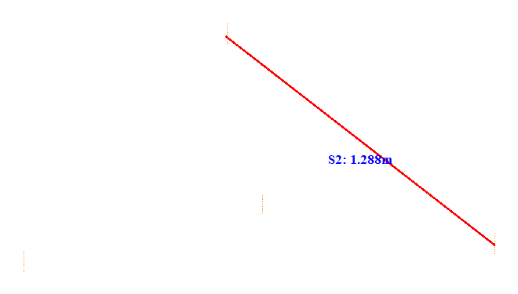

No. | Span | ID dan Lokasi Fasa | Nilai (m) (m) | Jarak Ke Menara Kecil (m)
233 | 82-83(82_83) | S3(Fasa Kiri Atas ke Fasa Kiri Tengah) | 0.662 | 23.054
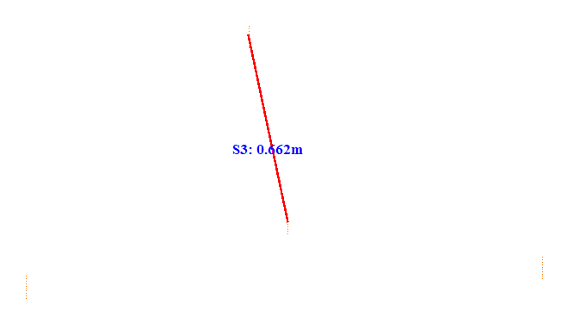

No. | Span | ID dan Lokasi Fasa | Nilai (m) (m) | Jarak Ke Menara Kecil (m)
234 | 83-84(83_84) | S1(LeftUpFasaPowerLineAndLeftDownFasaPowerLine) | 1.010 | 32.864
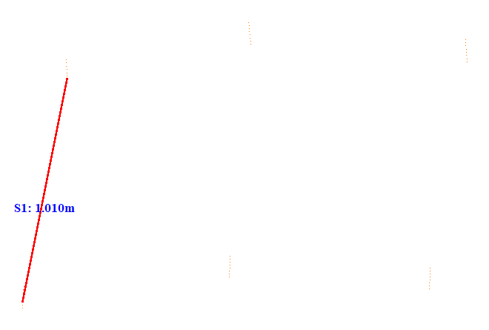

No. | Span | ID dan Lokasi Fasa | Nilai (m) (m) | Jarak Ke Menara Kecil (m)
235 | 83-84(83_84) | S2(Fasa Kanan Tengah ke Fasa Kanan Bawah) | 1.005 | 30.466
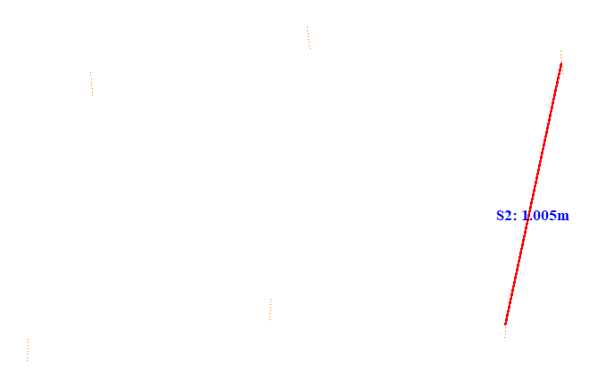

No. | Span | ID dan Lokasi Fasa | Nilai (m) (m) | Jarak Ke Menara Kecil (m)
236 | 83-84(83_84) | S3(Fasa Kiri Atas ke Fasa Kiri Tengah) | 0.908 | 14.106
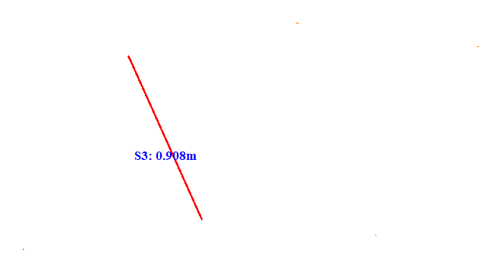

No. | Span | ID dan Lokasi Fasa | Nilai (m) (m) | Jarak Ke Menara Kecil (m)
237 | 83-84(83_84) | S4(RightMiddleFasaPowerLineAndLeftMiddleFasaPowerLine) | 1.379 | 37.609
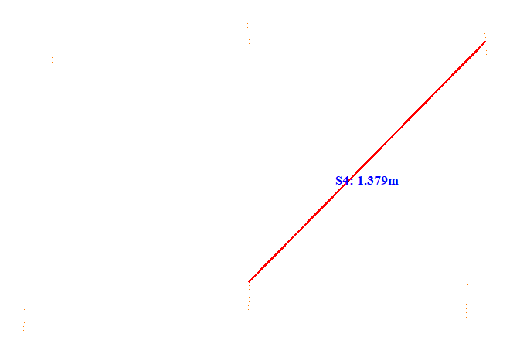

No. | Span | ID dan Lokasi Fasa | Nilai (m) (m) | Jarak Ke Menara Kecil (m)
238 | 85-86(85_86) | S1(LeftUpFasaPowerLineAndLeftDownFasaPowerLine) | 1.054 | 5.278
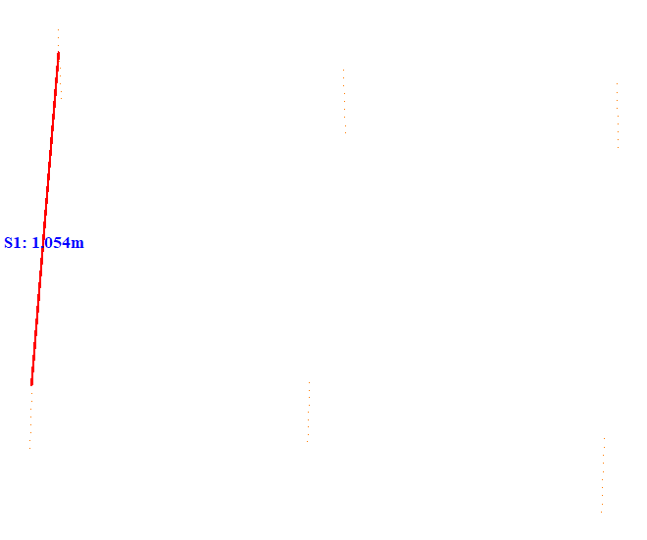

No. | Span | ID dan Lokasi Fasa | Nilai (m) (m) | Jarak Ke Menara Kecil (m)
239 | 85-86(85_86) | S2(Fasa Kanan Tengah ke Fasa Kanan Bawah) | 0.879 | 42.357
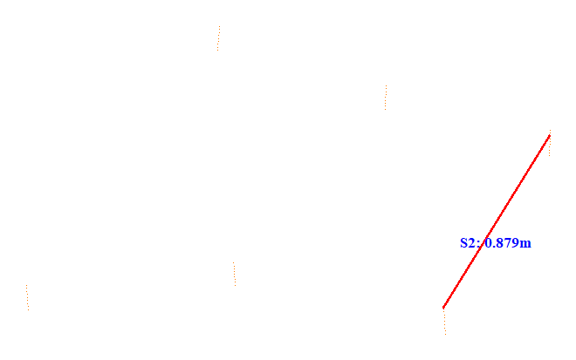

No. | Span | ID dan Lokasi Fasa | Nilai (m) (m) | Jarak Ke Menara Kecil (m)
240 | 85-86(85_86) | S3(Fasa Kiri Atas ke Fasa Kiri Tengah) | 0.994 | 35.455
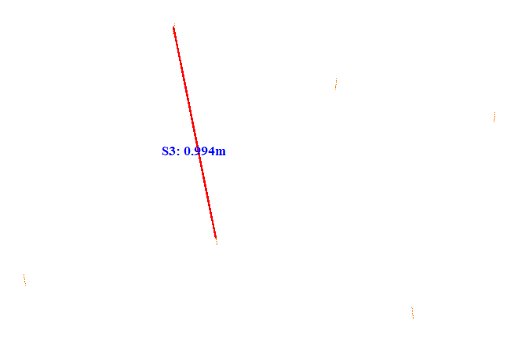

No. | Span | ID dan Lokasi Fasa | Nilai (m) (m) | Jarak Ke Menara Kecil (m)
241 | 85-86(85_86) | S4(RightMiddleFasaPowerLineAndLeftMiddleFasaPowerLine) | 1.294 | 13.052
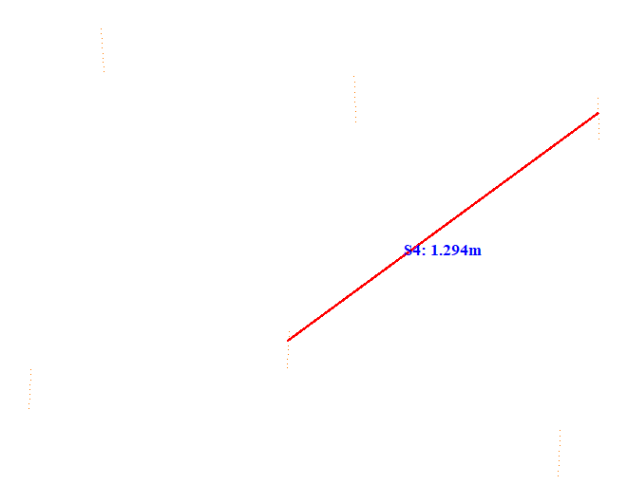

No. | Span | ID dan Lokasi Fasa | Nilai (m) (m) | Jarak Ke Menara Kecil (m)
242 | 85-86(85_86) | S5(LeftDownFasaPowerLineAndRightDownFasaPowerLine) | 1.793 | 15.699
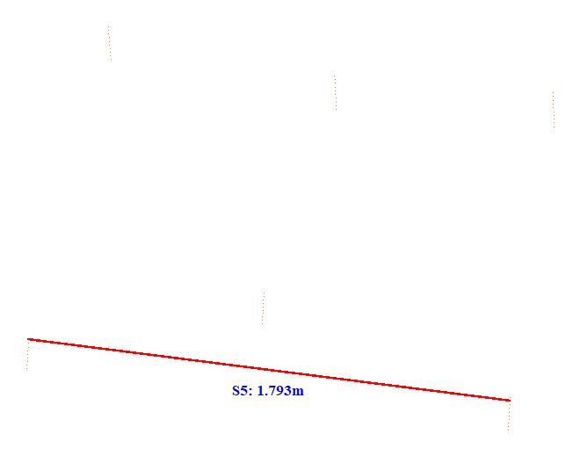

No. | Span | ID dan Lokasi Fasa | Nilai (m) (m) | Jarak Ke Menara Kecil (m)
243 | 85-86(85_86) | S6(LeftMiddleFasaPowerLineAndRightDownFasaPowerLine) | 0.988 | 15.604
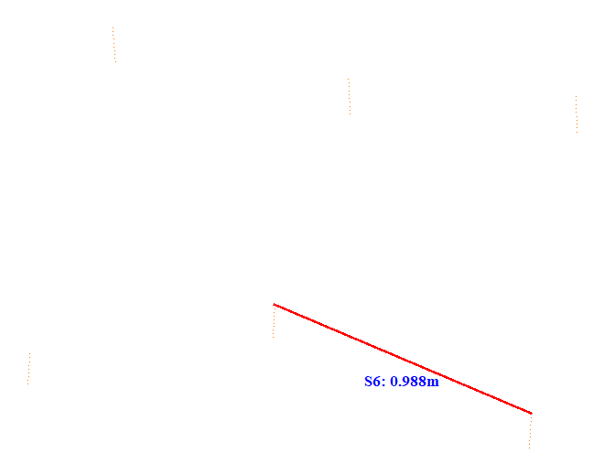

No. | Span | ID dan Lokasi Fasa | Nilai (m) (m) | Jarak Ke Menara Kecil (m)
244 | 85-86(85_86) | S7(LeftUpFasaPowerLineAndRightMiddleFasaPowerLine) | 1.498 | 42.452
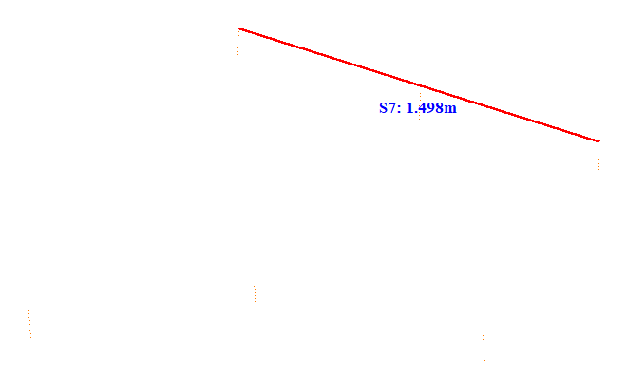

No. | Span | ID dan Lokasi Fasa | Nilai (m) (m) | Jarak Ke Menara Kecil (m)
245 | 85-86(85_86) | S8(Fasa Kanan Atas ke Fasa Kanan Tengah) | 0.736 | 42.402
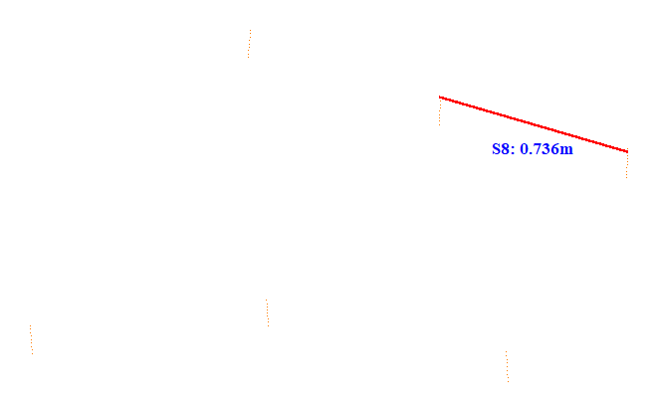

No. | Span | ID dan Lokasi Fasa | Nilai (m) (m) | Jarak Ke Menara Kecil (m)
246 | 85-86(85_86) | S9(RightMiddleFasaPowerLineAndLeftDownFasaPowerLine) | 2.341 | 40.643
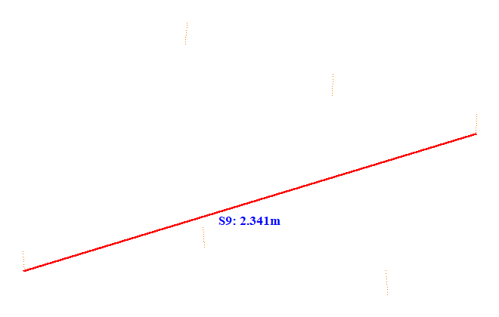

No. | Span | ID dan Lokasi Fasa | Nilai (m) (m) | Jarak Ke Menara Kecil (m)
247 | 86-87(86_87) | S1(LeftUpFasaPowerLineAndLeftDownFasaPowerLine) | 1.268 | 32.761
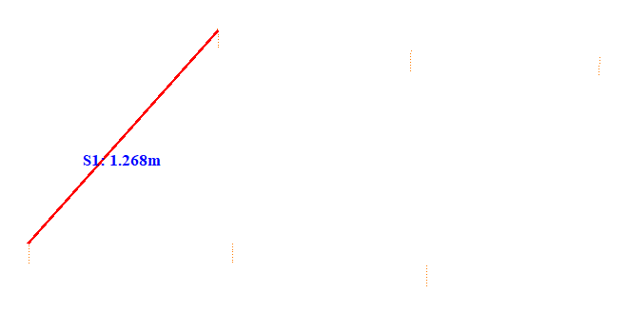

No. | Span | ID dan Lokasi Fasa | Nilai (m) (m) | Jarak Ke Menara Kecil (m)
248 | 86-87(86_87) | S2(Fasa Kanan Tengah ke Fasa Kanan Bawah) | 1.058 | 5.102
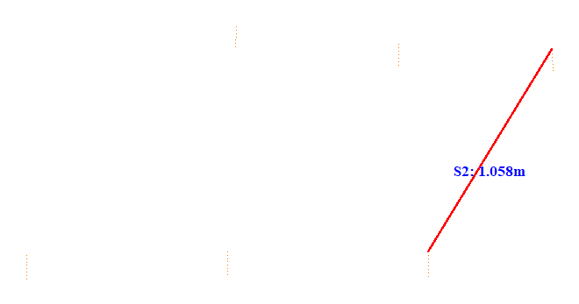

No. | Span | ID dan Lokasi Fasa | Nilai (m) (m) | Jarak Ke Menara Kecil (m)
249 | 86-87(86_87) | S3(Fasa Kiri Atas ke Fasa Kiri Tengah) | 0.954 | 32.752
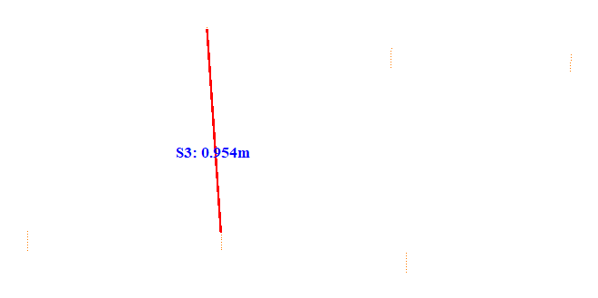

No. | Span | ID dan Lokasi Fasa | Nilai (m) (m) | Jarak Ke Menara Kecil (m)
250 | 86-87(86_87) | S4(RightMiddleFasaPowerLineAndLeftMiddleFasaPowerLine) | 1.704 | 5.056
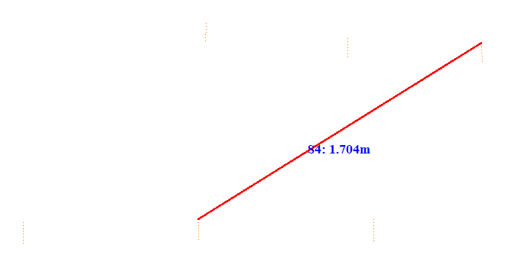

No. | Span | ID dan Lokasi Fasa | Nilai (m) (m) | Jarak Ke Menara Kecil (m)
251 | 87-88(87_88) | S1(LeftUpFasaPowerLineAndLeftDownFasaPowerLine) | 1.065 | 28.866
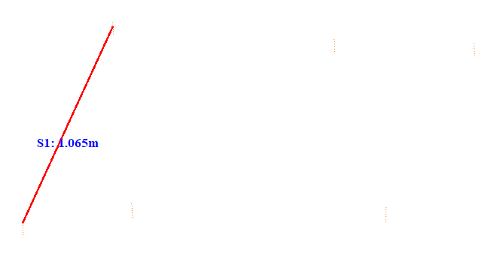

No. | Span | ID dan Lokasi Fasa | Nilai (m) (m) | Jarak Ke Menara Kecil (m)
252 | 87-88(87_88) | S2(Fasa Kanan Tengah ke Fasa Kanan Bawah) | 0.916 | 28.966
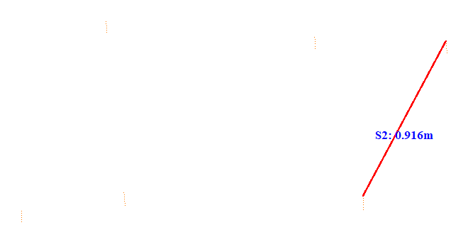

No. | Span | ID dan Lokasi Fasa | Nilai (m) (m) | Jarak Ke Menara Kecil (m)
253 | 87-88(87_88) | S3(Fasa Kiri Atas ke Fasa Kiri Tengah) | 0.883 | 21.904
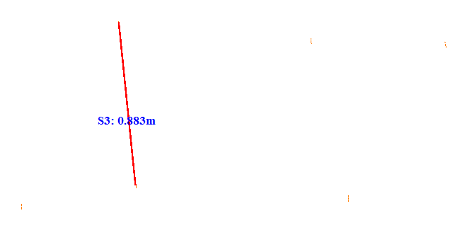

No. | Span | ID dan Lokasi Fasa | Nilai (m) (m) | Jarak Ke Menara Kecil (m)
254 | 87-88(87_88) | S4(RightMiddleFasaPowerLineAndLeftMiddleFasaPowerLine) | 1.850 | 20.805
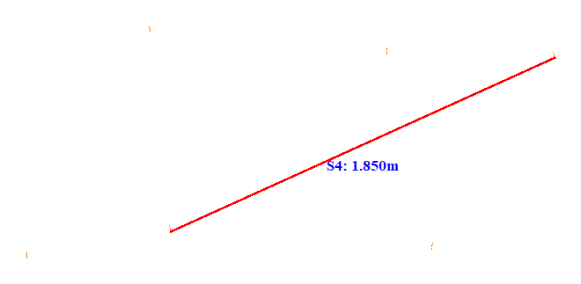

No. | Span | ID dan Lokasi Fasa | Nilai (m) (m) | Jarak Ke Menara Kecil (m)
255 | 88-89(88_89) | S1(LeftUpFasaPowerLineAndLeftDownFasaPowerLine) | 1.752 | 5.218
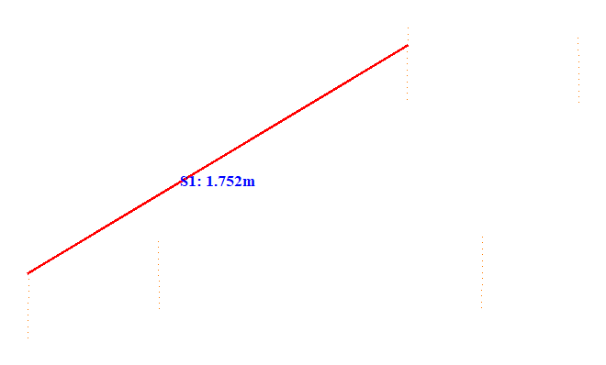

No. | Span | ID dan Lokasi Fasa | Nilai (m) (m) | Jarak Ke Menara Kecil (m)
256 | 88-89(88_89) | S2(Fasa Kanan Tengah ke Fasa Kanan Bawah) | 0.870 | 5.159
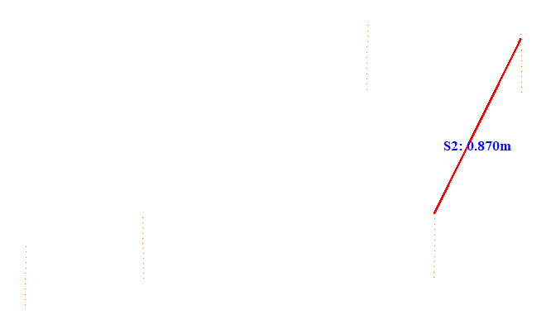

No. | Span | ID dan Lokasi Fasa | Nilai (m) (m) | Jarak Ke Menara Kecil (m)
257 | 88-89(88_89) | S3(Fasa Kiri Atas ke Fasa Kiri Tengah) | 1.069 | 35.202
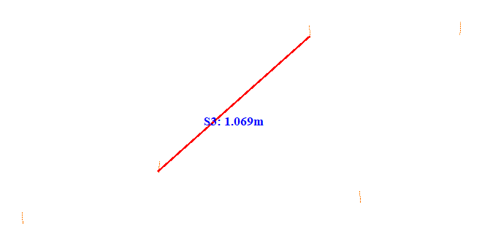

No. | Span | ID dan Lokasi Fasa | Nilai (m) (m) | Jarak Ke Menara Kecil (m)
258 | 88-89(88_89) | S4(RightMiddleFasaPowerLineAndLeftMiddleFasaPowerLine) | 1.750 | 32.401
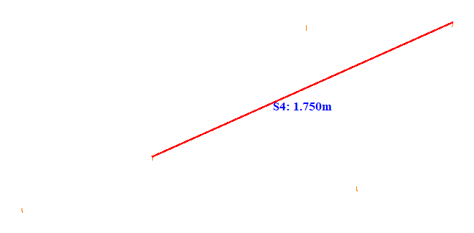

No. | Span | ID dan Lokasi Fasa | Nilai (m) (m) | Jarak Ke Menara Kecil (m)
259 | 89-90(89_90) | S1(LeftUpFasaPowerLineAndLeftDownFasaPowerLine) | 0.948 | 36.066
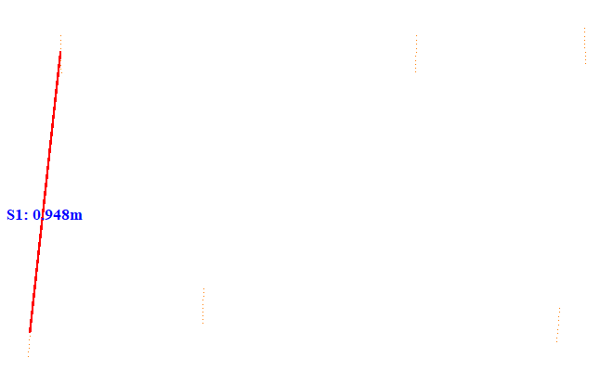

No. | Span | ID dan Lokasi Fasa | Nilai (m) (m) | Jarak Ke Menara Kecil (m)
260 | 89-90(89_90) | S2(RightUpFasaPowerLineAndRightDownFasaPowerLine) | 0.876 | 40.908
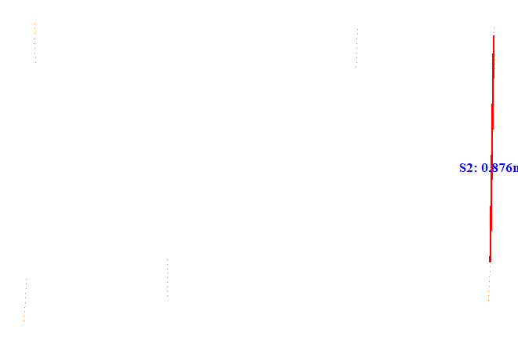

No. | Span | ID dan Lokasi Fasa | Nilai (m) (m) | Jarak Ke Menara Kecil (m)
261 | 89-90(89_90) | S3(Fasa Kiri Atas ke Fasa Kiri Tengah) | 0.906 | 24.107
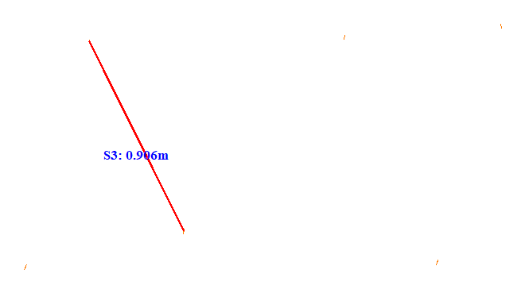

No. | Span | ID dan Lokasi Fasa | Nilai (m) (m) | Jarak Ke Menara Kecil (m)
262 | 89-90(89_90) | S4(RightUpFasaPowerLineAndLeftMiddleFasaPowerLine) | 1.516 | 40.953
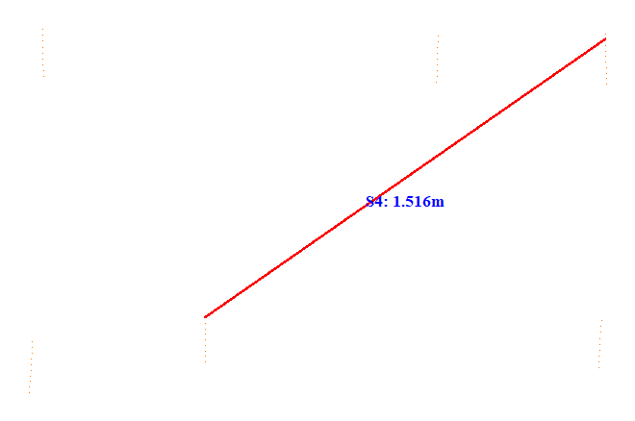

No. | Span | ID dan Lokasi Fasa | Nilai (m) (m) | Jarak Ke Menara Kecil (m)
263 | 90-91(90_91) | S1(LeftUpFasaPowerLineAndLeftDownFasaPowerLine) | 0.937 | 17.367
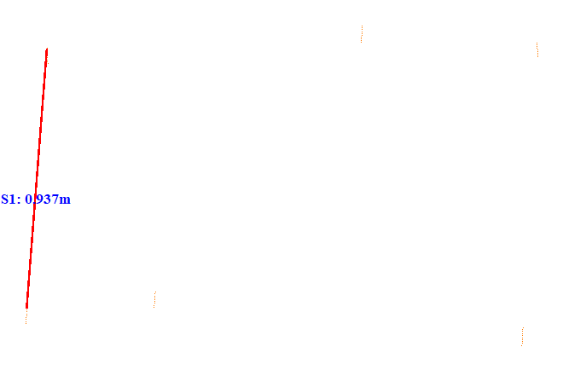

No. | Span | ID dan Lokasi Fasa | Nilai (m) (m) | Jarak Ke Menara Kecil (m)
264 | 90-91(90_91) | S2(Fasa Kanan Tengah ke Fasa Kanan Bawah) | 0.868 | 5.222
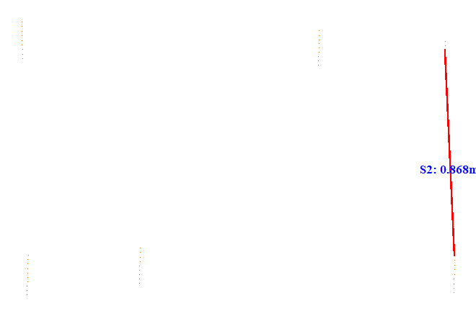

No. | Span | ID dan Lokasi Fasa | Nilai (m) (m) | Jarak Ke Menara Kecil (m)
265 | 90-91(90_91) | S3(Fasa Kiri Atas ke Fasa Kiri Tengah) | 0.929 | 28.625
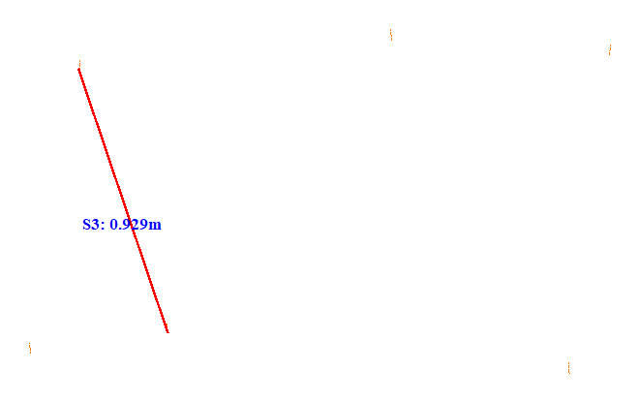

No. | Span | ID dan Lokasi Fasa | Nilai (m) (m) | Jarak Ke Menara Kecil (m)
266 | 90-91(90_91) | S4(RightMiddleFasaPowerLineAndLeftMiddleFasaPowerLine) | 1.519 | 5.137
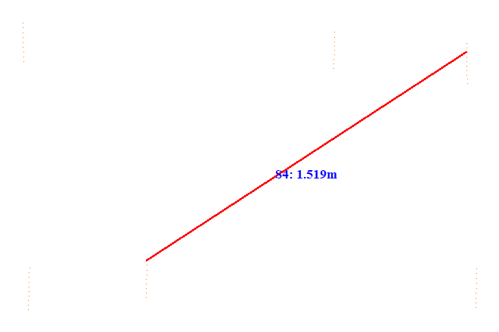

No. | Span | ID dan Lokasi Fasa | Nilai (m) (m) | Jarak Ke Menara Kecil (m)
267 | 91-92(91_92) | S1(LeftUpFasaPowerLineAndLeftDownFasaPowerLine) | 0.887 | 19.520
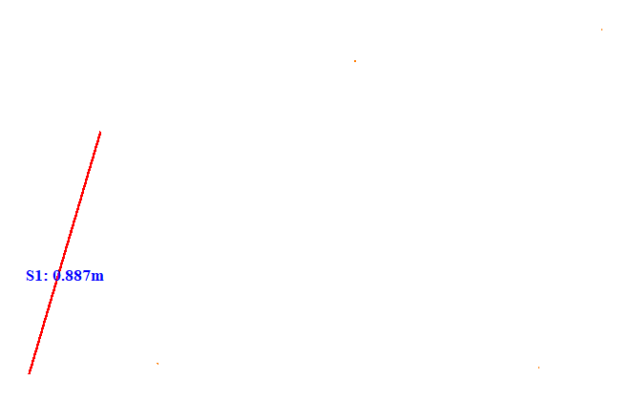

No. | Span | ID dan Lokasi Fasa | Nilai (m) (m) | Jarak Ke Menara Kecil (m)
268 | 91-92(91_92) | S2(RightUpFasaPowerLineAndRightDownFasaPowerLine) | 1.064 | 5.234
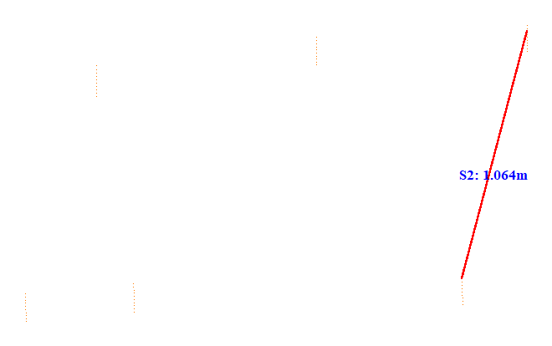

No. | Span | ID dan Lokasi Fasa | Nilai (m) (m) | Jarak Ke Menara Kecil (m)
269 | 91-92(91_92) | S3(Fasa Kiri Atas ke Fasa Kiri Tengah) | 0.842 | 17.689
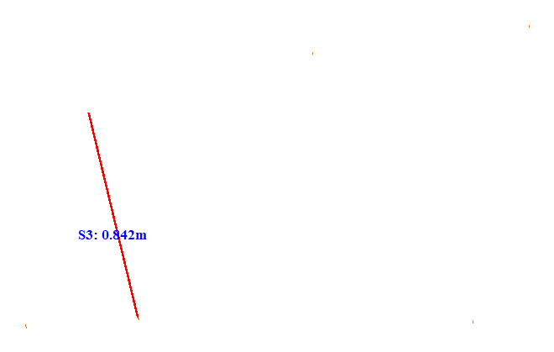

No. | Span | ID dan Lokasi Fasa | Nilai (m) (m) | Jarak Ke Menara Kecil (m)
270 | 91-92(91_92) | S4(RightUpFasaPowerLineAndLeftMiddleFasaPowerLine) | 1.914 | 42.630
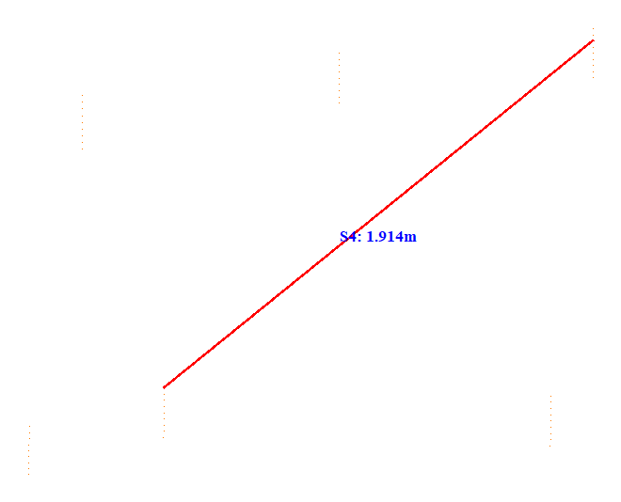

No. | Span | ID dan Lokasi Fasa | Nilai (m) (m) | Jarak Ke Menara Kecil (m)
271 | 92-93(92_93) | S1(LeftUpFasaPowerLineAndLeftDownFasaPowerLine) | 0.887 | 17.944
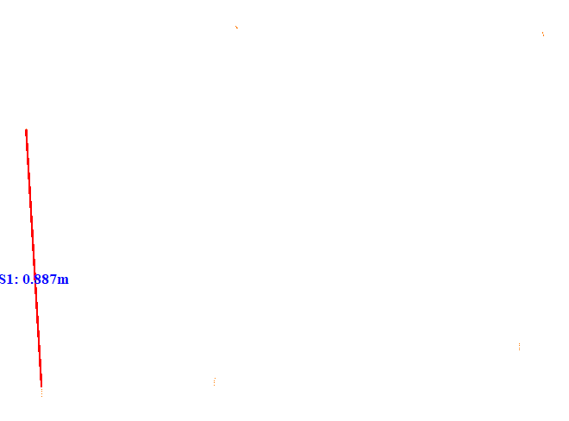

No. | Span | ID dan Lokasi Fasa | Nilai (m) (m) | Jarak Ke Menara Kecil (m)
272 | 92-93(92_93) | S2(Fasa Kanan Tengah ke Fasa Kanan Bawah) | 1.222 | 5.149
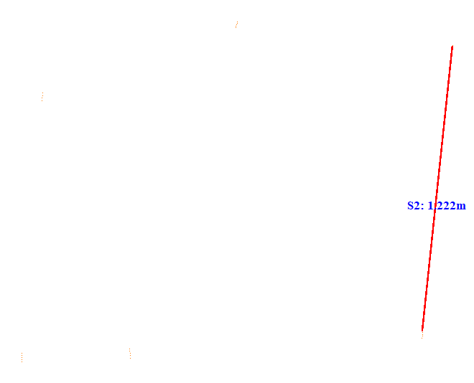

No. | Span | ID dan Lokasi Fasa | Nilai (m) (m) | Jarak Ke Menara Kecil (m)
273 | 92-93(92_93) | S3(Fasa Kiri Atas ke Fasa Kiri Tengah) | 1.074 | 17.931
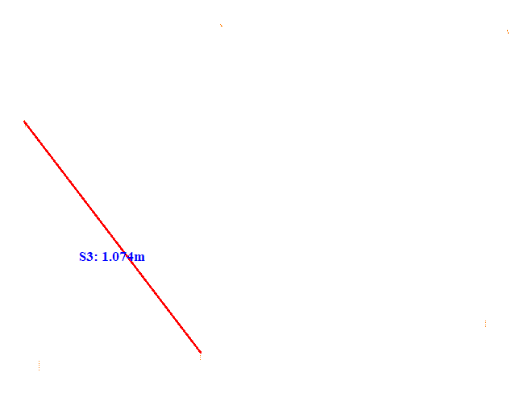

No. | Span | ID dan Lokasi Fasa | Nilai (m) (m) | Jarak Ke Menara Kecil (m)
274 | 92-93(92_93) | S4(RightMiddleFasaPowerLineAndLeftMiddleFasaPowerLine) | 1.887 | 5.094
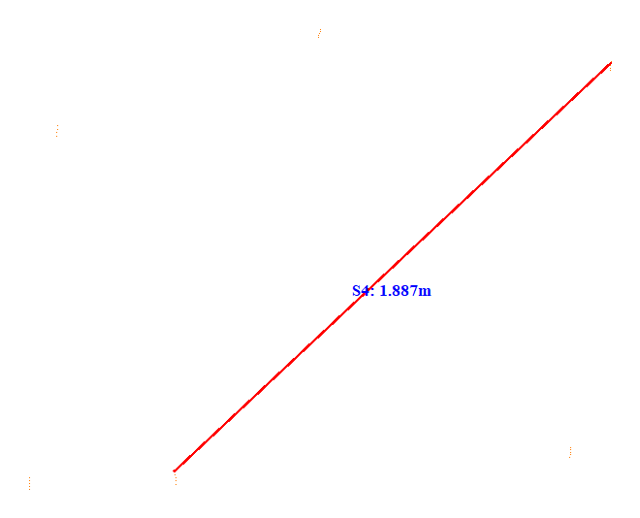

No. | Span | ID dan Lokasi Fasa | Nilai (m) (m) | Jarak Ke Menara Kecil (m)
275 | 92-93(92_93) | S5(RightUpFasaPowerLineAndLeftUpFasaPowerLine) | 0.808 | 17.903
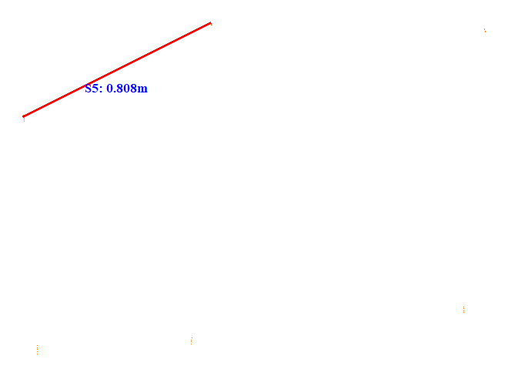

No. | Span | ID dan Lokasi Fasa | Nilai (m) (m) | Jarak Ke Menara Kecil (m)
276 | 92-93(92_93) | S6(RightMiddleFasaPowerLineAndLeftUpFasaPowerLine) | 1.773 | 6.902
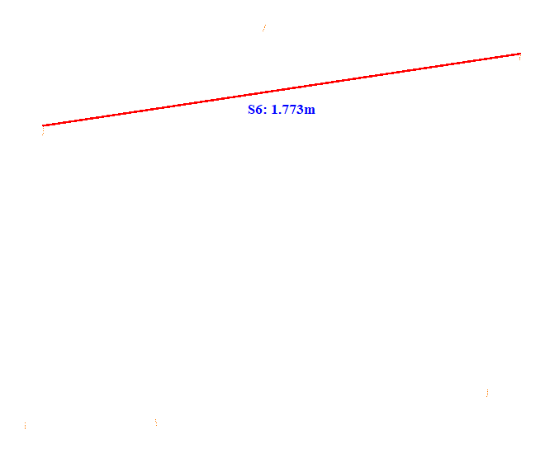

No. | Span | ID dan Lokasi Fasa | Nilai (m) (m) | Jarak Ke Menara Kecil (m)
277 | 92-93(92_93) | S7(LeftUpFasaPowerLineAndRightDownFasaPowerLine) | 1.853 | 17.848
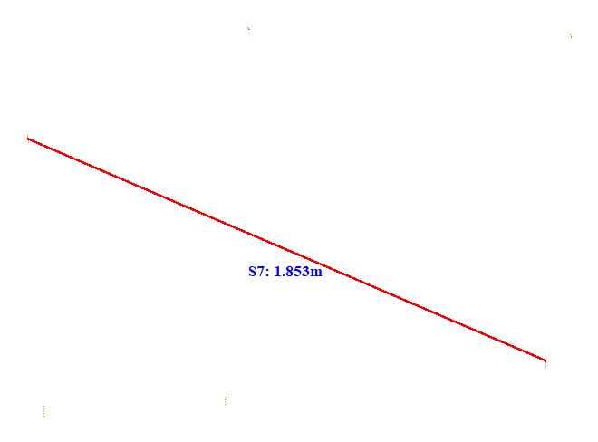

No. | Span | ID dan Lokasi Fasa | Nilai (m) (m) | Jarak Ke Menara Kecil (m)
278 | 101-102(101_102) | S1(LeftDownFasaPowerLineAndLeftMiddleFasaPowerLine) | 0.390 | 9.966
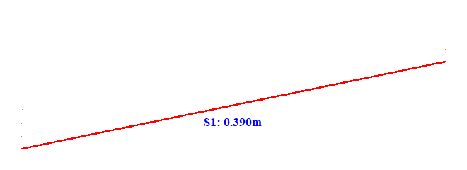

No. | Span | ID dan Lokasi Fasa | Nilai (m) (m) | Jarak Ke Menara Kecil (m)
279 | 103-104(103_104) | S1(Fasa Kiri Tengah ke Fasa Kiri Bawah) | 0.495 | 5.037
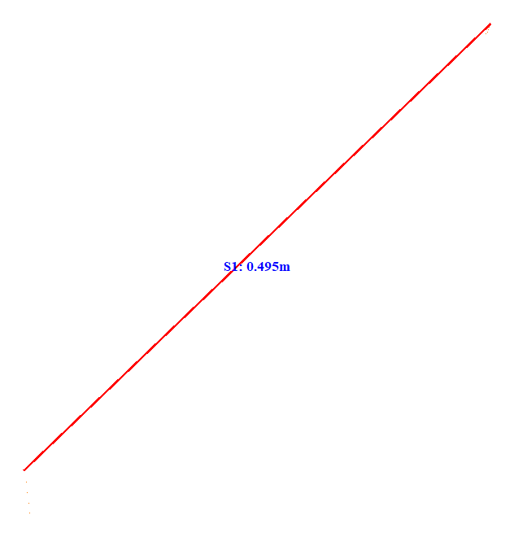

No. | Span | ID dan Lokasi Fasa | Nilai (m) (m) | Jarak Ke Menara Kecil (m)
280 | 104-105(104_105) | S1(LeftUpFasaPowerLineAndLeftDownFasaPowerLine) | 1.377 | 5.342
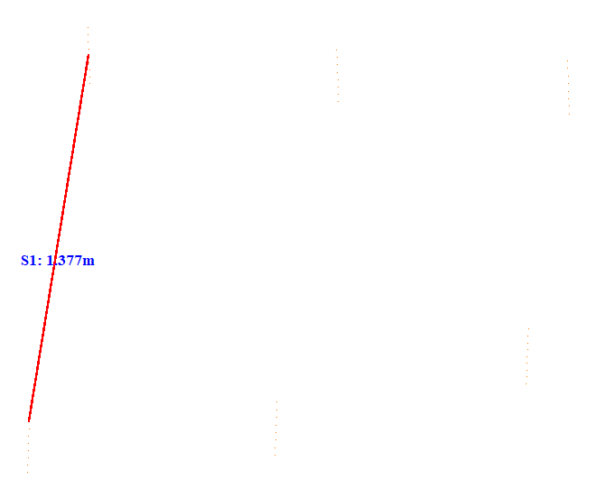

No. | Span | ID dan Lokasi Fasa | Nilai (m) (m) | Jarak Ke Menara Kecil (m)
281 | 104-105(104_105) | S2(Fasa Kanan Tengah ke Fasa Kanan Bawah) | 0.853 | 15.467
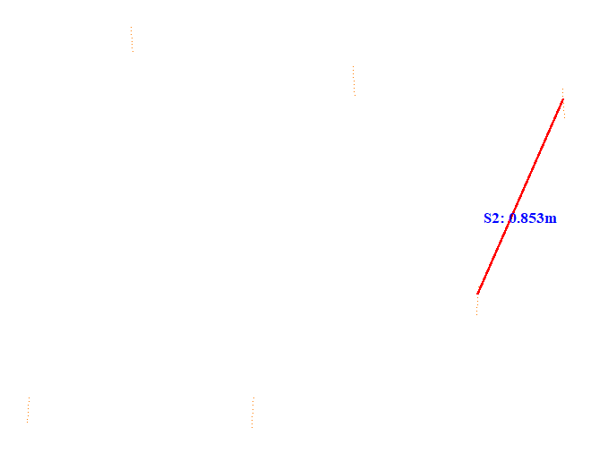

No. | Span | ID dan Lokasi Fasa | Nilai (m) (m) | Jarak Ke Menara Kecil (m)
282 | 104-105(104_105) | S3(Fasa Kiri Atas ke Fasa Kiri Tengah) | 1.431 | 37.005
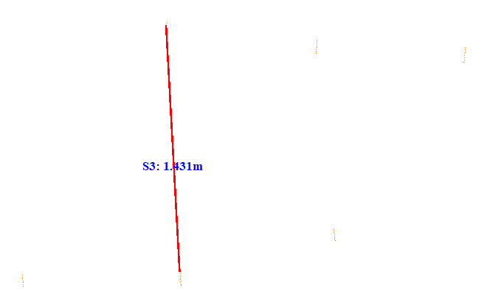

No. | Span | ID dan Lokasi Fasa | Nilai (m) (m) | Jarak Ke Menara Kecil (m)
283 | 104-105(104_105) | S4(RightMiddleFasaPowerLineAndLeftMiddleFasaPowerLine) | 1.588 | 5.254
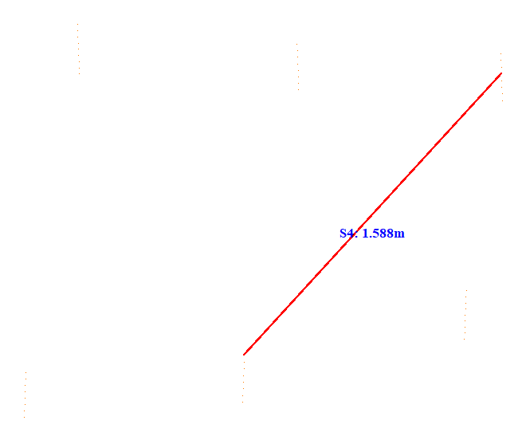

No. | Span | ID dan Lokasi Fasa | Nilai (m) (m) | Jarak Ke Menara Kecil (m)
284 | 104-105(104_105) | S5(Fasa Kiri Tengah ke Fasa Kiri Bawah) | 0.897 | 12.813
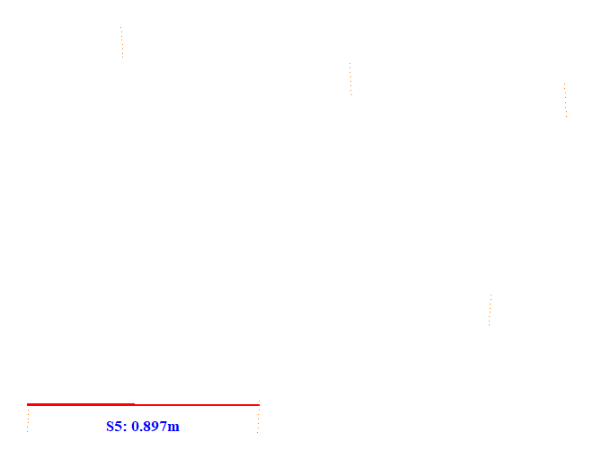

No. | Span | ID dan Lokasi Fasa | Nilai (m) (m) | Jarak Ke Menara Kecil (m)
285 | 104-105(104_105) | S6(RightDownFasaPowerLineAndLeftDownFasaPowerLine) | 1.846 | 12.850
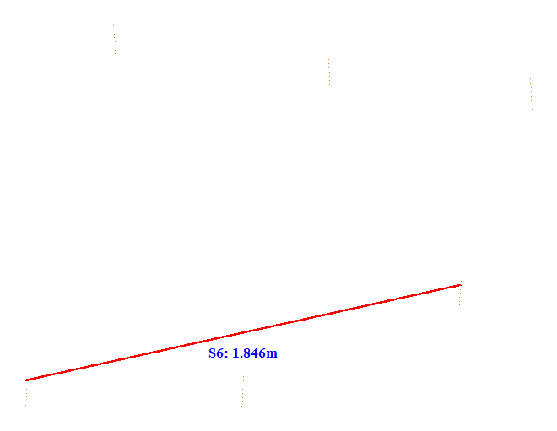

No. | Span | ID dan Lokasi Fasa | Nilai (m) (m) | Jarak Ke Menara Kecil (m)
286 | 104-105(104_105) | S7(LeftUpFasaPowerLineAndRightDownFasaPowerLine) | 1.661 | 20.156
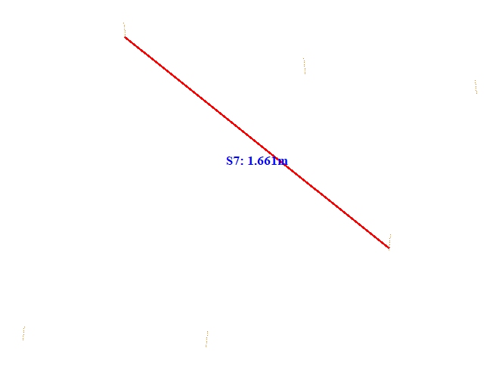

No. | Span | ID dan Lokasi Fasa | Nilai (m) (m) | Jarak Ke Menara Kecil (m)
287 | 104-105(104_105) | S8(RightDownFasaPowerLineAndLeftMiddleFasaPowerLine) | 0.995 | 13.552
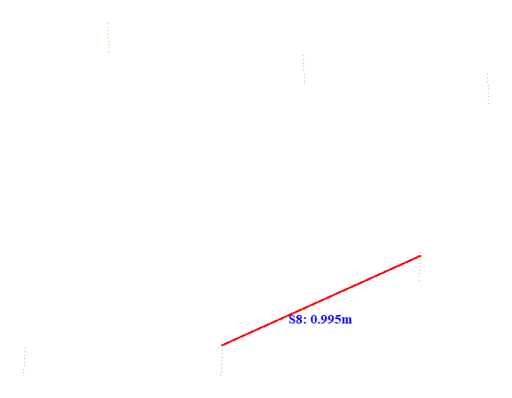

No. | Span | ID dan Lokasi Fasa | Nilai (m) (m) | Jarak Ke Menara Kecil (m)
288 | 105-106(105_106) | S1(Fasa Kiri Atas ke Fasa Kiri Tengah) | 1.315 | 35.866
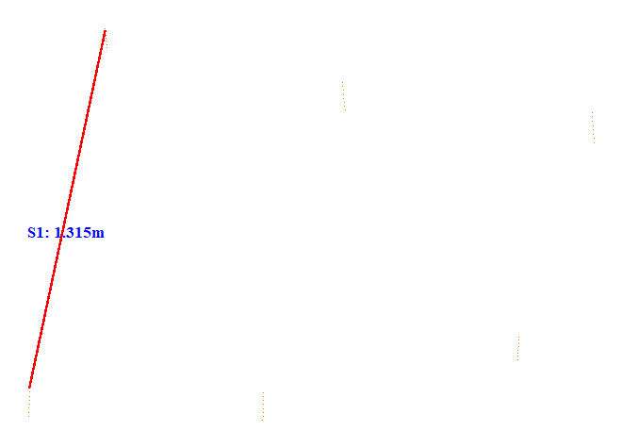

No. | Span | ID dan Lokasi Fasa | Nilai (m) (m) | Jarak Ke Menara Kecil (m)
289 | 105-106(105_106) | S2(Fasa Kanan Tengah ke Fasa Kanan Bawah) | 0.674 | 25.514
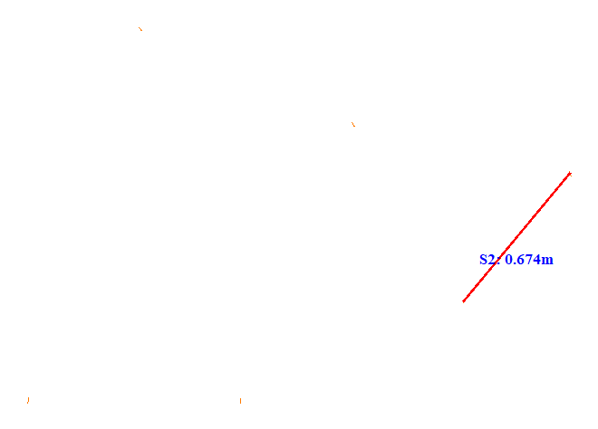

No. | Span | ID dan Lokasi Fasa | Nilai (m) (m) | Jarak Ke Menara Kecil (m)
290 | 105-106(105_106) | S3(LeftUpFasaPowerLineAndLeftDownFasaPowerLine) | 1.180 | 5.127
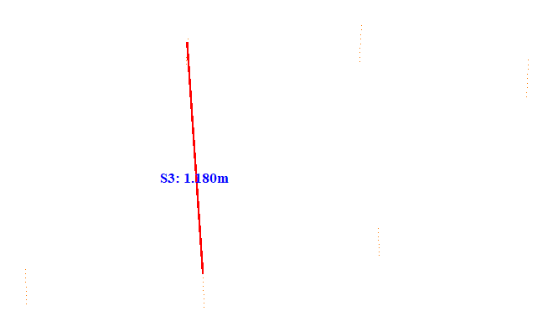

No. | Span | ID dan Lokasi Fasa | Nilai (m) (m) | Jarak Ke Menara Kecil (m)
291 | 105-106(105_106) | S4(RightMiddleFasaPowerLineAndLeftDownFasaPowerLine) | 1.547 | 35.807
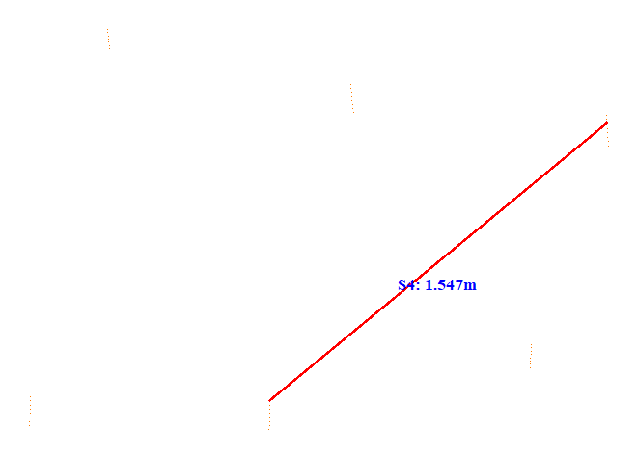

No. | Span | ID dan Lokasi Fasa | Nilai (m) (m) | Jarak Ke Menara Kecil (m)
292 | 105-106(105_106) | S5(LeftUpFasaPowerLineAndRightMiddleFasaPowerLine) | 1.793 | 13.453
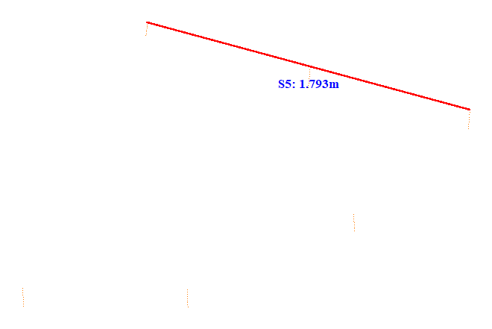

No. | Span | ID dan Lokasi Fasa | Nilai (m) (m) | Jarak Ke Menara Kecil (m)
293 | 105-106(105_106) | S6(Fasa Kanan Atas ke Fasa Kanan Tengah) | 0.885 | 13.422
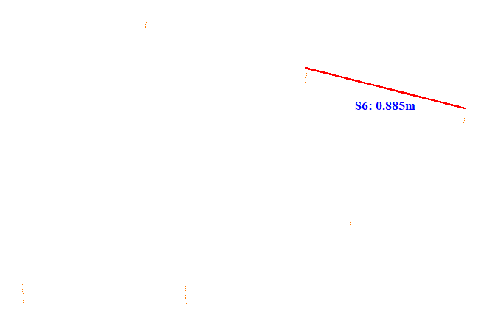

No. | Span | ID dan Lokasi Fasa | Nilai (m) (m) | Jarak Ke Menara Kecil (m)
294 | 105-106(105_106) | S7(RightMiddleFasaPowerLineAndLeftMiddleFasaPowerLine) | 2.278 | 33.360
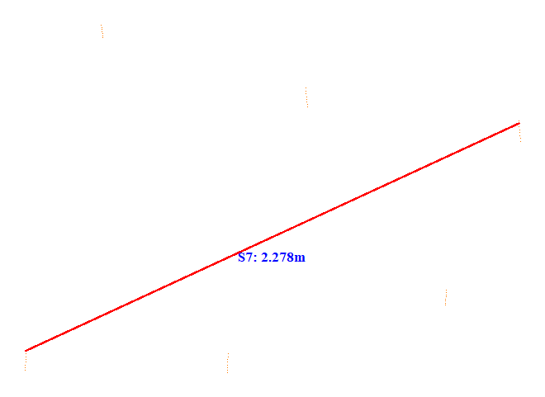

No. | Span | ID dan Lokasi Fasa | Nilai (m) (m) | Jarak Ke Menara Kecil (m)
295 | 106-107(106_107) | S1(LeftUpFasaPowerLineAndLeftDownFasaPowerLine) | 1.230 | 5.360
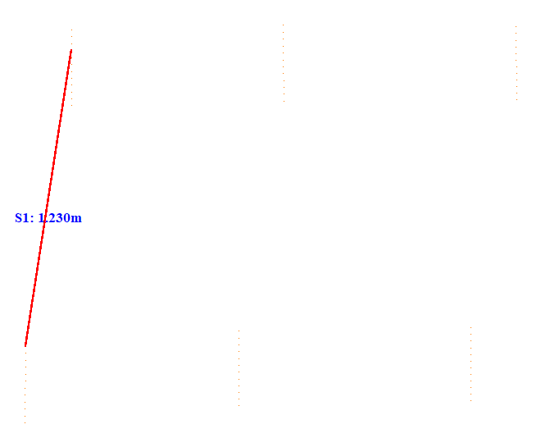

No. | Span | ID dan Lokasi Fasa | Nilai (m) (m) | Jarak Ke Menara Kecil (m)
296 | 106-107(106_107) | S2(Fasa Kanan Tengah ke Fasa Kanan Bawah) | 1.172 | 5.291
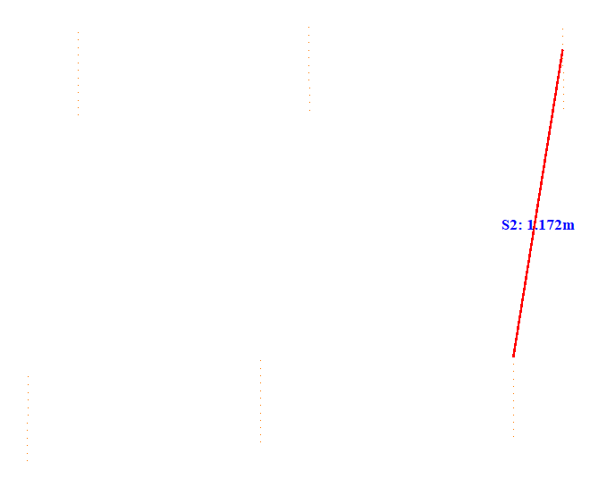

No. | Span | ID dan Lokasi Fasa | Nilai (m) (m) | Jarak Ke Menara Kecil (m)
297 | 106-107(106_107) | S3(Fasa Kiri Atas ke Fasa Kiri Tengah) | 1.259 | 51.353
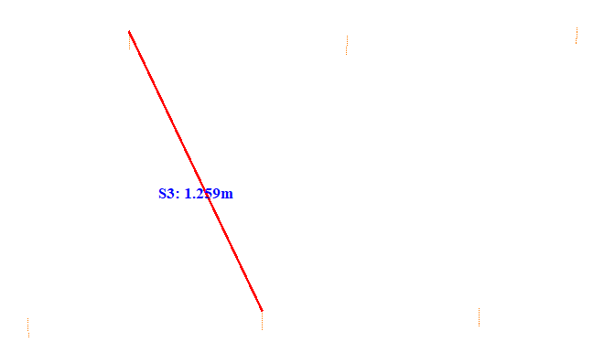

No. | Span | ID dan Lokasi Fasa | Nilai (m) (m) | Jarak Ke Menara Kecil (m)
298 | 106-107(106_107) | S4(RightMiddleFasaPowerLineAndLeftMiddleFasaPowerLine) | 1.612 | 5.251
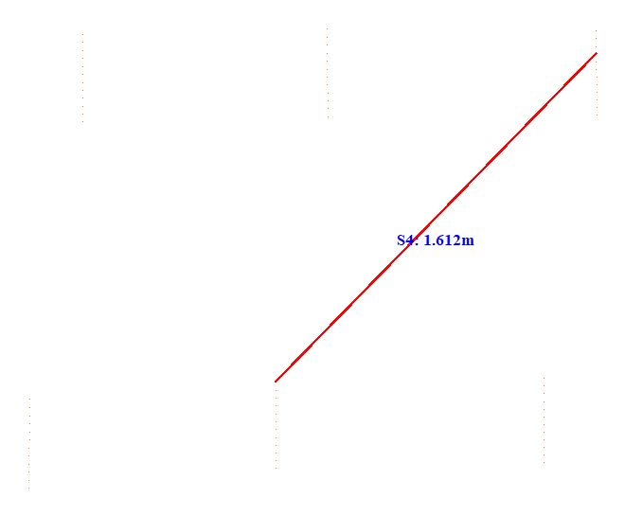

No. | Span | ID dan Lokasi Fasa | Nilai (m) (m) | Jarak Ke Menara Kecil (m)
299 | 107-108(107_108) | S1(LeftUpFasaPowerLineAndLeftDownFasaPowerLine) | 1.273 | 5.174
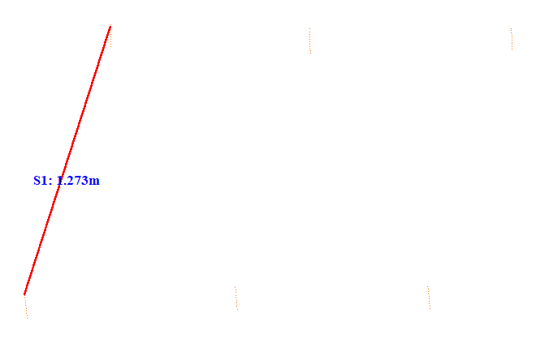

No. | Span | ID dan Lokasi Fasa | Nilai (m) (m) | Jarak Ke Menara Kecil (m)
300 | 107-108(107_108) | S2(RightUpFasaPowerLineAndRightDownFasaPowerLine) | 1.222 | 5.198
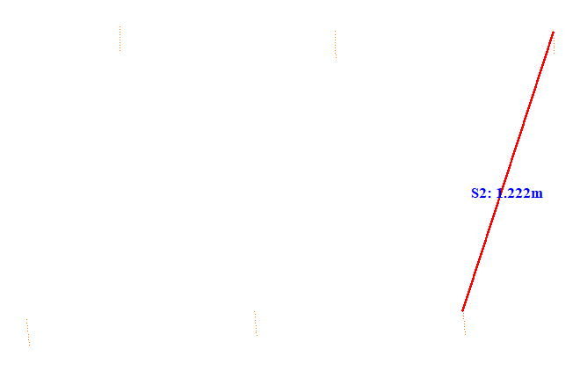

No. | Span | ID dan Lokasi Fasa | Nilai (m) (m) | Jarak Ke Menara Kecil (m)
301 | 107-108(107_108) | S3(Fasa Kiri Atas ke Fasa Kiri Tengah) | 1.308 | 5.090
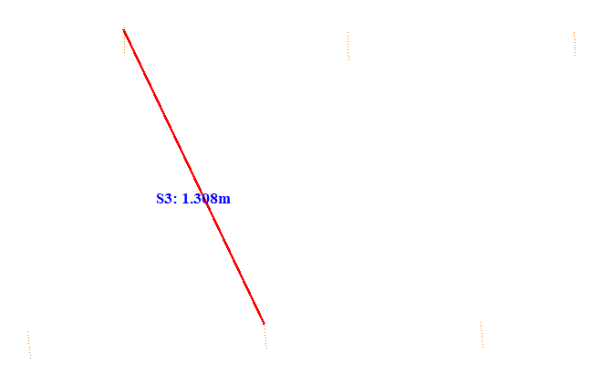

No. | Span | ID dan Lokasi Fasa | Nilai (m) (m) | Jarak Ke Menara Kecil (m)
302 | 107-108(107_108) | S4(RightUpFasaPowerLineAndLeftMiddleFasaPowerLine) | 1.599 | 43.903
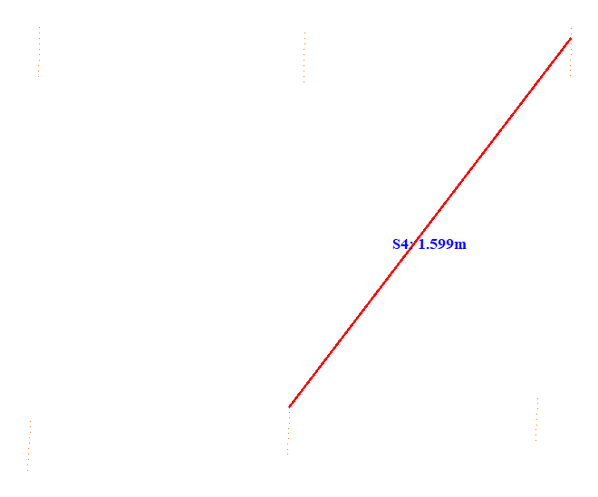

No. | Span | ID dan Lokasi Fasa | Nilai (m) (m) | Jarak Ke Menara Kecil (m)
303 | 108-109(108_109) | S1(LeftUpFasaPowerLineAndLeftDownFasaPowerLine) | 1.711 | 5.105
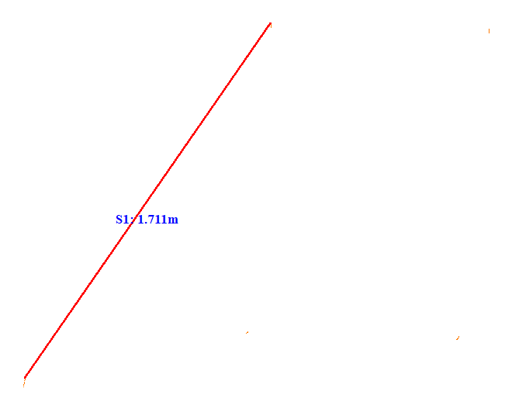

No. | Span | ID dan Lokasi Fasa | Nilai (m) (m) | Jarak Ke Menara Kecil (m)
304 | 108-109(108_109) | S2(Fasa Kanan Tengah ke Fasa Kanan Bawah) | 0.955 | 45.508
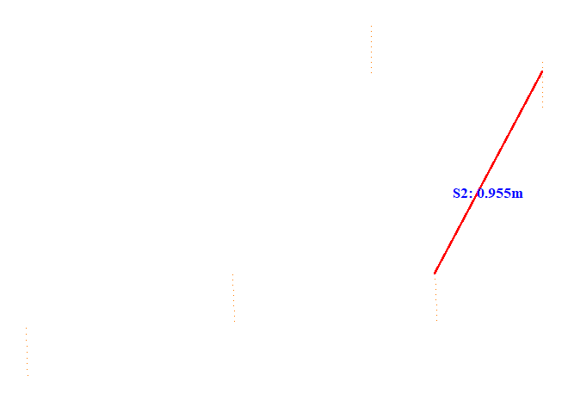

No. | Span | ID dan Lokasi Fasa | Nilai (m) (m) | Jarak Ke Menara Kecil (m)
305 | 108-109(108_109) | S3(Fasa Kiri Atas ke Fasa Kiri Tengah) | 1.104 | 29.847
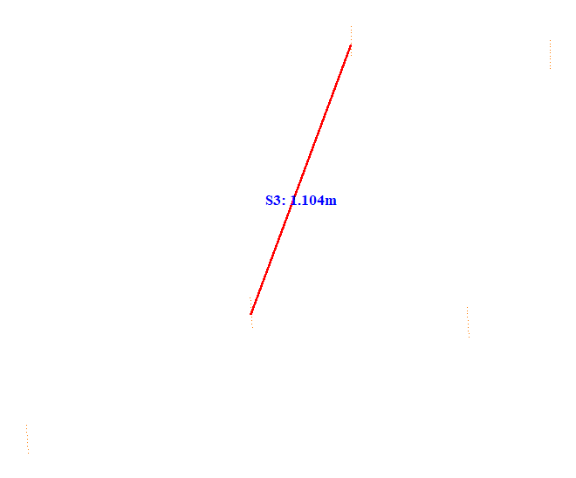

No. | Span | ID dan Lokasi Fasa | Nilai (m) (m) | Jarak Ke Menara Kecil (m)
306 | 108-109(108_109) | S4(RightMiddleFasaPowerLineAndLeftMiddleFasaPowerLine) | 1.515 | 36.650
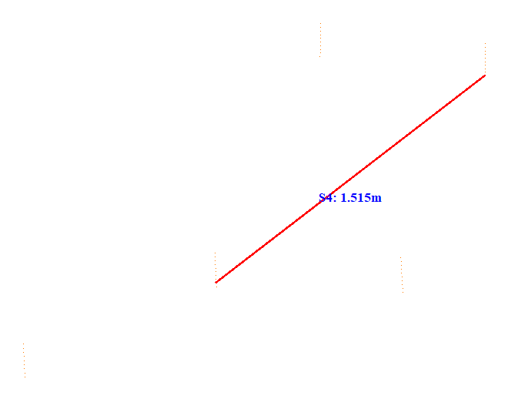

No. | Span | ID dan Lokasi Fasa | Nilai (m) (m) | Jarak Ke Menara Kecil (m)
307 | 108-109(108_109) | S5(Fasa Kiri Tengah ke Fasa Kiri Bawah) | 0.950 | 36.449
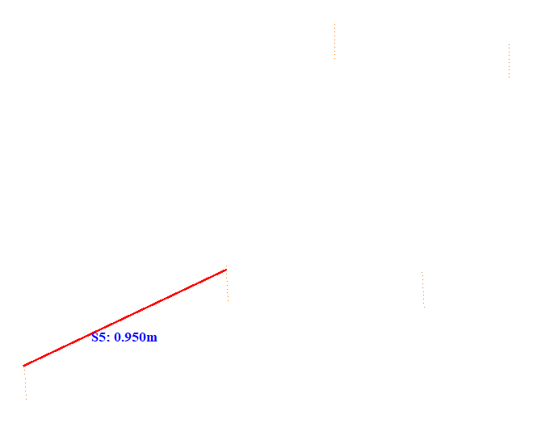

No. | Span | ID dan Lokasi Fasa | Nilai (m) (m) | Jarak Ke Menara Kecil (m)
308 | 108-109(108_109) | S6(RightDownFasaPowerLineAndLeftDownFasaPowerLine) | 1.729 | 36.448
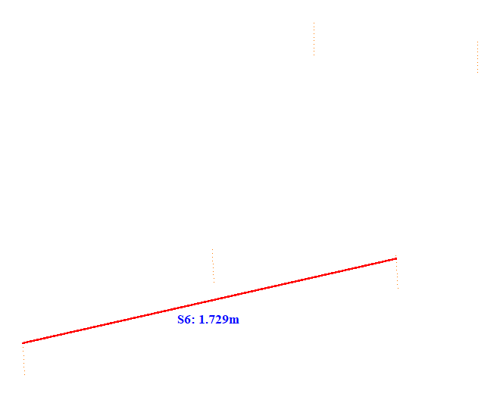

No. | Span | ID dan Lokasi Fasa | Nilai (m) (m) | Jarak Ke Menara Kecil (m)
309 | 109-110(109_110) | S1(LeftUpFasaPowerLineAndLeftDownFasaPowerLine) | 1.450 | 5.220
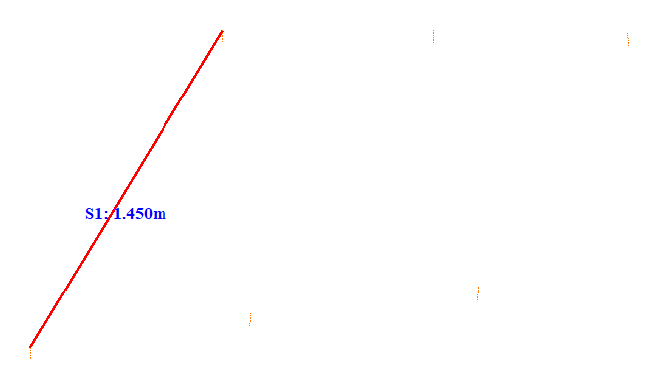

No. | Span | ID dan Lokasi Fasa | Nilai (m) (m) | Jarak Ke Menara Kecil (m)
310 | 109-110(109_110) | S2(Fasa Kanan Tengah ke Fasa Kanan Bawah) | 1.155 | 5.111
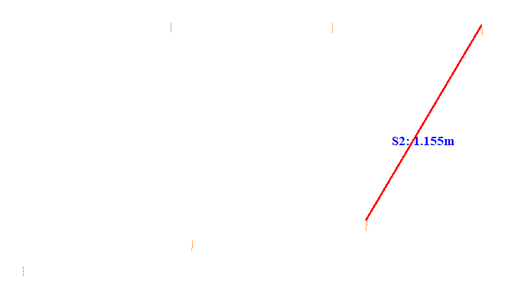

No. | Span | ID dan Lokasi Fasa | Nilai (m) (m) | Jarak Ke Menara Kecil (m)
311 | 109-110(109_110) | S3(Fasa Kiri Atas ke Fasa Kiri Tengah) | 1.115 | 5.168
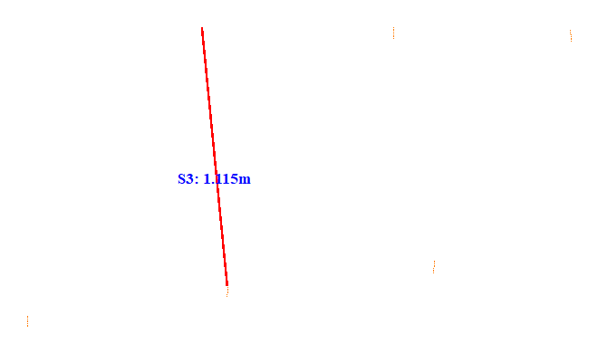

No. | Span | ID dan Lokasi Fasa | Nilai (m) (m) | Jarak Ke Menara Kecil (m)
312 | 109-110(109_110) | S4(RightMiddleFasaPowerLineAndLeftMiddleFasaPowerLine) | 1.838 | 5.160
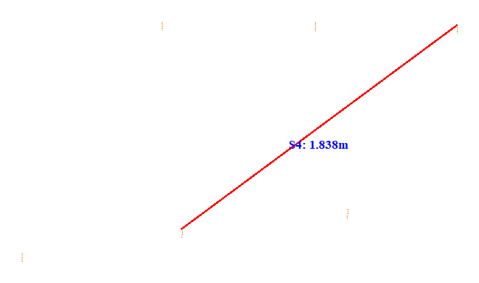

No. | Span | ID dan Lokasi Fasa | Nilai (m) (m) | Jarak Ke Menara Kecil (m)
313 | 110-111(110_111) | S1(LeftUpFasaPowerLineAndLeftDownFasaPowerLine) | 1.041 | 34.563
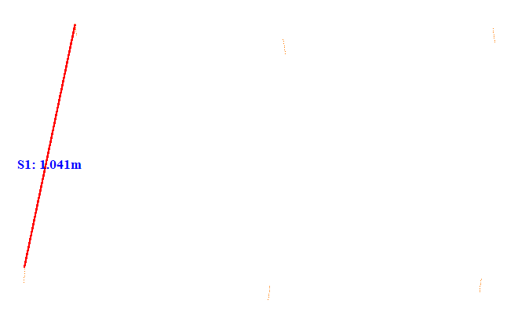

No. | Span | ID dan Lokasi Fasa | Nilai (m) (m) | Jarak Ke Menara Kecil (m)
314 | 110-111(110_111) | S2(Fasa Kanan Tengah ke Fasa Kanan Bawah) | 1.046 | 34.564
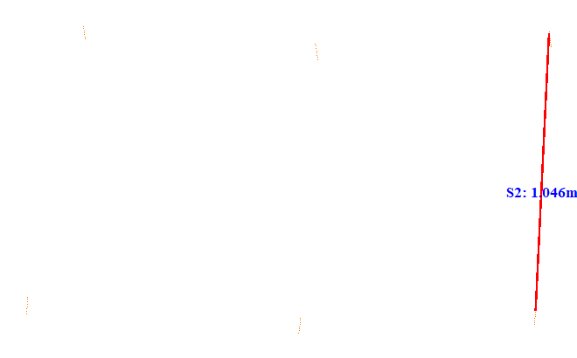

No. | Span | ID dan Lokasi Fasa | Nilai (m) (m) | Jarak Ke Menara Kecil (m)
315 | 110-111(110_111) | S3(Fasa Kiri Atas ke Fasa Kiri Tengah) | 1.167 | 5.066
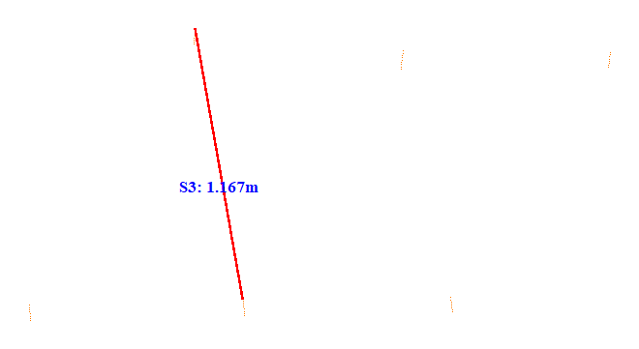

No. | Span | ID dan Lokasi Fasa | Nilai (m) (m) | Jarak Ke Menara Kecil (m)
316 | 110-111(110_111) | S4(RightMiddleFasaPowerLineAndLeftMiddleFasaPowerLine) | 1.427 | 34.560
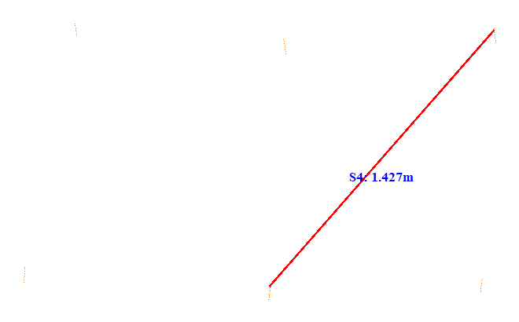

No. | Span | ID dan Lokasi Fasa | Nilai (m) (m) | Jarak Ke Menara Kecil (m)
317 | 111-112(111_112) | S1(LeftUpFasaPowerLineAndLeftDownFasaPowerLine) | 0.944 | 41.057
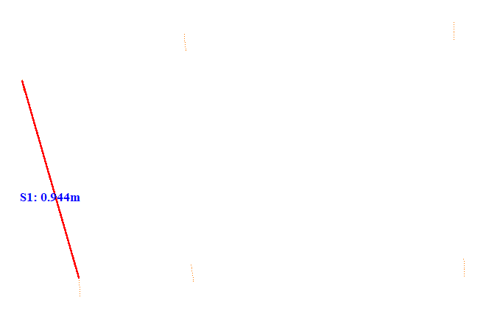

No. | Span | ID dan Lokasi Fasa | Nilai (m) (m) | Jarak Ke Menara Kecil (m)
318 | 111-112(111_112) | S2(Fasa Kanan Atas ke Fasa Kanan Tengah) | 1.067 | 20.122
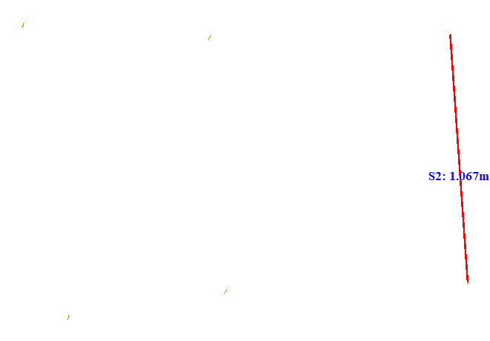

No. | Span | ID dan Lokasi Fasa | Nilai (m) (m) | Jarak Ke Menara Kecil (m)
319 | 111-112(111_112) | S3(LeftUpFasaPowerLineAndRightDownFasaPowerLine) | 1.149 | 41.052
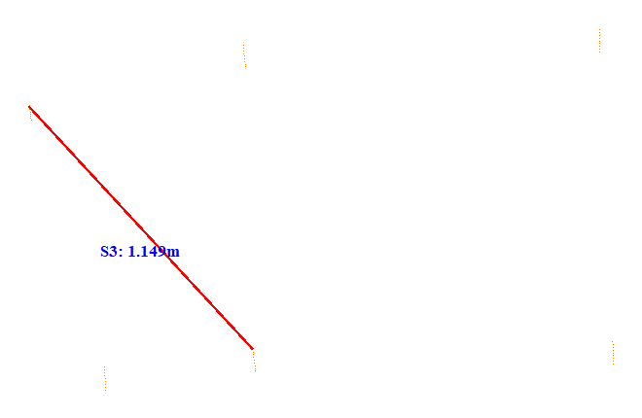

No. | Span | ID dan Lokasi Fasa | Nilai (m) (m) | Jarak Ke Menara Kecil (m)
320 | 111-112(111_112) | S4(RightUpFasaPowerLineAndRightDownFasaPowerLine) | 1.335 | 5.073
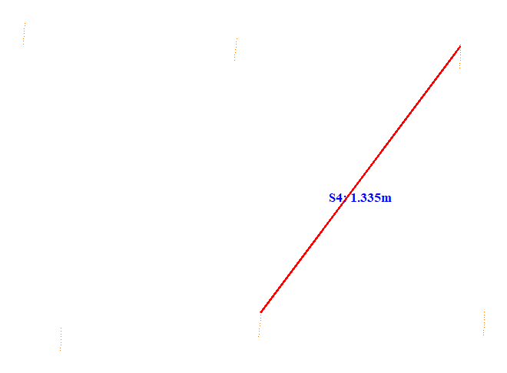

No. | Span | ID dan Lokasi Fasa | Nilai (m) (m) | Jarak Ke Menara Kecil (m)
321 | 112-113(112_113) | S1(Fasa Kiri Tengah ke Fasa Kiri Bawah) | 1.192 | 5.183
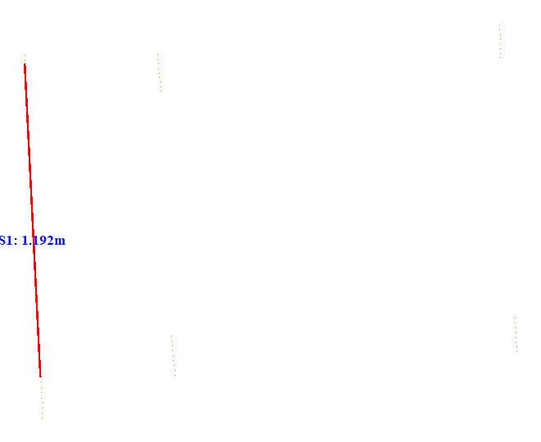

No. | Span | ID dan Lokasi Fasa | Nilai (m) (m) | Jarak Ke Menara Kecil (m)
322 | 112-113(112_113) | S2(Fasa Kanan Atas ke Fasa Kanan Tengah) | 1.088 | 5.271
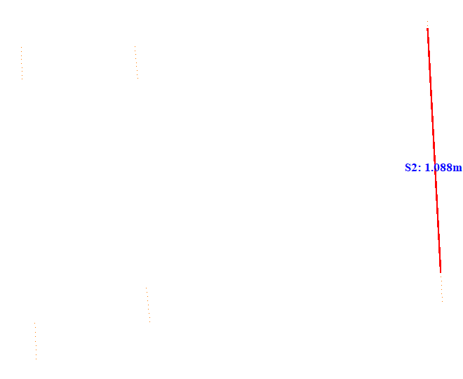

No. | Span | ID dan Lokasi Fasa | Nilai (m) (m) | Jarak Ke Menara Kecil (m)
323 | 112-113(112_113) | S3(LeftMiddleFasaPowerLineAndRightDownFasaPowerLine) | 1.175 | 5.146
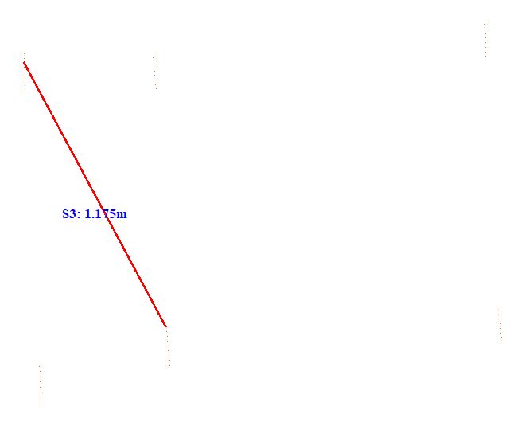

No. | Span | ID dan Lokasi Fasa | Nilai (m) (m) | Jarak Ke Menara Kecil (m)
324 | 112-113(112_113) | S4(RightUpFasaPowerLineAndRightDownFasaPowerLine) | 1.526 | 38.304
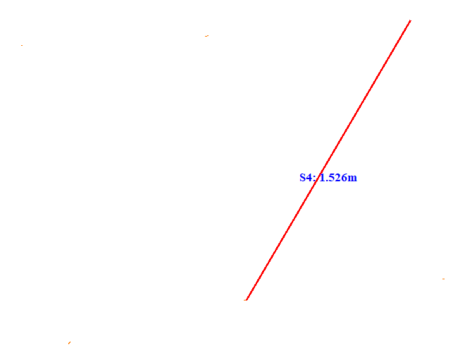

No. | Span | ID dan Lokasi Fasa | Nilai (m) (m) | Jarak Ke Menara Kecil (m)
325 | 113-114(113_114) | S1(Fasa Kiri Tengah ke Fasa Kiri Bawah) | 1.106 | 57.852
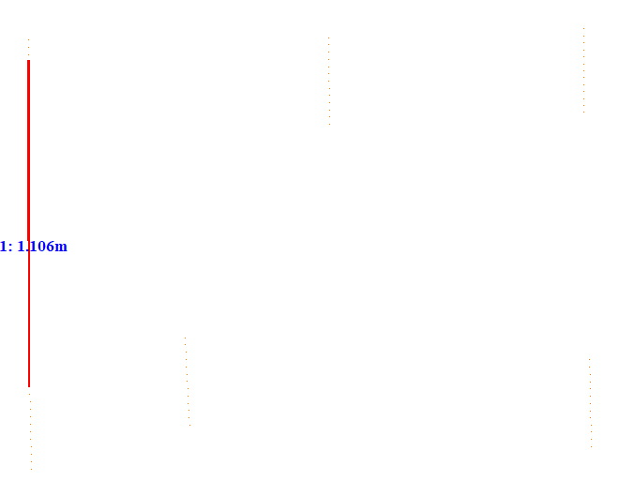

No. | Span | ID dan Lokasi Fasa | Nilai (m) (m) | Jarak Ke Menara Kecil (m)
326 | 113-114(113_114) | S2(Fasa Kanan Atas ke Fasa Kanan Tengah) | 1.060 | 57.908
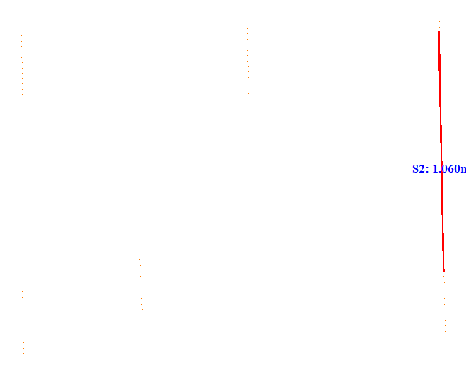

No. | Span | ID dan Lokasi Fasa | Nilai (m) (m) | Jarak Ke Menara Kecil (m)
327 | 113-114(113_114) | S3(LeftMiddleFasaPowerLineAndRightDownFasaPowerLine) | 1.079 | 57.900
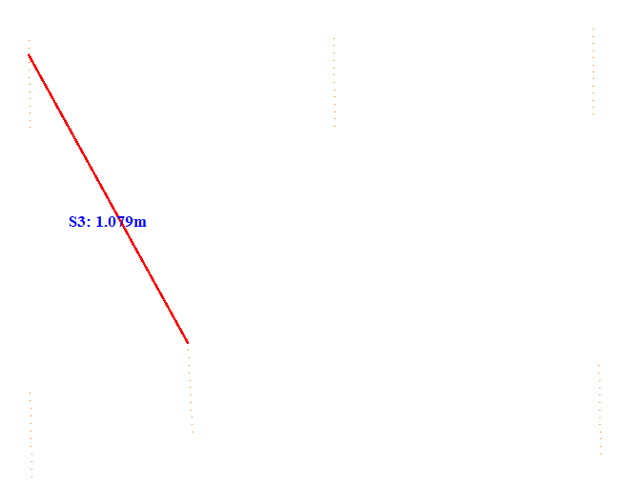

No. | Span | ID dan Lokasi Fasa | Nilai (m) (m) | Jarak Ke Menara Kecil (m)
328 | 113-114(113_114) | S4(RightUpFasaPowerLineAndRightDownFasaPowerLine) | 1.526 | 5.086
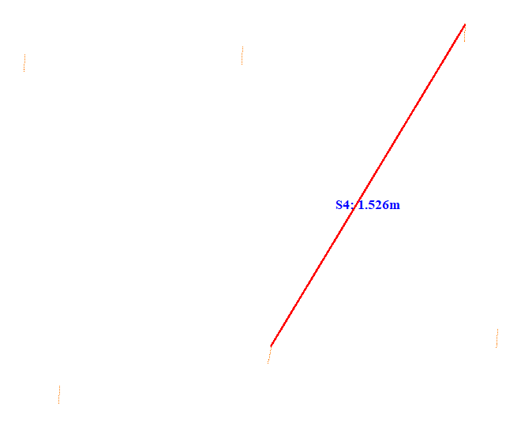

No. | Span | ID dan Lokasi Fasa | Nilai (m) (m) | Jarak Ke Menara Kecil (m)
329 | 114-115(114_115) | S1(LeftUpFasaPowerLineAndLeftDownFasaPowerLine) | 1.133 | 60.910
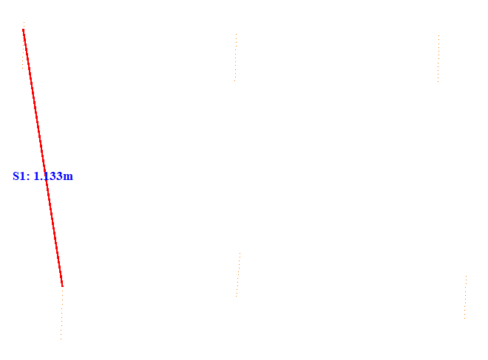

No. | Span | ID dan Lokasi Fasa | Nilai (m) (m) | Jarak Ke Menara Kecil (m)
330 | 114-115(114_115) | S2(RightUpFasaPowerLineAndRightDownFasaPowerLine) | 1.025 | 60.904
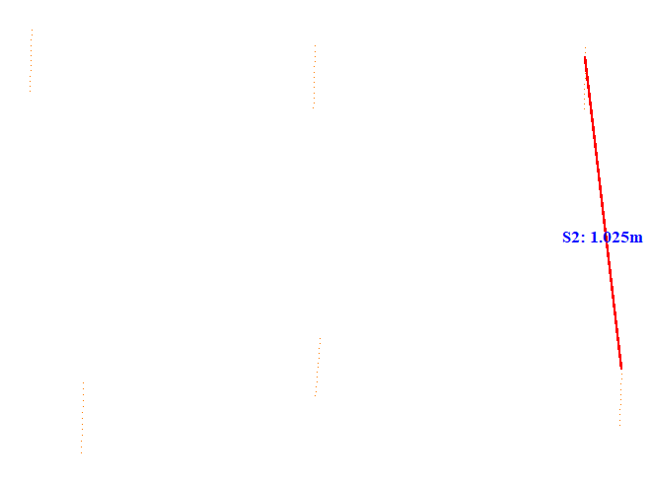

No. | Span | ID dan Lokasi Fasa | Nilai (m) (m) | Jarak Ke Menara Kecil (m)
331 | 114-115(114_115) | S3(Fasa Kiri Atas ke Fasa Kiri Tengah) | 1.053 | 10.287
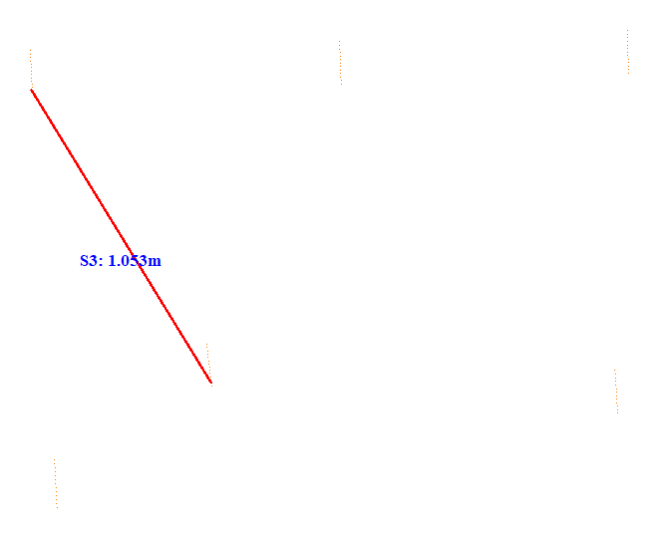

No. | Span | ID dan Lokasi Fasa | Nilai (m) (m) | Jarak Ke Menara Kecil (m)
332 | 114-115(114_115) | S4(RightUpFasaPowerLineAndLeftMiddleFasaPowerLine) | 1.256 | 57.352
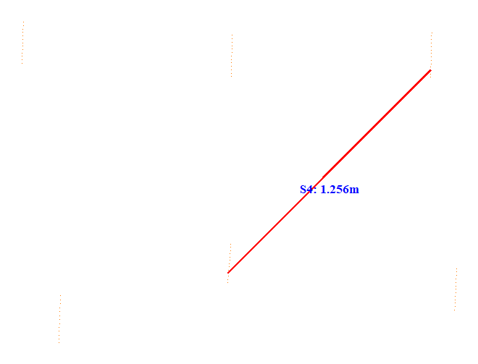

No. | Span | ID dan Lokasi Fasa | Nilai (m) (m) | Jarak Ke Menara Kecil (m)
333 | 114-115(114_115) | S5(Fasa Kiri Tengah ke Fasa Kiri Bawah) | 0.605 | 10.434
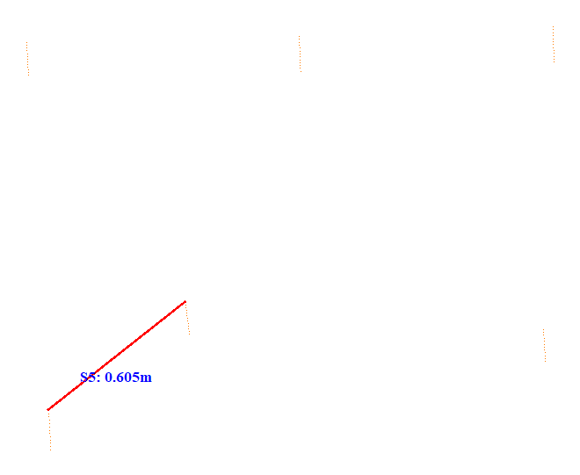

No. | Span | ID dan Lokasi Fasa | Nilai (m) (m) | Jarak Ke Menara Kecil (m)
334 | 114-115(114_115) | S6(RightDownFasaPowerLineAndLeftDownFasaPowerLine) | 1.740 | 10.502
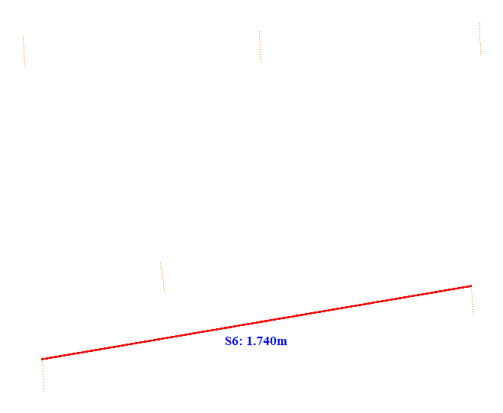

No. | Span | ID dan Lokasi Fasa | Nilai (m) (m) | Jarak Ke Menara Kecil (m)
335 | 115-116(115_116) | S1(LeftUpFasaPowerLineAndLeftDownFasaPowerLine) | 0.716 | 11.484
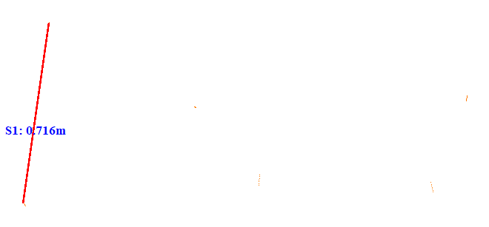

No. | Span | ID dan Lokasi Fasa | Nilai (m) (m) | Jarak Ke Menara Kecil (m)
336 | 115-116(115_116) | S2(RightUpFasaPowerLineAndRightDownFasaPowerLine) | 0.349 | 14.350
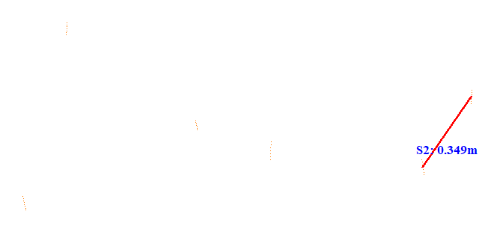

No. | Span | ID dan Lokasi Fasa | Nilai (m) (m) | Jarak Ke Menara Kecil (m)
337 | 115-116(115_116) | S3(LeftUpFasaPowerLineAndRightMiddleFasaPowerLine) | 1.010 | 12.404
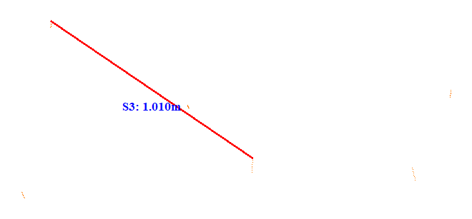

No. | Span | ID dan Lokasi Fasa | Nilai (m) (m) | Jarak Ke Menara Kecil (m)
338 | 115-116(115_116) | S4(Fasa Kanan Atas ke Fasa Kanan Tengah) | 0.868 | 12.438
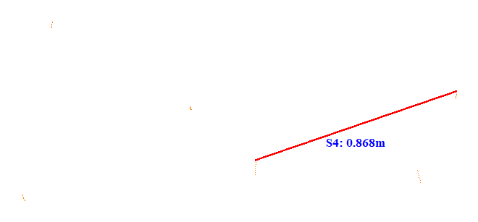

No. | Span | ID dan Lokasi Fasa | Nilai (m) (m) | Jarak Ke Menara Kecil (m)
339 | 115-116(115_116) | S5(Fasa Kiri Atas ke Fasa Kiri Tengah) | 0.663 | 17.804
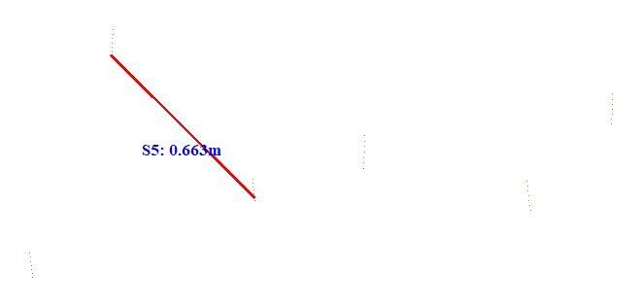

No. | Span | ID dan Lokasi Fasa | Nilai (m) (m) | Jarak Ke Menara Kecil (m)
340 | 115-116(115_116) | S6(RightUpFasaPowerLineAndLeftMiddleFasaPowerLine) | 1.196 | 17.826
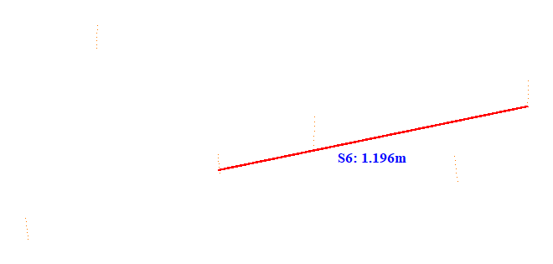

No. | Span | ID dan Lokasi Fasa | Nilai (m) (m) | Jarak Ke Menara Kecil (m)
341 | 116-117(116_117) | S1(LeftUpFasaPowerLineAndRightMiddleFasaPowerLine) | 1.629 | 5.085
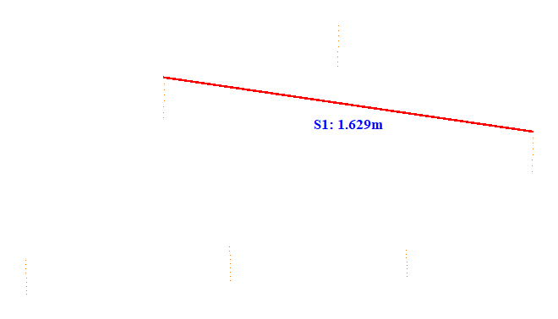

No. | Span | ID dan Lokasi Fasa | Nilai (m) (m) | Jarak Ke Menara Kecil (m)
342 | 116-117(116_117) | S2(Fasa Kanan Atas ke Fasa Kanan Tengah) | 0.960 | 5.121
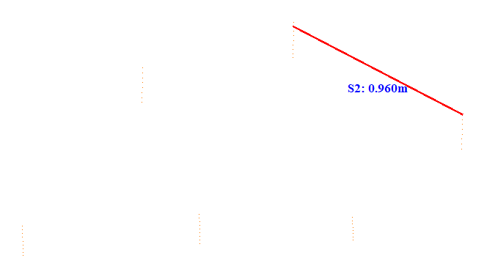

No. | Span | ID dan Lokasi Fasa | Nilai (m) (m) | Jarak Ke Menara Kecil (m)
343 | 116-117(116_117) | S3(RightMiddleFasaPowerLineAndLeftDownFasaPowerLine) | 2.238 | 7.432
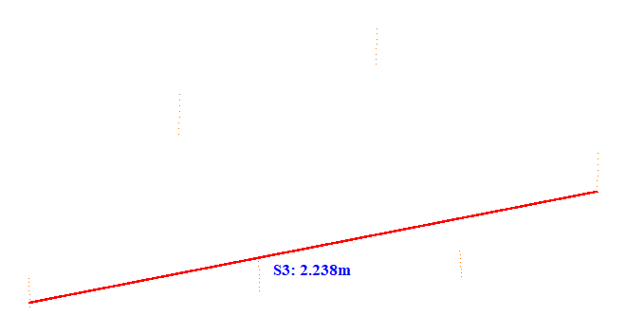

No. | Span | ID dan Lokasi Fasa | Nilai (m) (m) | Jarak Ke Menara Kecil (m)
344 | 116-117(116_117) | S4(Fasa Kanan Tengah ke Fasa Kanan Bawah) | 0.265 | 29.489
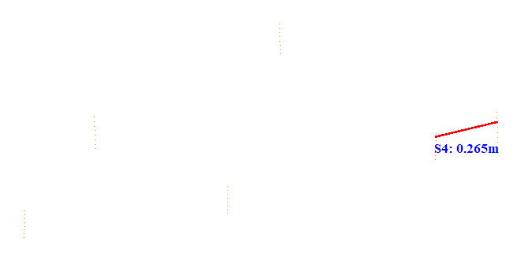

No. | Span | ID dan Lokasi Fasa | Nilai (m) (m) | Jarak Ke Menara Kecil (m)
345 | 116-117(116_117) | S5(RightMiddleFasaPowerLineAndLeftMiddleFasaPowerLine) | 1.165 | 28.982
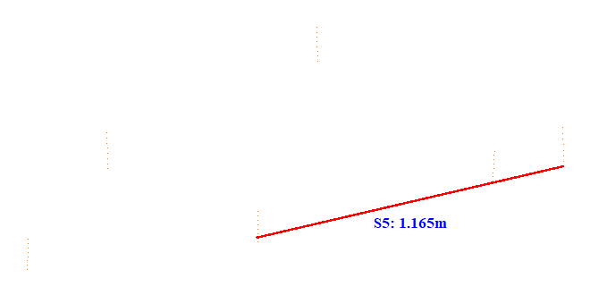

No. | Span | ID dan Lokasi Fasa | Nilai (m) (m) | Jarak Ke Menara Kecil (m)
346 | 116-117(116_117) | S6(Fasa Kiri Atas ke Fasa Kiri Tengah) | 0.617 | 28.902
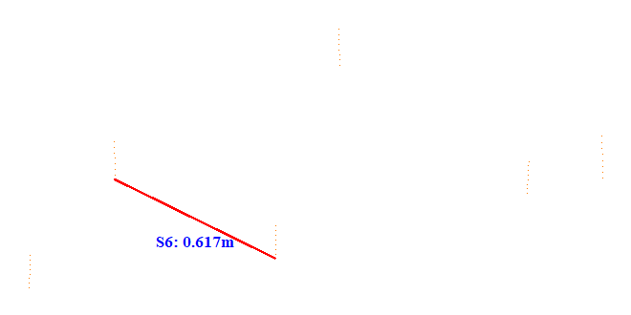

No. | Span | ID dan Lokasi Fasa | Nilai (m) (m) | Jarak Ke Menara Kecil (m)
347 | 116-117(116_117) | S7(LeftUpFasaPowerLineAndRightDownFasaPowerLine) | 1.222 | 7.447
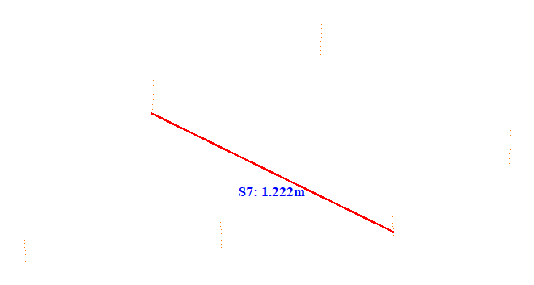

No. | Span | ID dan Lokasi Fasa | Nilai (m) (m) | Jarak Ke Menara Kecil (m)
348 | 116-117(116_117) | S8(RightUpFasaPowerLineAndRightDownFasaPowerLine) | 0.879 | 7.458
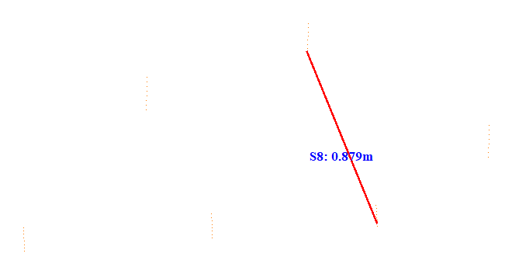

No. | Span | ID dan Lokasi Fasa | Nilai (m) (m) | Jarak Ke Menara Kecil (m)
349 | 116-117(116_117) | S9(Fasa Kiri Tengah ke Fasa Kiri Bawah) | 0.891 | 7.535
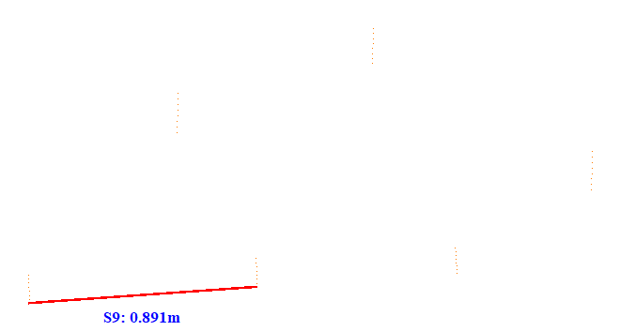

No. | Span | ID dan Lokasi Fasa | Nilai (m) (m) | Jarak Ke Menara Kecil (m)
350 | 116-117(116_117) | S10(LeftUpFasaPowerLineAndLeftDownFasaPowerLine) | 0.479 | 28.964
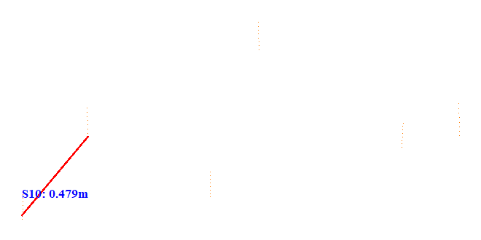

No. | Span | ID dan Lokasi Fasa | Nilai (m) (m) | Jarak Ke Menara Kecil (m)
351 | 116-117(116_117) | S11(RightUpFasaPowerLineAndLeftDownFasaPowerLine) | 1.321 | 28.757
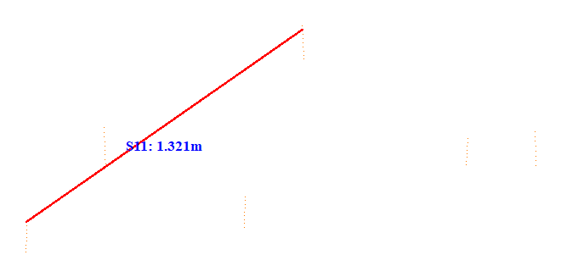

No. | Span | ID dan Lokasi Fasa | Nilai (m) (m) | Jarak Ke Menara Kecil (m)
352 | 116-117(116_117) | S12(RightUpFasaPowerLineAndLeftMiddleFasaPowerLine) | 0.685 | 26.351
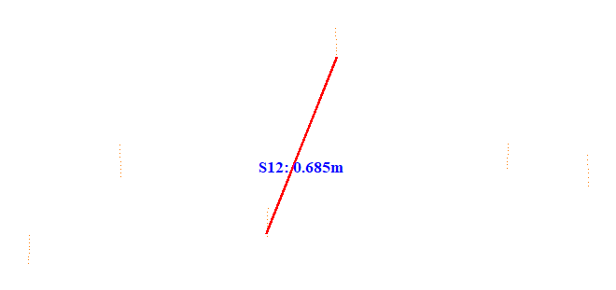

No. | Span | ID dan Lokasi Fasa | Nilai (m) (m) | Jarak Ke Menara Kecil (m)
353 | 119-120(119_120) | S1(Fasa Kiri ke Fasa Tengah) | 0.723 | 5.111
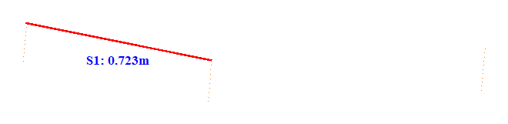

No. | Span | ID dan Lokasi Fasa | Nilai (m) (m) | Jarak Ke Menara Kecil (m)
354 | 119-120(119_120) | S2(Fasa Tengah ke Fasa Kanan) | 0.944 | 46.004
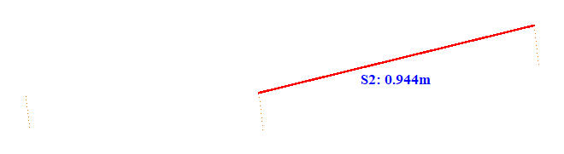

No. | Span | ID dan Lokasi Fasa | Nilai (m) (m) | Jarak Ke Menara Kecil (m)
355 | 119-120(119_120) | S3(Fasa Kiri ke Fasa Kanan) | 1.711 | 41.801
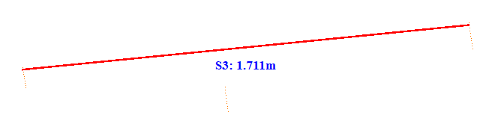

No. | Span | ID dan Lokasi Fasa | Nilai (m) (m) | Jarak Ke Menara Kecil (m)
356 | 120-121(120_121) | S1(Fasa Kiri ke Fasa Tengah) | 0.708 | 41.614
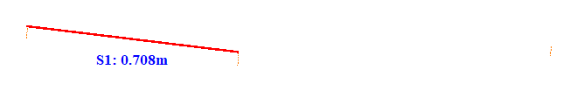

No. | Span | ID dan Lokasi Fasa | Nilai (m) (m) | Jarak Ke Menara Kecil (m)
357 | 120-121(120_121) | S2(Fasa Tengah ke Fasa Kanan) | 0.948 | 5.054
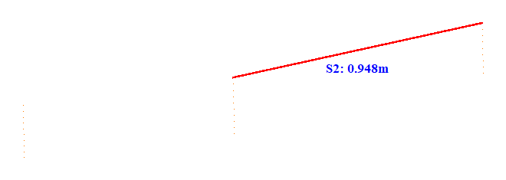

No. | Span | ID dan Lokasi Fasa | Nilai (m) (m) | Jarak Ke Menara Kecil (m)
358 | 120-121(120_121) | S3(Fasa Kiri ke Fasa Kanan) | 1.724 | 16.011
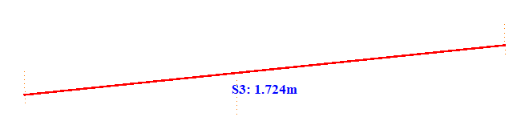

No. | Span | ID dan Lokasi Fasa | Nilai (m) (m) | Jarak Ke Menara Kecil (m)
359 | 121-122(121_122) | S1(Fasa Kiri ke Fasa Tengah) | 0.648 | 5.077
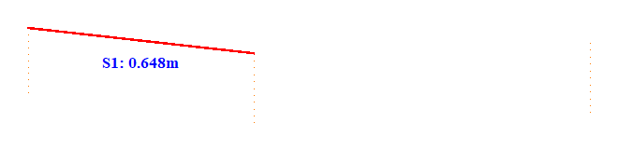

No. | Span | ID dan Lokasi Fasa | Nilai (m) (m) | Jarak Ke Menara Kecil (m)
360 | 121-122(121_122) | S2(Fasa Tengah ke Fasa Kanan) | 0.931 | 46.700
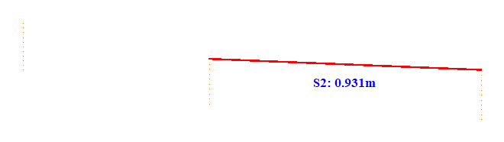

No. | Span | ID dan Lokasi Fasa | Nilai (m) (m) | Jarak Ke Menara Kecil (m)
361 | 121-122(121_122) | S3(Fasa Kiri ke Fasa Kanan) | 1.578 | 46.702
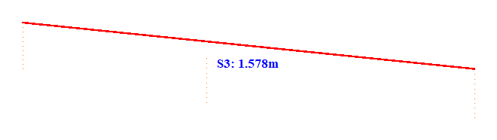

No. | Span | ID dan Lokasi Fasa | Nilai (m) (m) | Jarak Ke Menara Kecil (m)
362 | 122-123(122_123) | S1(Fasa Kiri ke Fasa Tengah) | 0.723 | 33.813
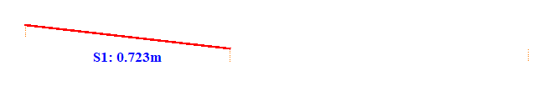

No. | Span | ID dan Lokasi Fasa | Nilai (m) (m) | Jarak Ke Menara Kecil (m)
363 | 122-123(122_123) | S2(Fasa Tengah ke Fasa Kanan) | 1.047 | 33.800
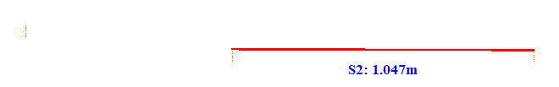

No. | Span | ID dan Lokasi Fasa | Nilai (m) (m) | Jarak Ke Menara Kecil (m)
364 | 122-123(122_123) | S3(Fasa Kiri ke Fasa Kanan) | 1.767 | 33.803
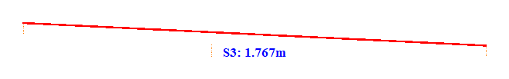

No. | Span | ID dan Lokasi Fasa | Nilai (m) (m) | Jarak Ke Menara Kecil (m)
365 | 123-124(123_124) | S1(Fasa Kiri ke Fasa Tengah) | 0.733 | 5.187
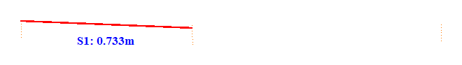

No. | Span | ID dan Lokasi Fasa | Nilai (m) (m) | Jarak Ke Menara Kecil (m)
366 | 123-124(123_124) | S2(Fasa Tengah ke Fasa Kanan) | 0.995 | 34.301
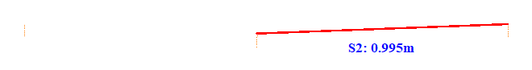

No. | Span | ID dan Lokasi Fasa | Nilai (m) (m) | Jarak Ke Menara Kecil (m)
367 | 123-124(123_124) | S3(Fasa Kiri ke Fasa Kanan) | 1.803 | 5.115
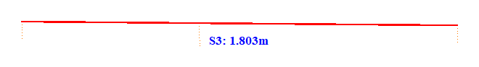

No. | Span | ID dan Lokasi Fasa | Nilai (m) (m) | Jarak Ke Menara Kecil (m)
368 | 124-125(124_125) | S1(Fasa Kiri ke Fasa Tengah) | 0.695 | 41.211
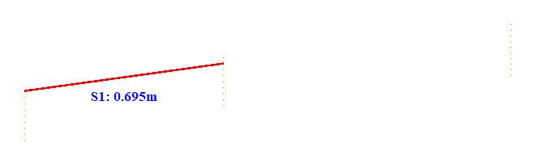

No. | Span | ID dan Lokasi Fasa | Nilai (m) (m) | Jarak Ke Menara Kecil (m)
369 | 124-125(124_125) | S2(Fasa Tengah ke Fasa Kanan) | 0.979 | 5.100
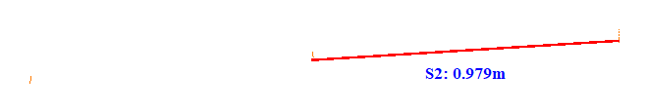

No. | Span | ID dan Lokasi Fasa | Nilai (m) (m) | Jarak Ke Menara Kecil (m)
370 | 124-125(124_125) | S3(Fasa Kiri ke Fasa Kanan) | 1.705 | 41.205
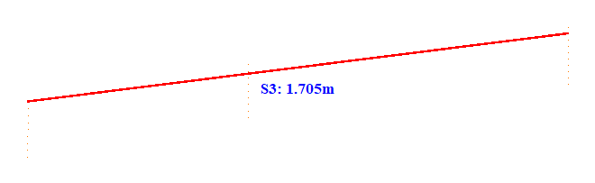

No. | Span | ID dan Lokasi Fasa | Nilai (m) (m) | Jarak Ke Menara Kecil (m)
371 | 125-126(125_126) | S1(Fasa Kiri ke Fasa Tengah) | 0.715 | 5.078
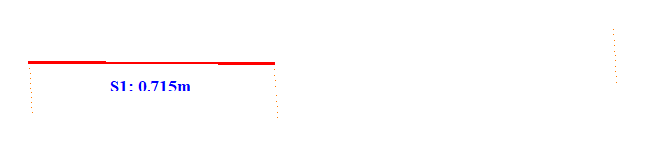

No. | Span | ID dan Lokasi Fasa | Nilai (m) (m) | Jarak Ke Menara Kecil (m)
372 | 125-126(125_126) | S2(Fasa Tengah ke Fasa Kanan) | 0.837 | 48.701
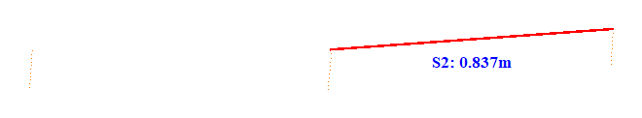

No. | Span | ID dan Lokasi Fasa | Nilai (m) (m) | Jarak Ke Menara Kecil (m)
373 | 125-126(125_126) | S3(Fasa Kiri ke Fasa Kanan) | 1.714 | 10.607
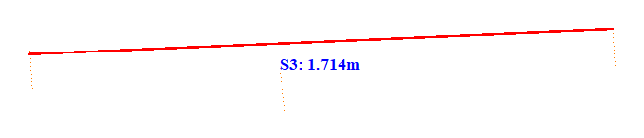

No. | Span | ID dan Lokasi Fasa | Nilai (m) (m) | Jarak Ke Menara Kecil (m)
374 | 126-127(126_127) | S1(Fasa Kiri ke Fasa Tengah) | 0.678 | 43.502
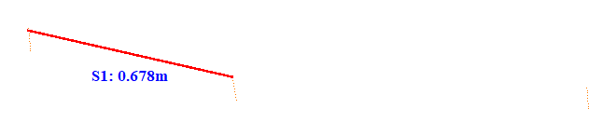

No. | Span | ID dan Lokasi Fasa | Nilai (m) (m) | Jarak Ke Menara Kecil (m)
375 | 126-127(126_127) | S2(Fasa Tengah ke Fasa Kanan) | 0.855 | 5.024
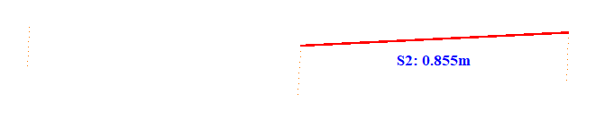

No. | Span | ID dan Lokasi Fasa | Nilai (m) (m) | Jarak Ke Menara Kecil (m)
376 | 126-127(126_127) | S3(Fasa Kiri ke Fasa Kanan) | 1.723 | 5.099
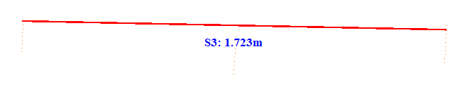

No. | Span | ID dan Lokasi Fasa | Nilai (m) (m) | Jarak Ke Menara Kecil (m)
377 | 127-128(127_128) | S1(Fasa Kiri ke Fasa Tengah) | 0.639 | 5.174
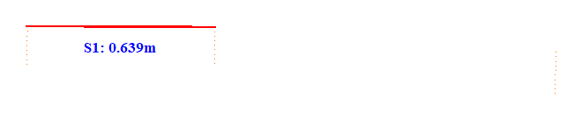

No. | Span | ID dan Lokasi Fasa | Nilai (m) (m) | Jarak Ke Menara Kecil (m)
378 | 127-128(127_128) | S2(Fasa Tengah ke Fasa Kanan) | 1.069 | 43.601
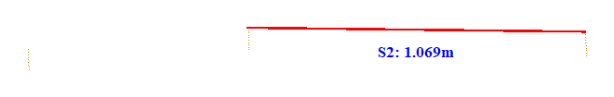

No. | Span | ID dan Lokasi Fasa | Nilai (m) (m) | Jarak Ke Menara Kecil (m)
379 | 127-128(127_128) | S3(Fasa Kiri ke Fasa Kanan) | 1.767 | 43.601
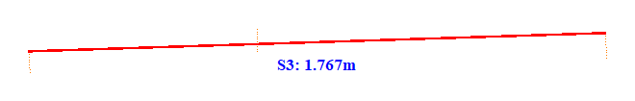

No. | Span | ID dan Lokasi Fasa | Nilai (m) (m) | Jarak Ke Menara Kecil (m)
380 | 128-129(128_129) | S1(Fasa Kiri ke Fasa Tengah) | 0.671 | 43.212
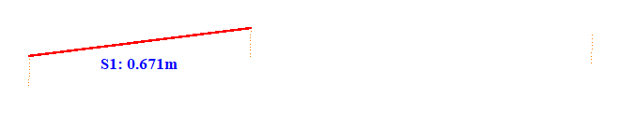

No. | Span | ID dan Lokasi Fasa | Nilai (m) (m) | Jarak Ke Menara Kecil (m)
381 | 128-129(128_129) | S2(Fasa Tengah ke Fasa Kanan) | 1.028 | 43.200
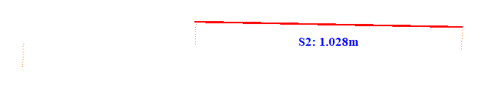

No. | Span | ID dan Lokasi Fasa | Nilai (m) (m) | Jarak Ke Menara Kecil (m)
382 | 128-129(128_129) | S3(Fasa Kiri ke Fasa Kanan) | 1.695 | 43.203
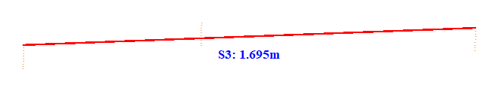

No. | Span | ID dan Lokasi Fasa | Nilai (m) (m) | Jarak Ke Menara Kecil (m)
383 | 129-130(129_130) | S1(Fasa Kiri ke Fasa Tengah) | 0.660 | 5.152
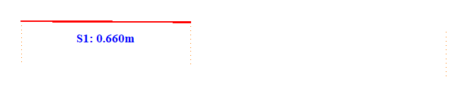

No. | Span | ID dan Lokasi Fasa | Nilai (m) (m) | Jarak Ke Menara Kecil (m)
384 | 129-130(129_130) | S2(Fasa Tengah ke Fasa Kanan) | 0.998 | 5.101
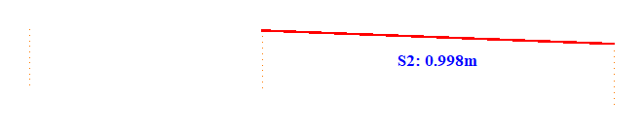

No. | Span | ID dan Lokasi Fasa | Nilai (m) (m) | Jarak Ke Menara Kecil (m)
385 | 129-130(129_130) | S3(Fasa Kiri ke Fasa Kanan) | 1.658 | 5.105
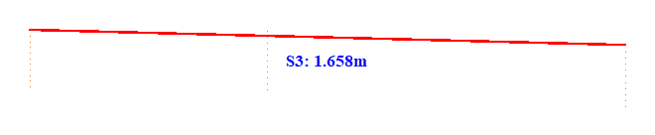

No. | Span | ID dan Lokasi Fasa | Nilai (m) (m) | Jarak Ke Menara Kecil (m)
386 | 130-131(130_131) | S1(Fasa Kiri ke Fasa Tengah) | 0.639 | 49.008
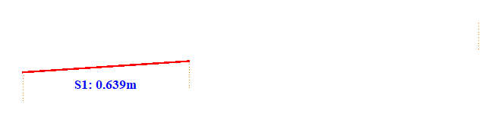

No. | Span | ID dan Lokasi Fasa | Nilai (m) (m) | Jarak Ke Menara Kecil (m)
387 | 130-131(130_131) | S2(Fasa Tengah ke Fasa Kanan) | 1.085 | 5.100
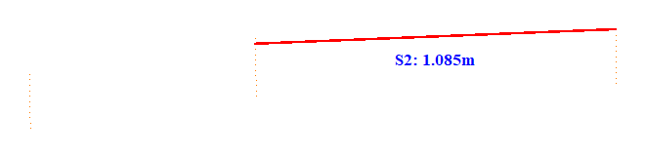

No. | Span | ID dan Lokasi Fasa | Nilai (m) (m) | Jarak Ke Menara Kecil (m)
388 | 130-131(130_131) | S3(Fasa Kiri ke Fasa Kanan) | 1.760 | 49.001
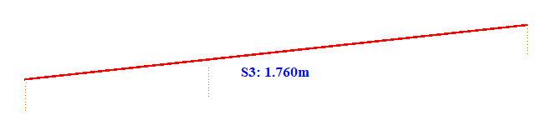

No. | Span | ID dan Lokasi Fasa | Nilai (m) (m) | Jarak Ke Menara Kecil (m)
389 | 131-132(131_132) | S1(Fasa Kiri ke Fasa Tengah) | 0.690 | 5.062
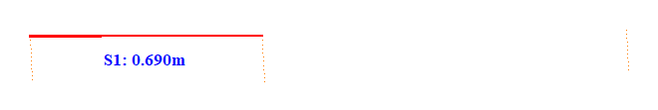

No. | Span | ID dan Lokasi Fasa | Nilai (m) (m) | Jarak Ke Menara Kecil (m)
390 | 131-132(131_132) | S2(Fasa Tengah ke Fasa Kanan) | 1.032 | 50.700
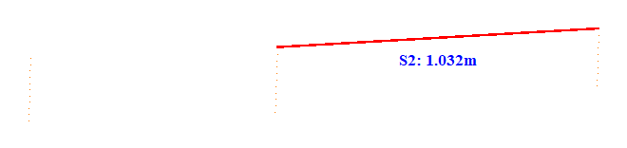

No. | Span | ID dan Lokasi Fasa | Nilai (m) (m) | Jarak Ke Menara Kecil (m)
391 | 131-132(131_132) | S3(Fasa Kiri ke Fasa Kanan) | 1.776 | 5.106
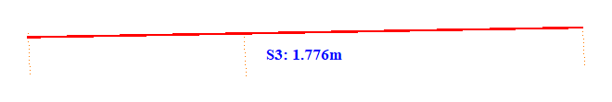

No. | Span | ID dan Lokasi Fasa | Nilai (m) (m) | Jarak Ke Menara Kecil (m)
392 | 132-133(132_133) | S1(Fasa Kiri ke Fasa Tengah) | 0.670 | 5.032
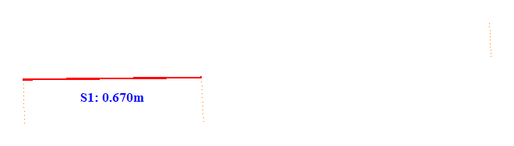

No. | Span | ID dan Lokasi Fasa | Nilai (m) (m) | Jarak Ke Menara Kecil (m)
393 | 132-133(132_133) | S2(Fasa Tengah ke Fasa Kanan) | 0.992 | 49.301
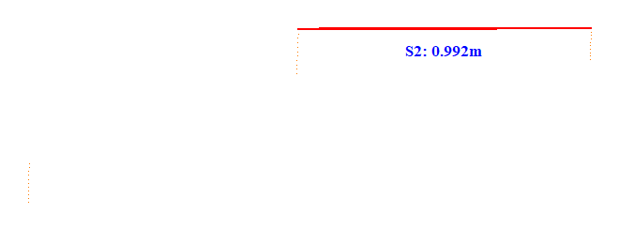

No. | Span | ID dan Lokasi Fasa | Nilai (m) (m) | Jarak Ke Menara Kecil (m)
394 | 132-133(132_133) | S3(Fasa Kiri ke Fasa Kanan) | 1.771 | 5.098
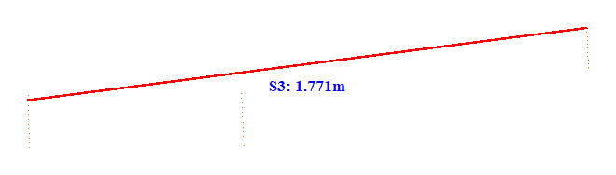

No. | Span | ID dan Lokasi Fasa | Nilai (m) (m) | Jarak Ke Menara Kecil (m)
395 | 133-134(133_134) | S1(Fasa Kiri ke Fasa Tengah) | 0.889 | 5.119
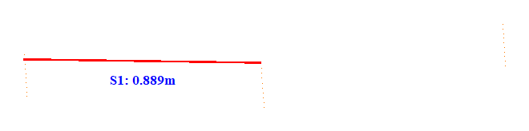

No. | Span | ID dan Lokasi Fasa | Nilai (m) (m) | Jarak Ke Menara Kecil (m)
396 | 133-134(133_134) | S2(Fasa Tengah ke Fasa Kanan) | 0.816 | 43.703
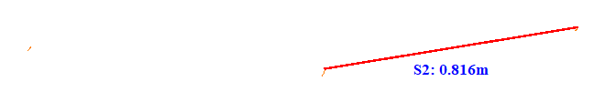

No. | Span | ID dan Lokasi Fasa | Nilai (m) (m) | Jarak Ke Menara Kecil (m)
397 | 133-134(133_134) | S3(Fasa Kiri ke Fasa Kanan) | 1.746 | 43.701
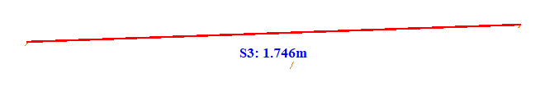

No. | Span | ID dan Lokasi Fasa | Nilai (m) (m) | Jarak Ke Menara Kecil (m)
398 | 135-136(135_136) | S1(Fasa Kiri ke Fasa Tengah) | 1.052 | 35.803
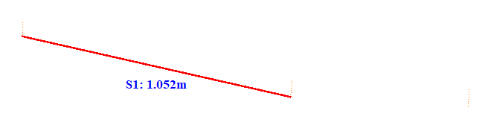

No. | Span | ID dan Lokasi Fasa | Nilai (m) (m) | Jarak Ke Menara Kecil (m)
399 | 135-136(135_136) | S2(Fasa Tengah ke Fasa Kanan) | 0.581 | 5.144
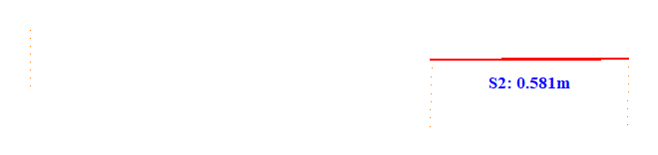

No. | Span | ID dan Lokasi Fasa | Nilai (m) (m) | Jarak Ke Menara Kecil (m)
400 | 135-136(135_136) | S3(Fasa Kiri ke Fasa Kanan) | 1.728 | 35.806
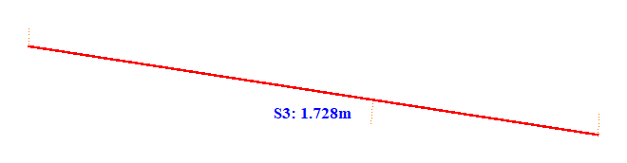

No. | Span | ID dan Lokasi Fasa | Nilai (m) (m) | Jarak Ke Menara Kecil (m)
401 | 136-137(136_137) | S1(Fasa Kiri ke Fasa Tengah) | 0.839 | 45.402
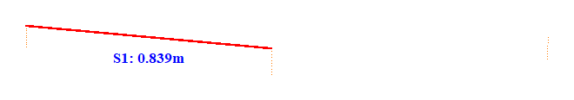

No. | Span | ID dan Lokasi Fasa | Nilai (m) (m) | Jarak Ke Menara Kecil (m)
402 | 136-137(136_137) | S2(Fasa Tengah ke Fasa Kanan) | 0.642 | 5.208
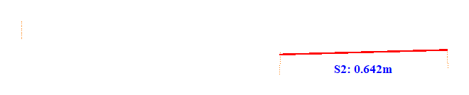

No. | Span | ID dan Lokasi Fasa | Nilai (m) (m) | Jarak Ke Menara Kecil (m)
403 | 136-137(136_137) | S3(Fasa Kiri ke Fasa Kanan) | 1.640 | 5.128
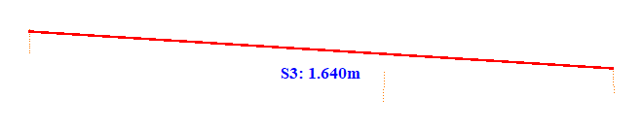

No. | Span | ID dan Lokasi Fasa | Nilai (m) (m) | Jarak Ke Menara Kecil (m)
404 | 137-138(137_138) | S1(Fasa Kiri ke Fasa Tengah) | 0.886 | 49.101
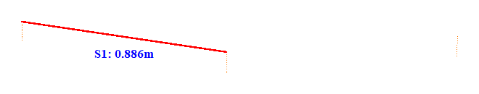

No. | Span | ID dan Lokasi Fasa | Nilai (m) (m) | Jarak Ke Menara Kecil (m)
405 | 137-138(137_138) | S2(Fasa Tengah ke Fasa Kanan) | 0.788 | 5.197
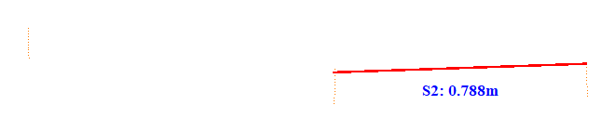

No. | Span | ID dan Lokasi Fasa | Nilai (m) (m) | Jarak Ke Menara Kecil (m)
406 | 137-138(137_138) | S3(Fasa Kiri ke Fasa Kanan) | 1.750 | 5.125
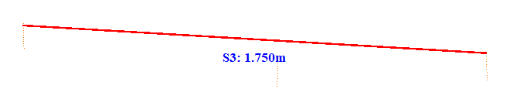

No. | Span | ID dan Lokasi Fasa | Nilai (m) (m) | Jarak Ke Menara Kecil (m)
407 | 138-139(138_139) | S1(Fasa Kiri ke Fasa Tengah) | 0.922 | 5.100
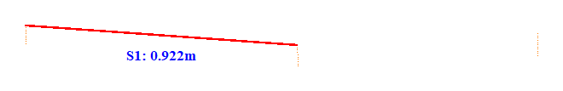

No. | Span | ID dan Lokasi Fasa | Nilai (m) (m) | Jarak Ke Menara Kecil (m)
408 | 138-139(138_139) | S2(Fasa Tengah ke Fasa Kanan) | 0.634 | 45.811
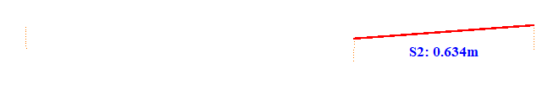

No. | Span | ID dan Lokasi Fasa | Nilai (m) (m) | Jarak Ke Menara Kecil (m)
409 | 138-139(138_139) | S3(Fasa Kiri ke Fasa Kanan) | 1.737 | 5.127
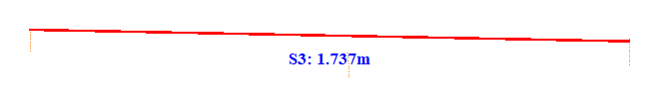

No. | Span | ID dan Lokasi Fasa | Nilai (m) (m) | Jarak Ke Menara Kecil (m)
410 | 139-140(139_140) | S1(Fasa Kiri ke Fasa Tengah) | 0.946 | 47.702
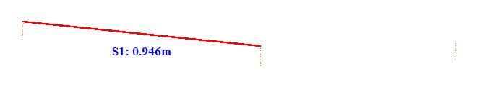

No. | Span | ID dan Lokasi Fasa | Nilai (m) (m) | Jarak Ke Menara Kecil (m)
411 | 139-140(139_140) | S2(Fasa Tengah ke Fasa Kanan) | 0.652 | 5.208
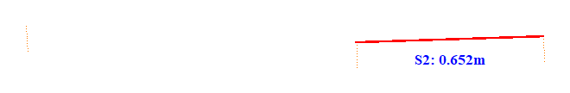

No. | Span | ID dan Lokasi Fasa | Nilai (m) (m) | Jarak Ke Menara Kecil (m)
412 | 139-140(139_140) | S3(Fasa Kiri ke Fasa Kanan) | 1.718 | 47.703
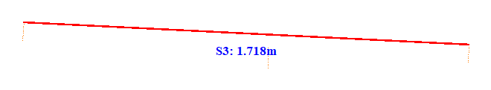

No. | Span | ID dan Lokasi Fasa | Nilai (m) (m) | Jarak Ke Menara Kecil (m)
413 | 140-141(140_141) | S1(Fasa Kiri ke Fasa Tengah) | 0.947 | 5.104
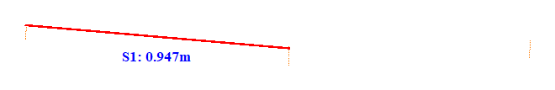

No. | Span | ID dan Lokasi Fasa | Nilai (m) (m) | Jarak Ke Menara Kecil (m)
414 | 140-141(140_141) | S2(Fasa Tengah ke Fasa Kanan) | 0.760 | 46.914
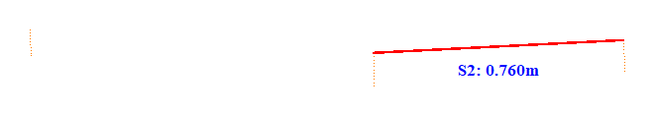

No. | Span | ID dan Lokasi Fasa | Nilai (m) (m) | Jarak Ke Menara Kecil (m)
415 | 140-141(140_141) | S3(Fasa Kiri ke Fasa Kanan) | 1.806 | 46.905
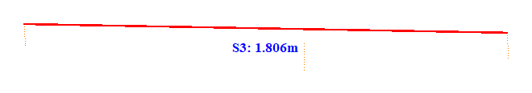

No. | Span | ID dan Lokasi Fasa | Nilai (m) (m) | Jarak Ke Menara Kecil (m)
416 | 141-142(141_142) | S1(Fasa Kiri ke Fasa Tengah) | 1.085 | 5.101
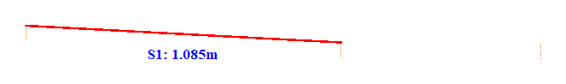

No. | Span | ID dan Lokasi Fasa | Nilai (m) (m) | Jarak Ke Menara Kecil (m)
417 | 141-142(141_142) | S2(Fasa Tengah ke Fasa Kanan) | 0.660 | 36.015
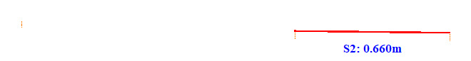

No. | Span | ID dan Lokasi Fasa | Nilai (m) (m) | Jarak Ke Menara Kecil (m)
418 | 141-142(141_142) | S3(Fasa Kiri ke Fasa Kanan) | 1.772 | 5.123
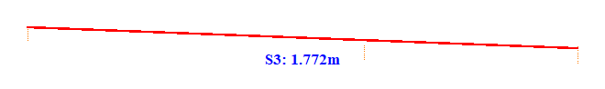

No. | Span | ID dan Lokasi Fasa | Nilai (m) (m) | Jarak Ke Menara Kecil (m)
419 | 142-143(142_143) | S1(Fasa Kiri ke Fasa Tengah) | 1.072 | 39.301
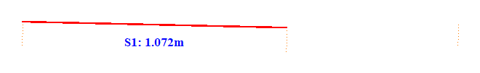

No. | Span | ID dan Lokasi Fasa | Nilai (m) (m) | Jarak Ke Menara Kecil (m)
420 | 142-143(142_143) | S2(Fasa Tengah ke Fasa Kanan) | 0.662 | 5.199
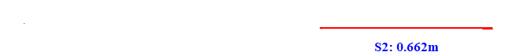

No. | Span | ID dan Lokasi Fasa | Nilai (m) (m) | Jarak Ke Menara Kecil (m)
421 | 142-143(142_143) | S3(Fasa Kiri ke Fasa Kanan) | 1.769 | 39.303
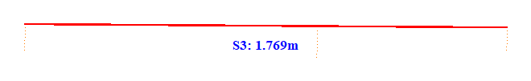

No. | Span | ID dan Lokasi Fasa | Nilai (m) (m) | Jarak Ke Menara Kecil (m)
422 | 143-144(143_144) | S1(Fasa Kiri ke Fasa Tengah) | 1.054 | 5.102
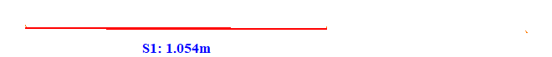

No. | Span | ID dan Lokasi Fasa | Nilai (m) (m) | Jarak Ke Menara Kecil (m)
423 | 143-144(143_144) | S2(Fasa Tengah ke Fasa Kanan) | 0.537 | 42.015
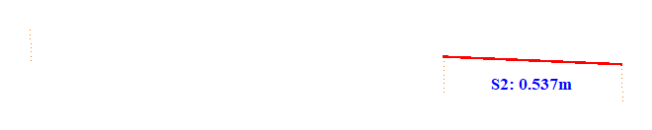

No. | Span | ID dan Lokasi Fasa | Nilai (m) (m) | Jarak Ke Menara Kecil (m)
424 | 143-144(143_144) | S3(Fasa Kiri ke Fasa Kanan) | 1.760 | 5.131
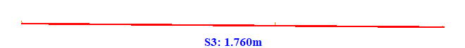

No. | Span | ID dan Lokasi Fasa | Nilai (m) (m) | Jarak Ke Menara Kecil (m)
425 | 144-145(144_145) | S1(Fasa Kiri ke Fasa Tengah) | 0.780 | 41.403
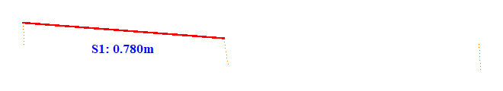

No. | Span | ID dan Lokasi Fasa | Nilai (m) (m) | Jarak Ke Menara Kecil (m)
426 | 144-145(144_145) | S2(Fasa Tengah ke Fasa Kanan) | 0.569 | 5.086
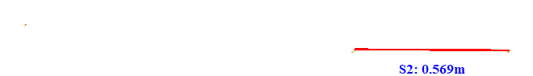

No. | Span | ID dan Lokasi Fasa | Nilai (m) (m) | Jarak Ke Menara Kecil (m)
427 | 144-145(144_145) | S3(Fasa Kiri ke Fasa Kanan) | 1.766 | 41.401
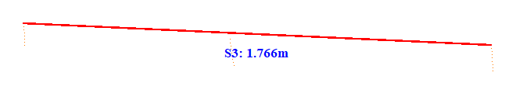

No. | Span | ID dan Lokasi Fasa | Nilai (m) (m) | Jarak Ke Menara Kecil (m)
428 | 145-146(145_146) | S1(Fasa Kiri ke Fasa Tengah) | 0.759 | 5.028
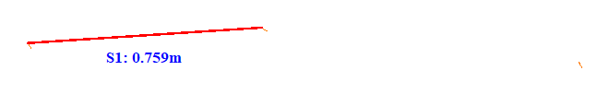

No. | Span | ID dan Lokasi Fasa | Nilai (m) (m) | Jarak Ke Menara Kecil (m)
429 | 145-146(145_146) | S2(Fasa Tengah ke Fasa Kanan) | 0.768 | 41.903
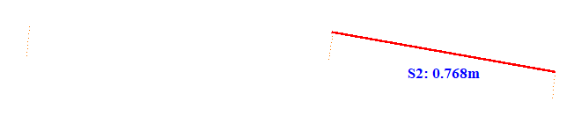

No. | Span | ID dan Lokasi Fasa | Nilai (m) (m) | Jarak Ke Menara Kecil (m)
430 | 145-146(145_146) | S3(Fasa Kiri ke Fasa Kanan) | 1.783 | 5.099
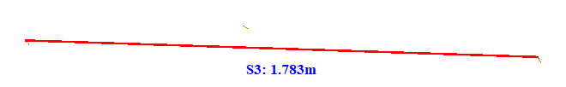

No. | Span | ID dan Lokasi Fasa | Nilai (m) (m) | Jarak Ke Menara Kecil (m)
431 | 146-147(146_147) | S1(Fasa Kiri ke Fasa Tengah) | 0.905 | 34.101
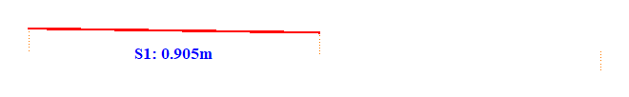

No. | Span | ID dan Lokasi Fasa | Nilai (m) (m) | Jarak Ke Menara Kecil (m)
432 | 146-147(146_147) | S2(Fasa Tengah ke Fasa Kanan) | 0.730 | 5.204
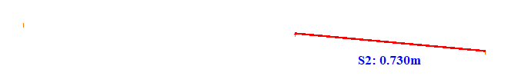

No. | Span | ID dan Lokasi Fasa | Nilai (m) (m) | Jarak Ke Menara Kecil (m)
433 | 146-147(146_147) | S3(Fasa Kiri ke Fasa Kanan) | 1.776 | 5.124
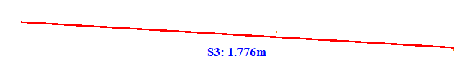

No. | Span | ID dan Lokasi Fasa | Nilai (m) (m) | Jarak Ke Menara Kecil (m)
434 | 147-148(147_148) | S1(Fasa Kiri ke Fasa Tengah) | 0.915 | 5.100
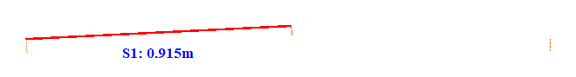

No. | Span | ID dan Lokasi Fasa | Nilai (m) (m) | Jarak Ke Menara Kecil (m)
435 | 147-148(147_148) | S2(Fasa Tengah ke Fasa Kanan) | 0.723 | 48.411
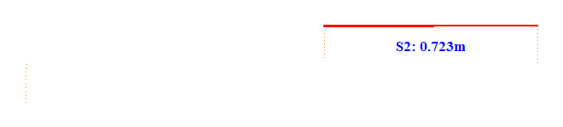

No. | Span | ID dan Lokasi Fasa | Nilai (m) (m) | Jarak Ke Menara Kecil (m)
436 | 147-148(147_148) | S3(Fasa Kiri ke Fasa Kanan) | 1.743 | 48.404
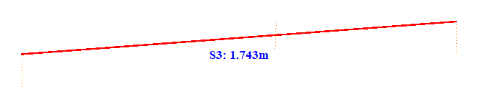

No. | Span | ID dan Lokasi Fasa | Nilai (m) (m) | Jarak Ke Menara Kecil (m)
437 | 148-149(148_149) | S1(Fasa Kiri ke Fasa Tengah) | 0.872 | 42.302
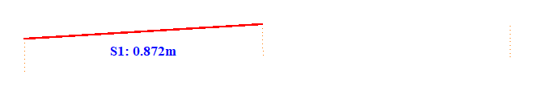

No. | Span | ID dan Lokasi Fasa | Nilai (m) (m) | Jarak Ke Menara Kecil (m)
438 | 148-149(148_149) | S2(Fasa Tengah ke Fasa Kanan) | 0.737 | 5.114
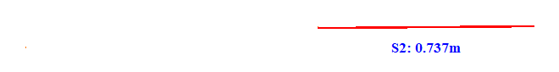

No. | Span | ID dan Lokasi Fasa | Nilai (m) (m) | Jarak Ke Menara Kecil (m)
439 | 148-149(148_149) | S3(Fasa Kiri ke Fasa Kanan) | 1.746 | 5.131
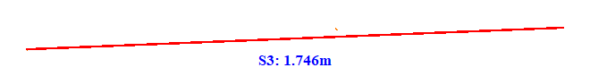

No. | Span | ID dan Lokasi Fasa | Nilai (m) (m) | Jarak Ke Menara Kecil (m)
440 | 149-150(149_150) | S1(Fasa Kiri ke Fasa Tengah) | 0.877 | 5.099
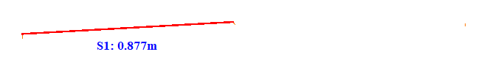

No. | Span | ID dan Lokasi Fasa | Nilai (m) (m) | Jarak Ke Menara Kecil (m)
441 | 149-150(149_150) | S2(Fasa Tengah ke Fasa Kanan) | 0.719 | 46.611
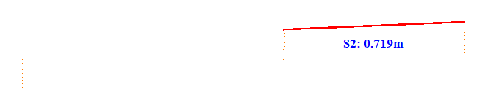

No. | Span | ID dan Lokasi Fasa | Nilai (m) (m) | Jarak Ke Menara Kecil (m)
442 | 149-150(149_150) | S3(Fasa Kiri ke Fasa Kanan) | 1.774 | 46.604
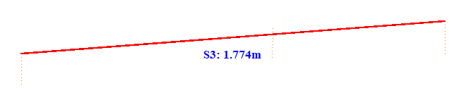

No. | Span | ID dan Lokasi Fasa | Nilai (m) (m) | Jarak Ke Menara Kecil (m)
443 | 150-151(150_151) | S1(Fasa Kiri ke Fasa Tengah) | 1.069 | 32.101
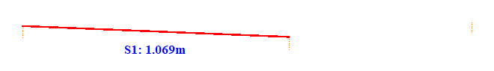

No. | Span | ID dan Lokasi Fasa | Nilai (m) (m) | Jarak Ke Menara Kecil (m)
444 | 150-151(150_151) | S2(Fasa Tengah ke Fasa Kanan) | 0.661 | 5.212
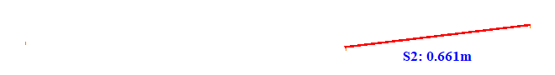

No. | Span | ID dan Lokasi Fasa | Nilai (m) (m) | Jarak Ke Menara Kecil (m)
445 | 150-151(150_151) | S3(Fasa Kiri ke Fasa Kanan) | 1.799 | 5.125
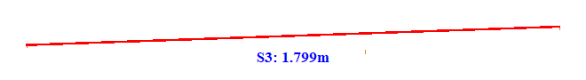

No. | Span | ID dan Lokasi Fasa | Nilai (m) (m) | Jarak Ke Menara Kecil (m)
446 | 151-152(151_152) | S1(Fasa Kiri ke Fasa Tengah) | 1.015 | 42.401
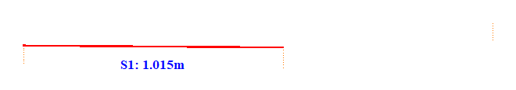

No. | Span | ID dan Lokasi Fasa | Nilai (m) (m) | Jarak Ke Menara Kecil (m)
447 | 151-152(151_152) | S2(Fasa Tengah ke Fasa Kanan) | 0.722 | 5.214
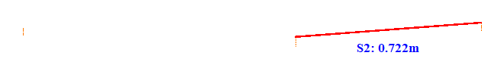

No. | Span | ID dan Lokasi Fasa | Nilai (m) (m) | Jarak Ke Menara Kecil (m)
448 | 151-152(151_152) | S3(Fasa Kiri ke Fasa Kanan) | 1.778 | 5.129
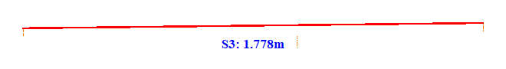

No. | Span | ID dan Lokasi Fasa | Nilai (m) (m) | Jarak Ke Menara Kecil (m)
449 | 152-153(152_153) | S1(Fasa Kiri ke Fasa Tengah) | 1.054 | 5.103
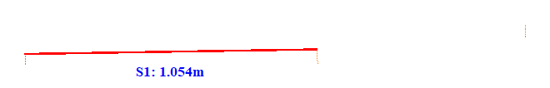

No. | Span | ID dan Lokasi Fasa | Nilai (m) (m) | Jarak Ke Menara Kecil (m)
450 | 152-153(152_153) | S2(Fasa Tengah ke Fasa Kanan) | 0.642 | 38.916
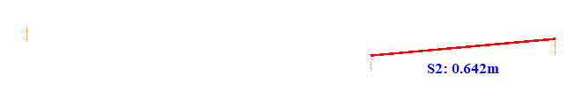

No. | Span | ID dan Lokasi Fasa | Nilai (m) (m) | Jarak Ke Menara Kecil (m)
451 | 152-153(152_153) | S3(Fasa Kiri ke Fasa Kanan) | 1.812 | 5.134
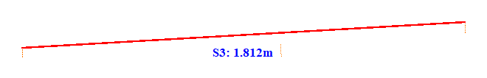

No. | Span | ID dan Lokasi Fasa | Nilai (m) (m) | Jarak Ke Menara Kecil (m)
452 | 153-154(153_154) | S1(Fasa Kiri ke Fasa Tengah) | 1.048 | 40.702
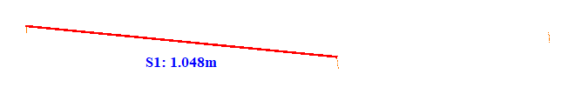

No. | Span | ID dan Lokasi Fasa | Nilai (m) (m) | Jarak Ke Menara Kecil (m)
453 | 153-154(153_154) | S2(Fasa Tengah ke Fasa Kanan) | 0.590 | 5.125
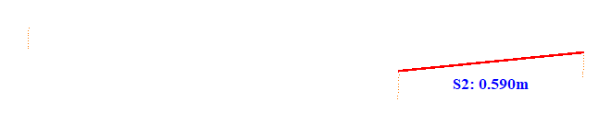

No. | Span | ID dan Lokasi Fasa | Nilai (m) (m) | Jarak Ke Menara Kecil (m)
454 | 153-154(153_154) | S3(Fasa Kiri ke Fasa Kanan) | 1.754 | 40.704
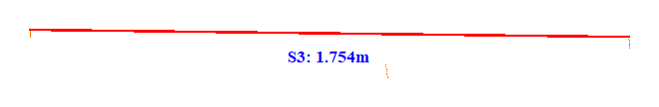

No. | Span | ID dan Lokasi Fasa | Nilai (m) (m) | Jarak Ke Menara Kecil (m)
455 | 154-155(154_155) | S1(Fasa Kiri ke Fasa Tengah) | 0.894 | 39.101
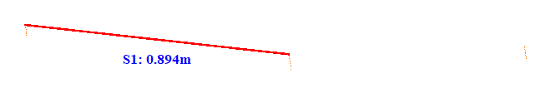

No. | Span | ID dan Lokasi Fasa | Nilai (m) (m) | Jarak Ke Menara Kecil (m)
456 | 154-155(154_155) | S2(Fasa Tengah ke Fasa Kanan) | 0.747 | 5.089
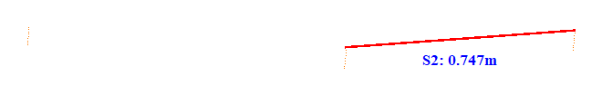

No. | Span | ID dan Lokasi Fasa | Nilai (m) (m) | Jarak Ke Menara Kecil (m)
457 | 154-155(154_155) | S3(Fasa Kiri ke Fasa Kanan) | 1.685 | 39.103
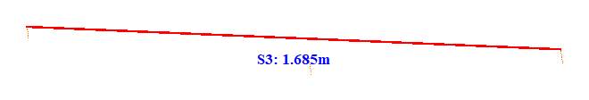

No. | Span | ID dan Lokasi Fasa | Nilai (m) (m) | Jarak Ke Menara Kecil (m)
458 | 155-156(155_156) | S1(Fasa Kiri ke Fasa Tengah) | 0.746 | 41.002
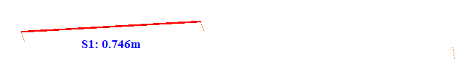

No. | Span | ID dan Lokasi Fasa | Nilai (m) (m) | Jarak Ke Menara Kecil (m)
459 | 155-156(155_156) | S2(Fasa Tengah ke Fasa Kanan) | 0.853 | 5.023
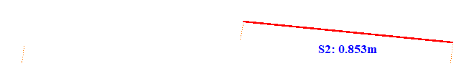

No. | Span | ID dan Lokasi Fasa | Nilai (m) (m) | Jarak Ke Menara Kecil (m)
460 | 155-156(155_156) | S3(Fasa Kiri ke Fasa Kanan) | 1.741 | 5.099
